**MATLAB Tutorial – Bioinformatics Toolbox – Calculating & Visualizing Sequence Statistics – Tuesday, June 18, 2019**

Link: <https://www.mathworks.com/help/bioinfo/examples/calculating-and-visualizing-sequence-statistics.html>

Box One:



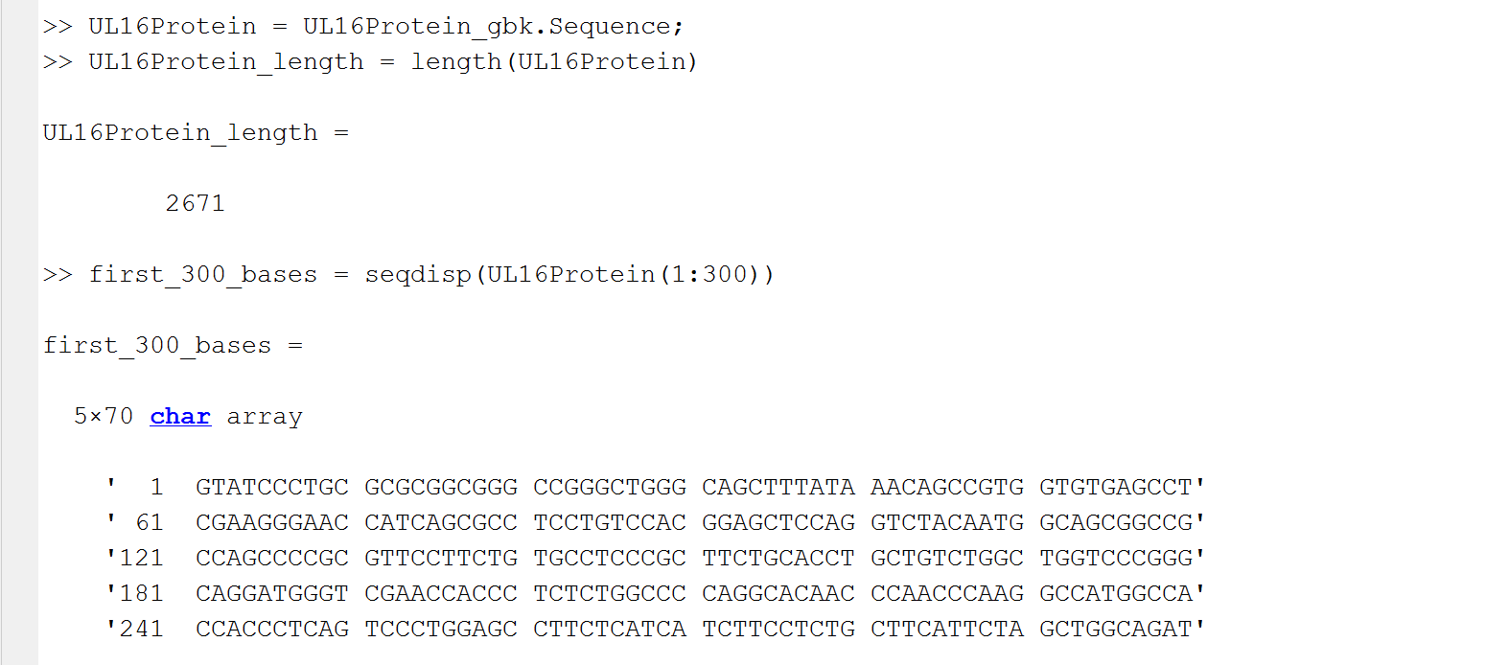

Box Two:

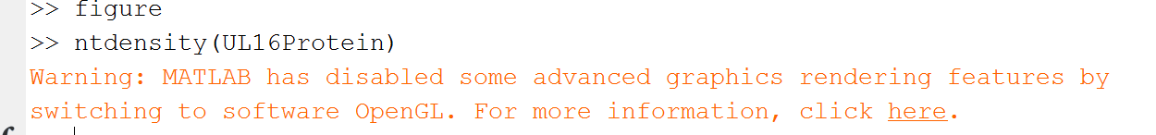

Nucleotide Density Figure 1:

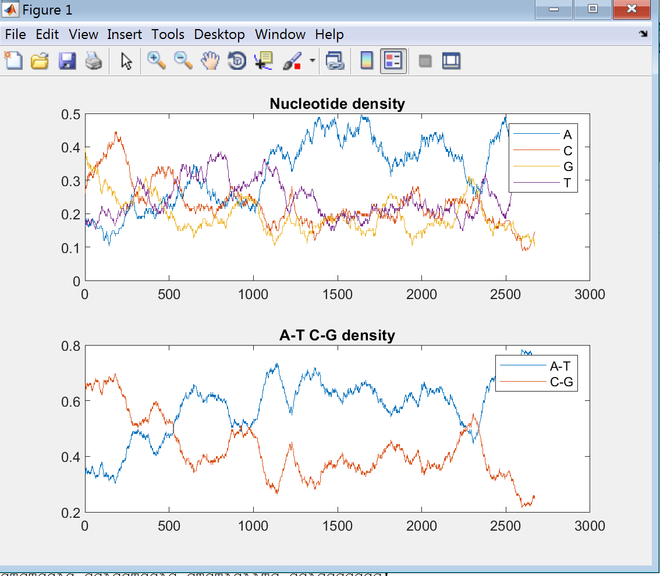

Box Three:

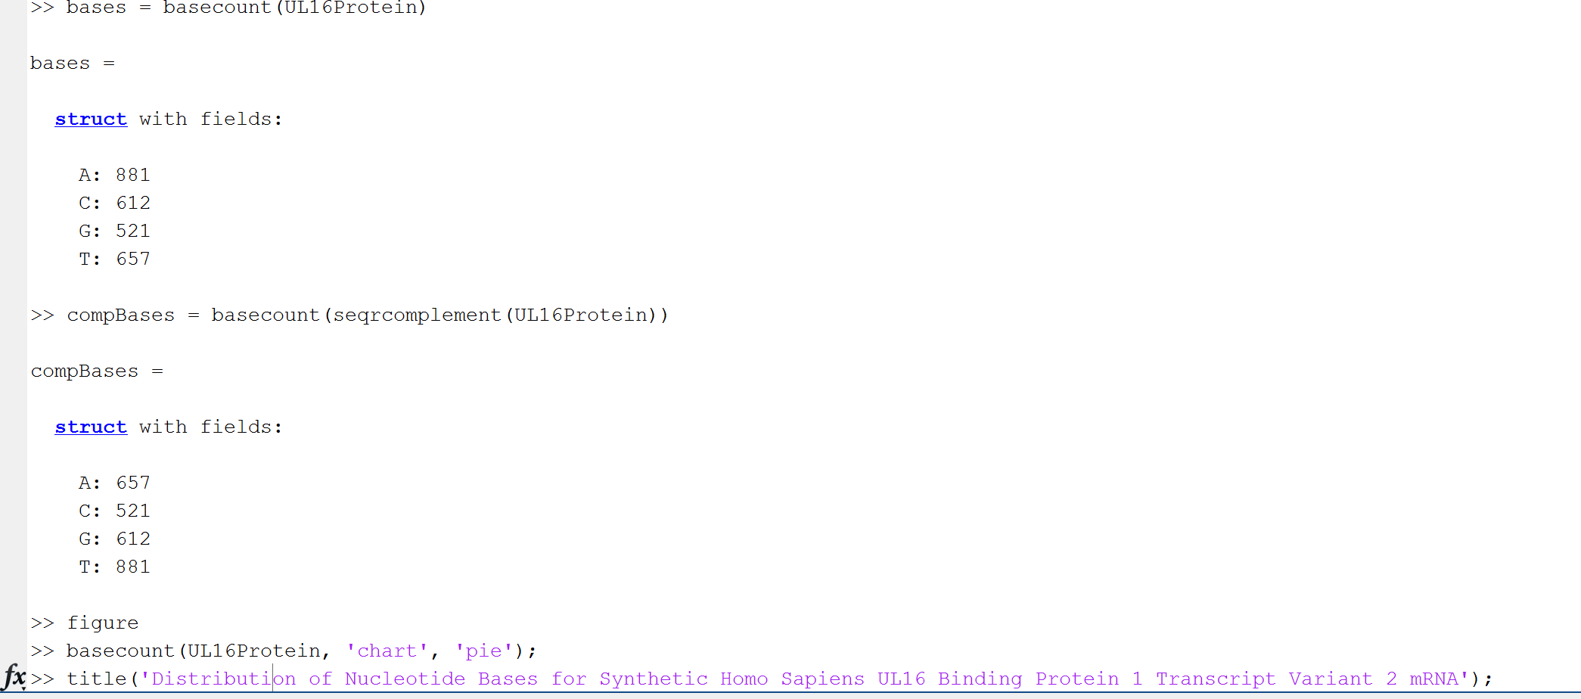

*Distribution of Nucleotide Base for Synthetic Homo Sapiens UL16 Binding Protein 1 Transcript Variant 2 mRNA - Figure 2:

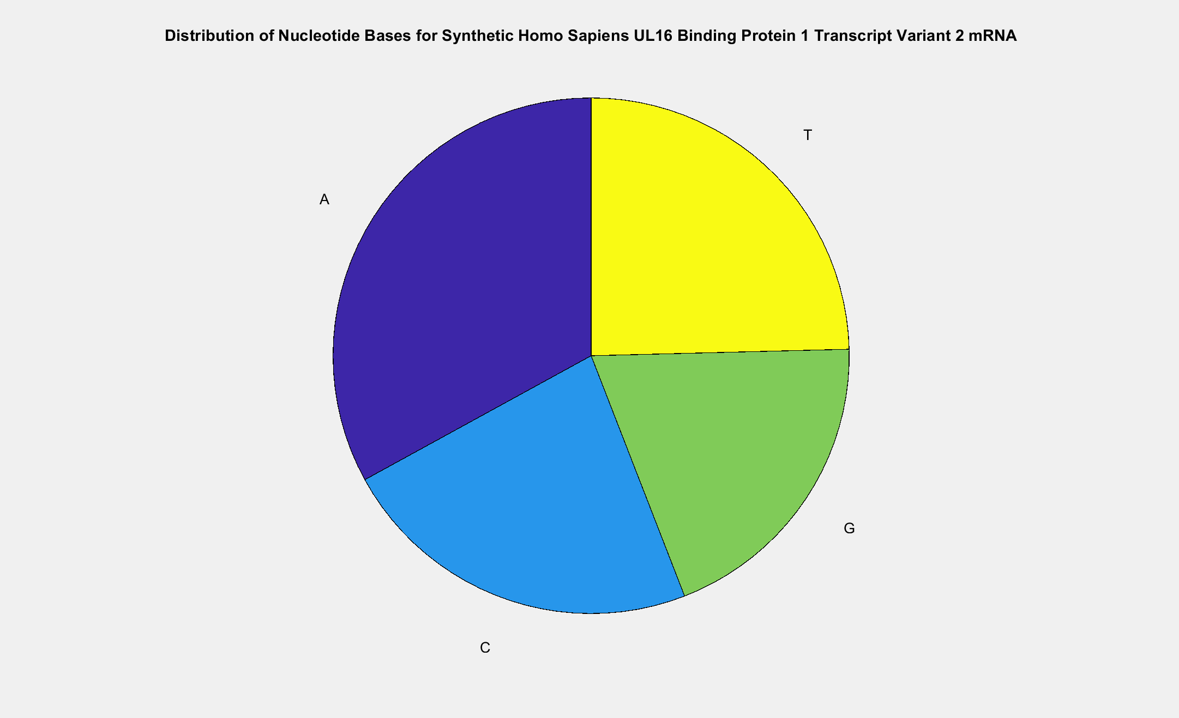

Box Four:

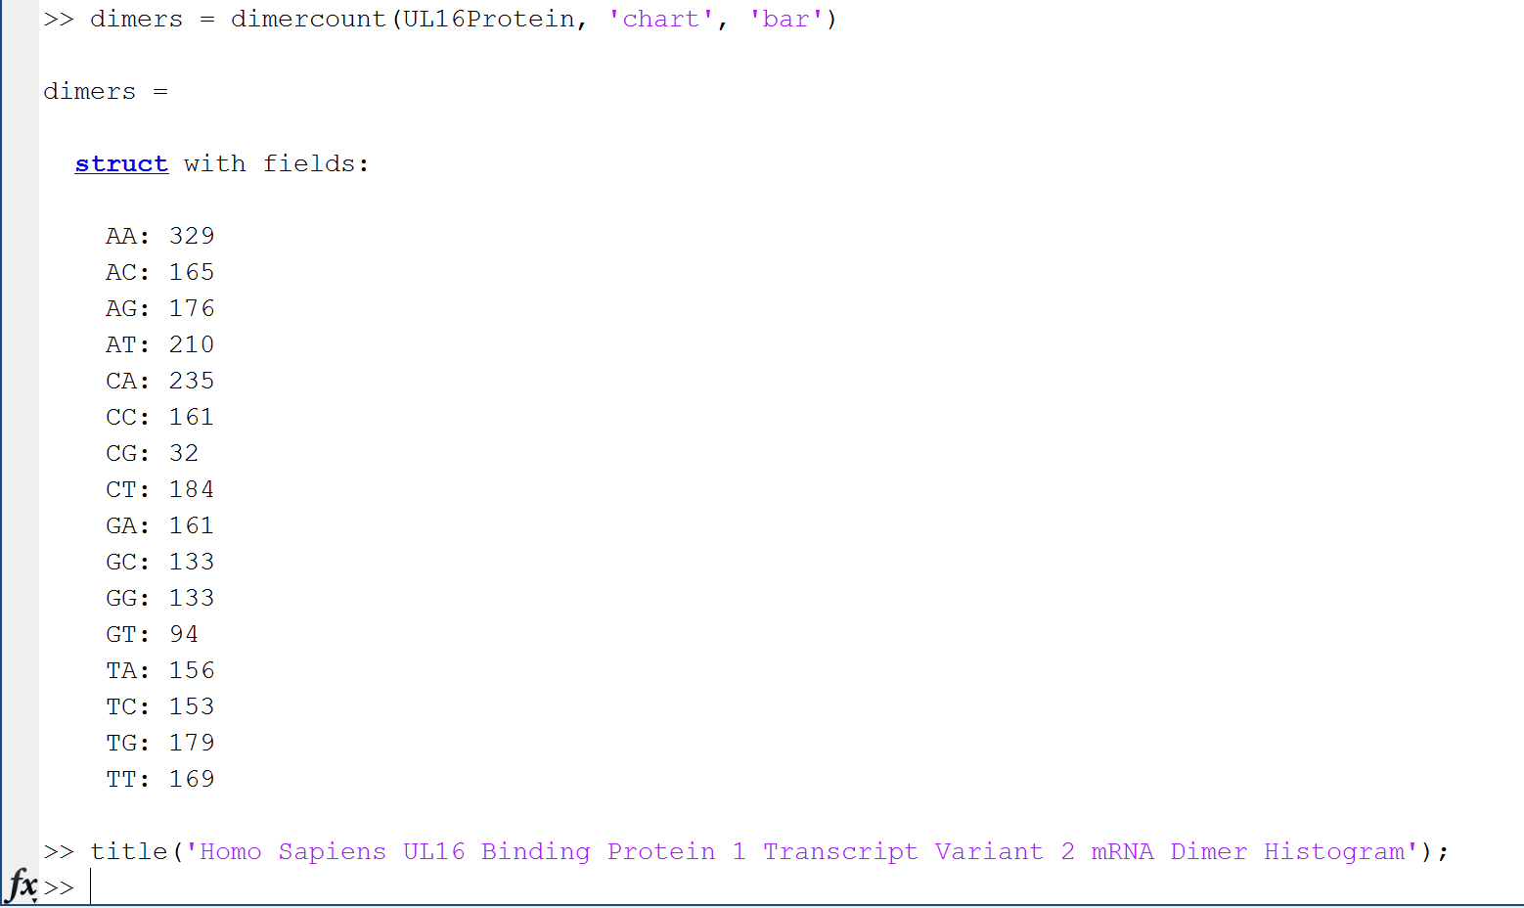

Homo Sapiens Ul16 Binding Protein 1 Transcript Variant 2 mRNA Dimer Histogram Figure:

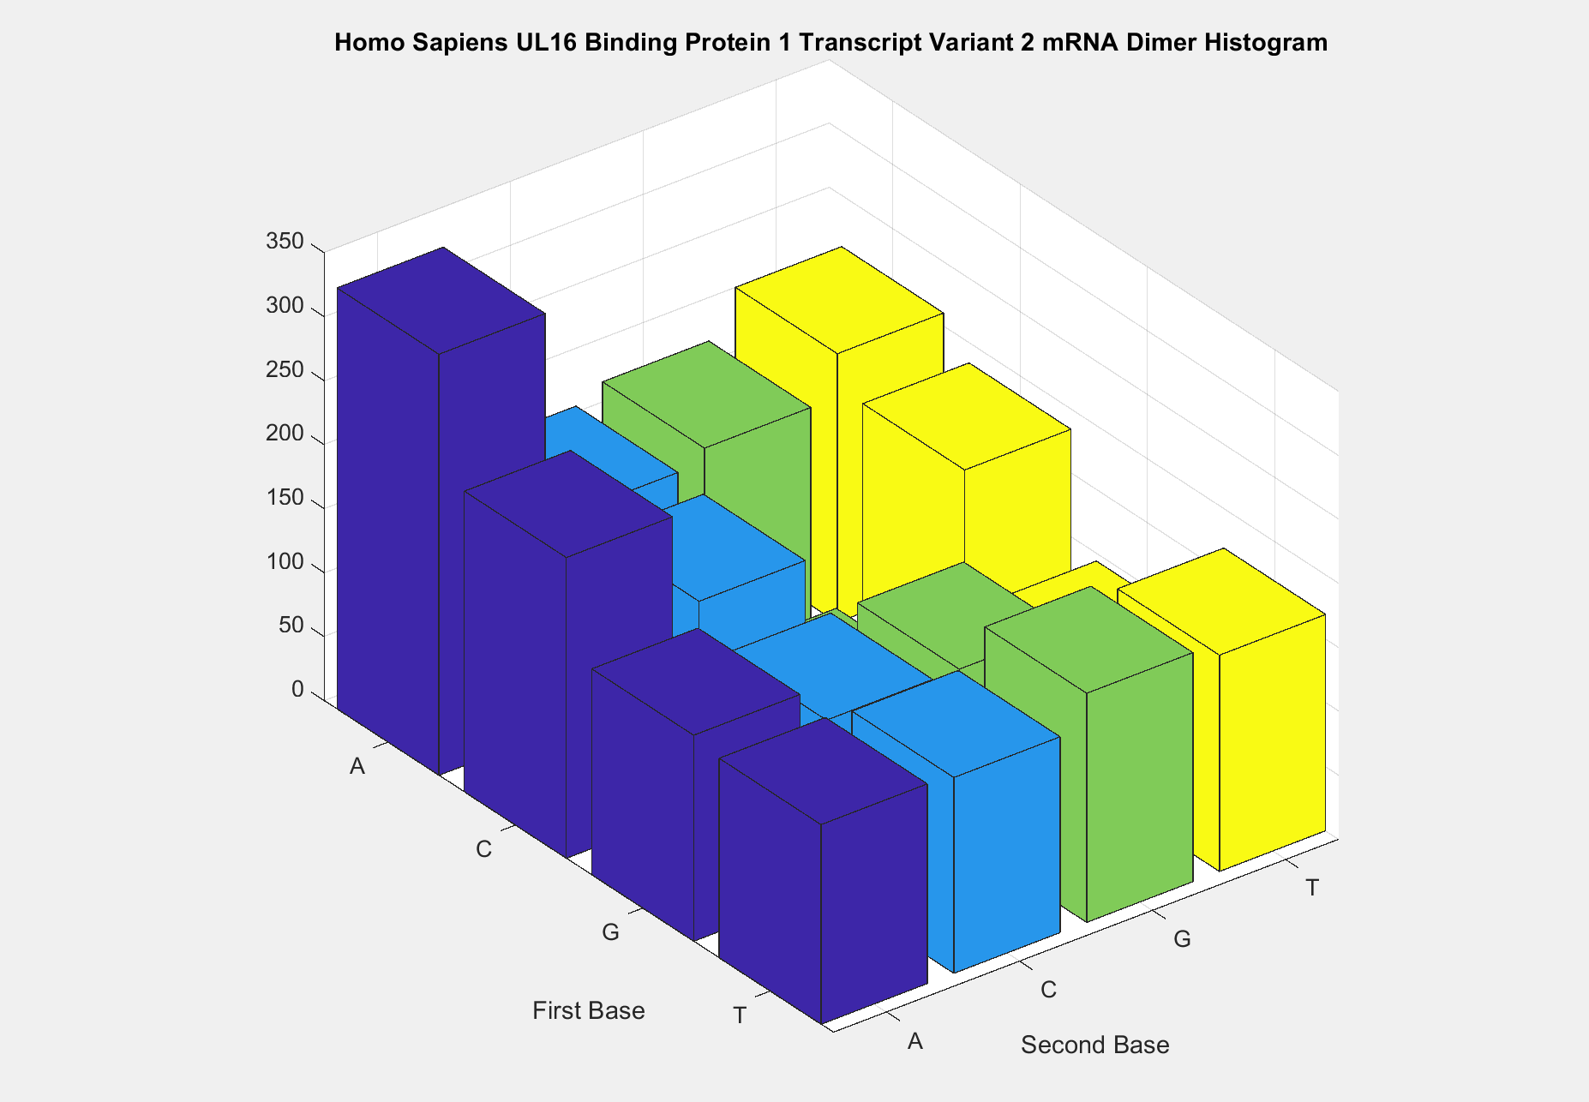

Box Four:



Sequence Open Reading Frames Figure:

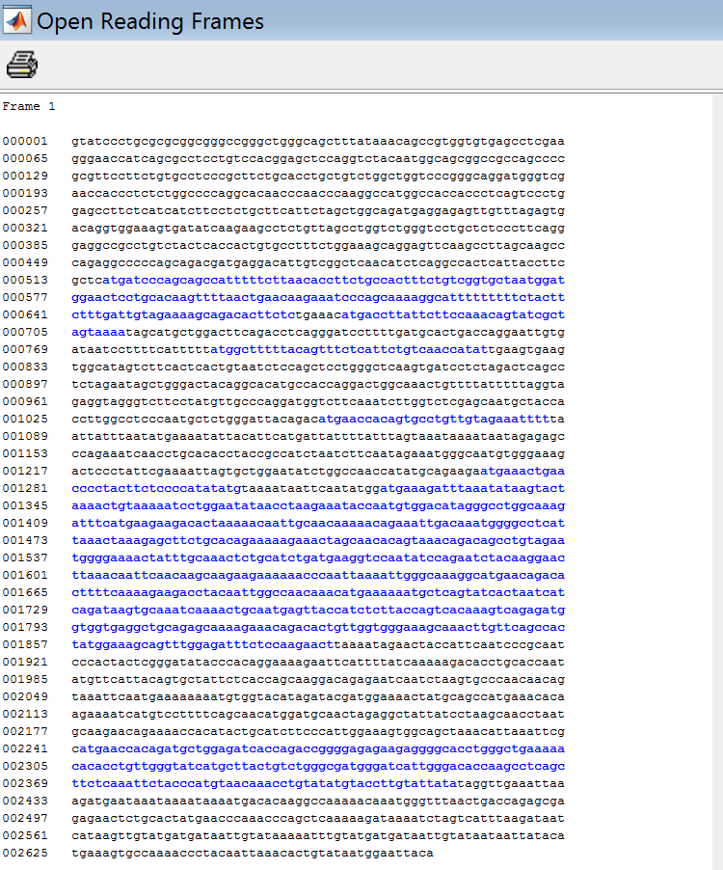

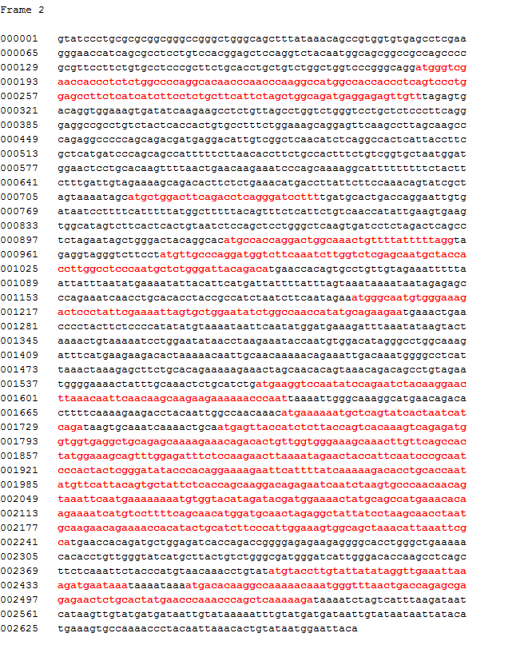

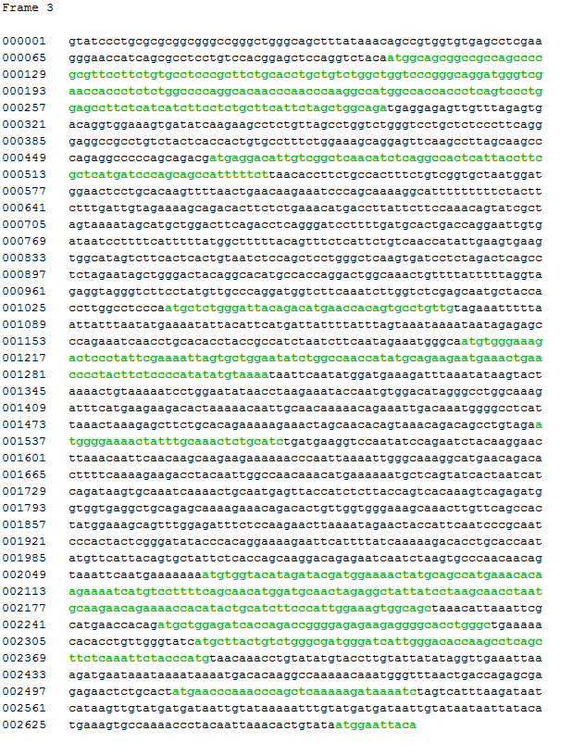

Box :

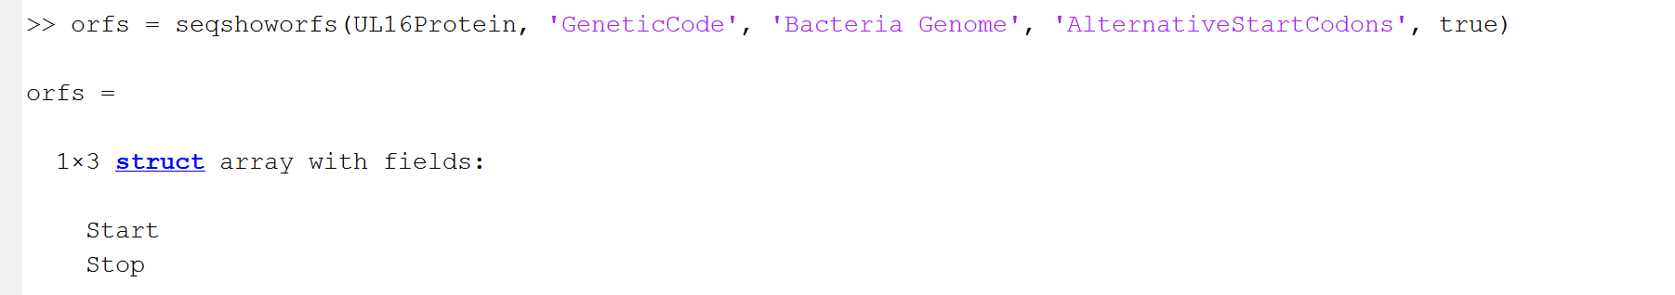

Alternative Codons Open Reading Frame:

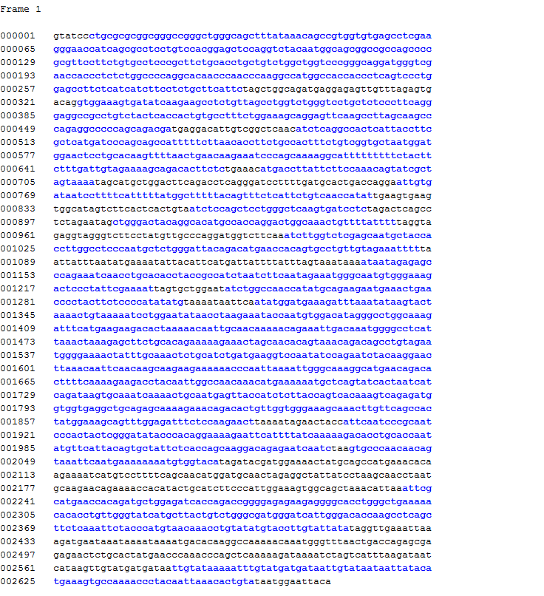

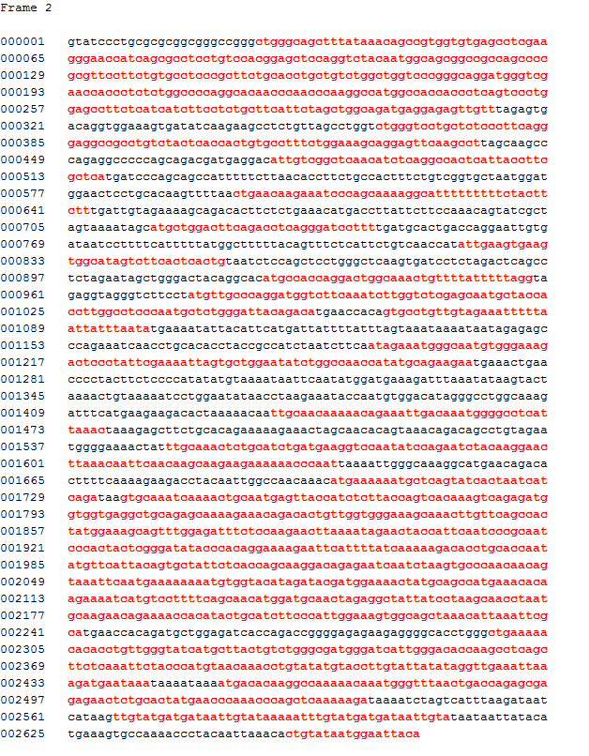

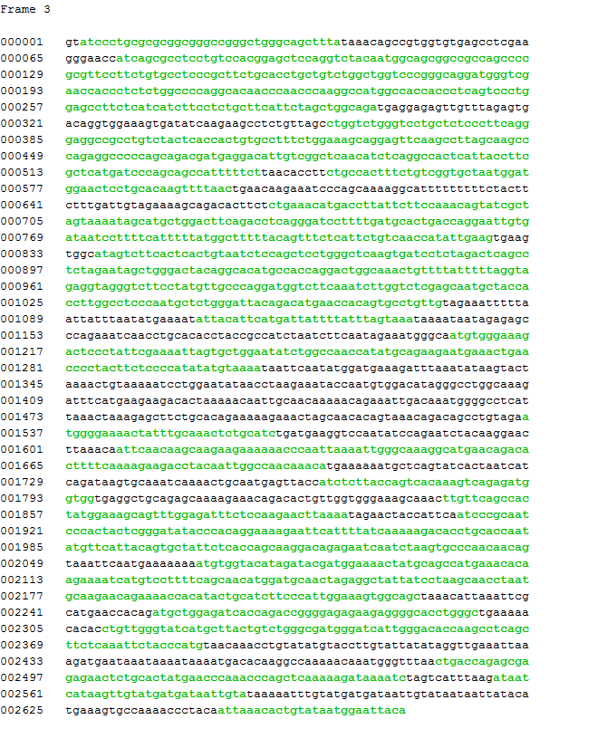

Box Five:



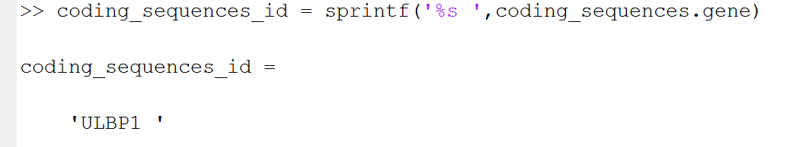

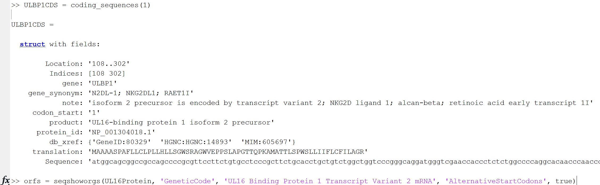

Figure:

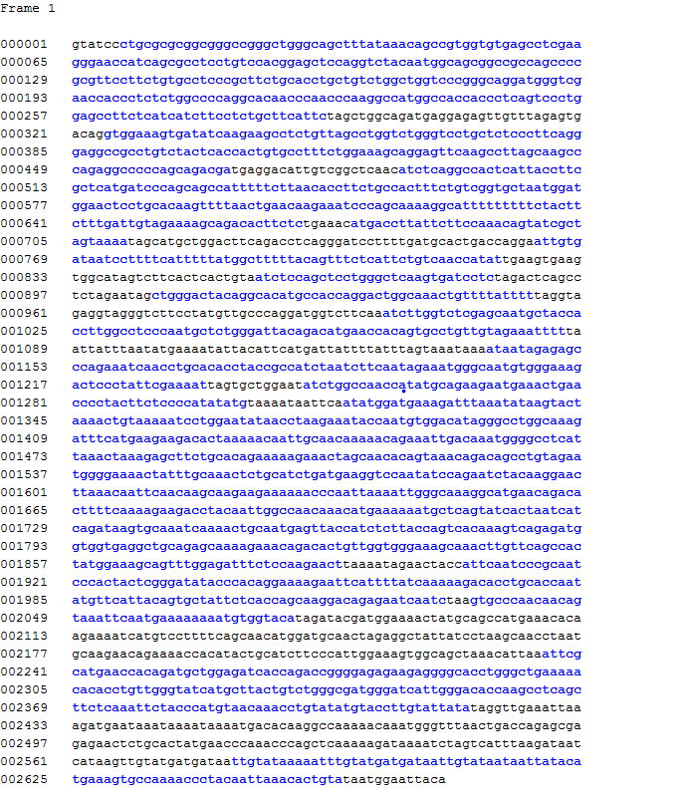

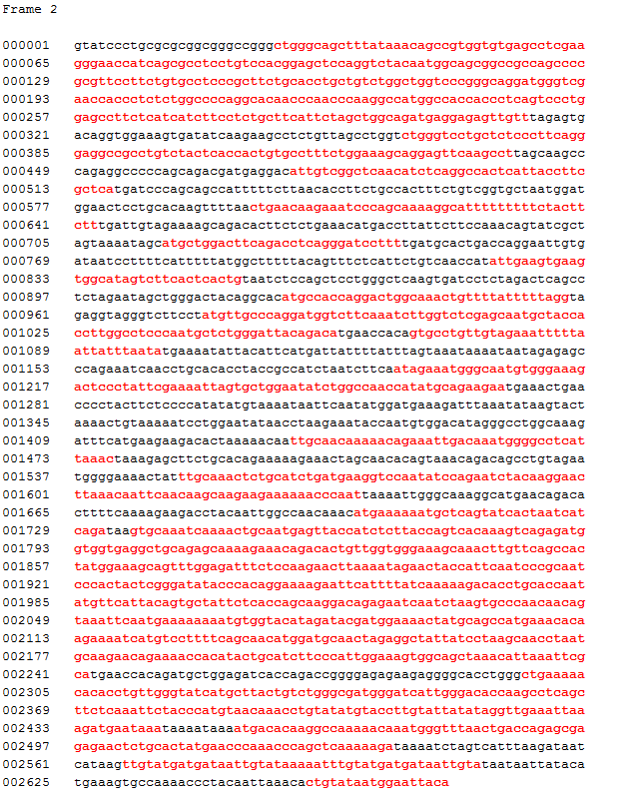

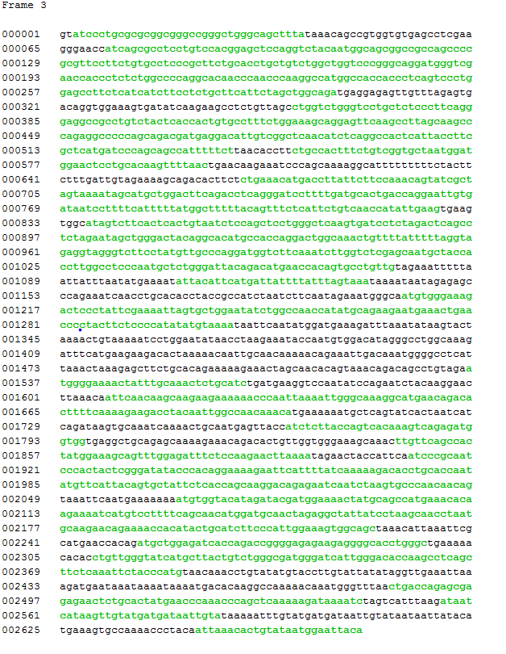

**Box:**



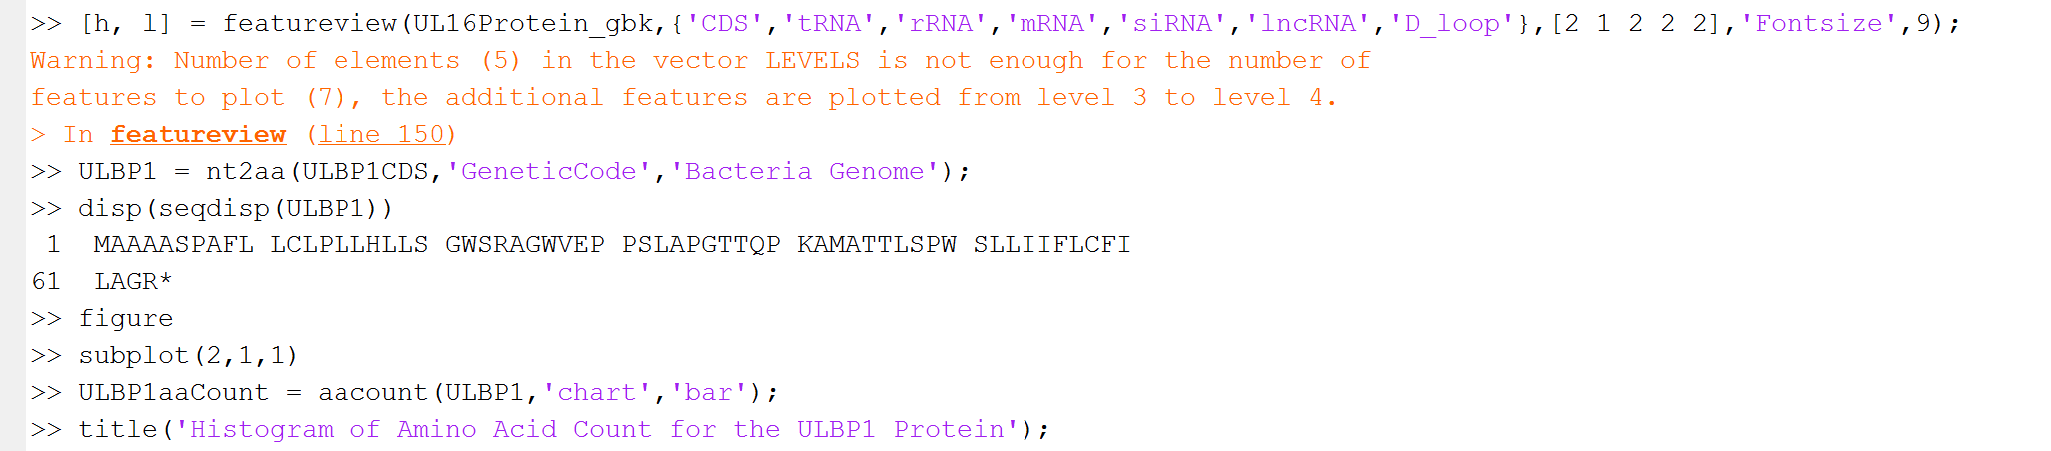

**Figure:**

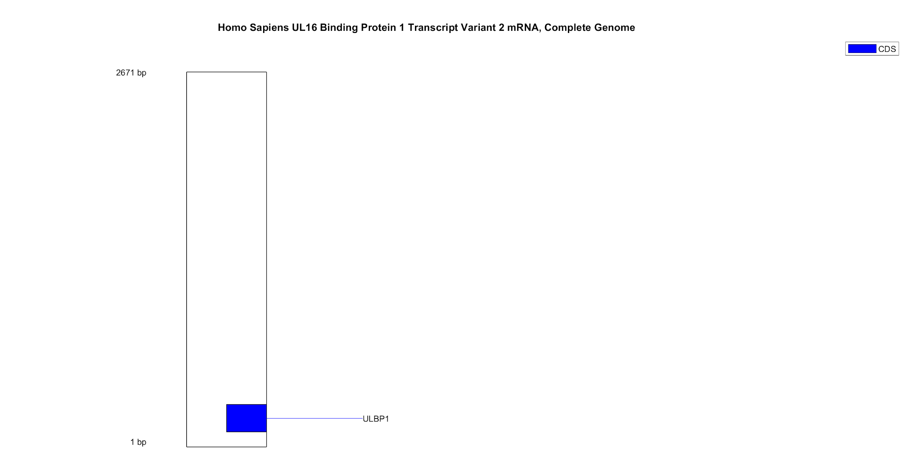

**Figure:**

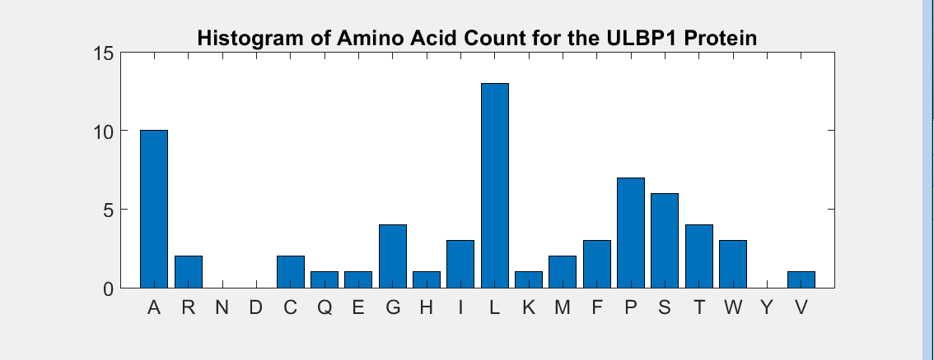

**Box:**

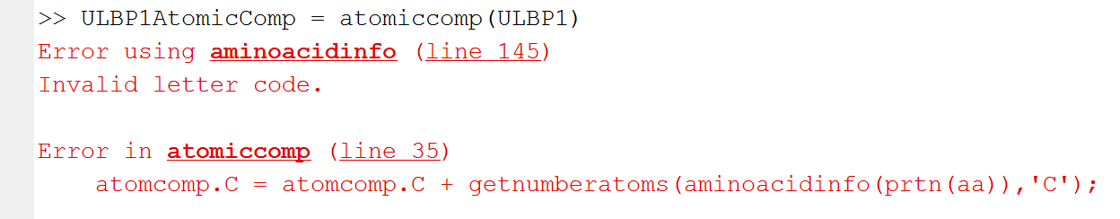

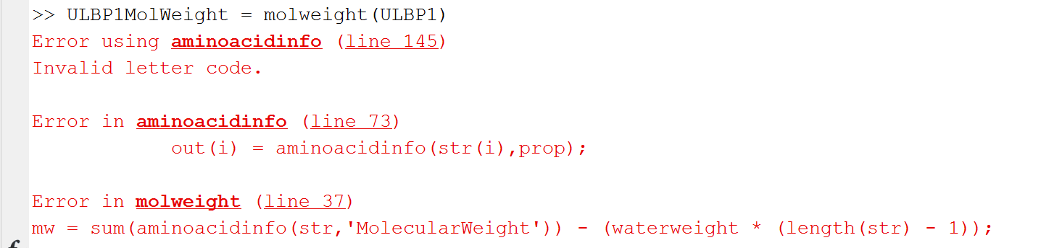

**Box:**

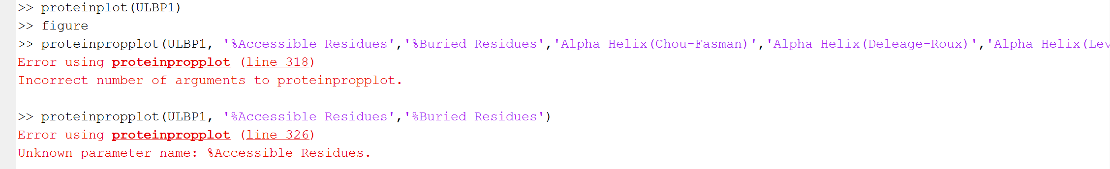



**Protein Plots (There Are A Lot of Them):**

**%Accessible Residues**

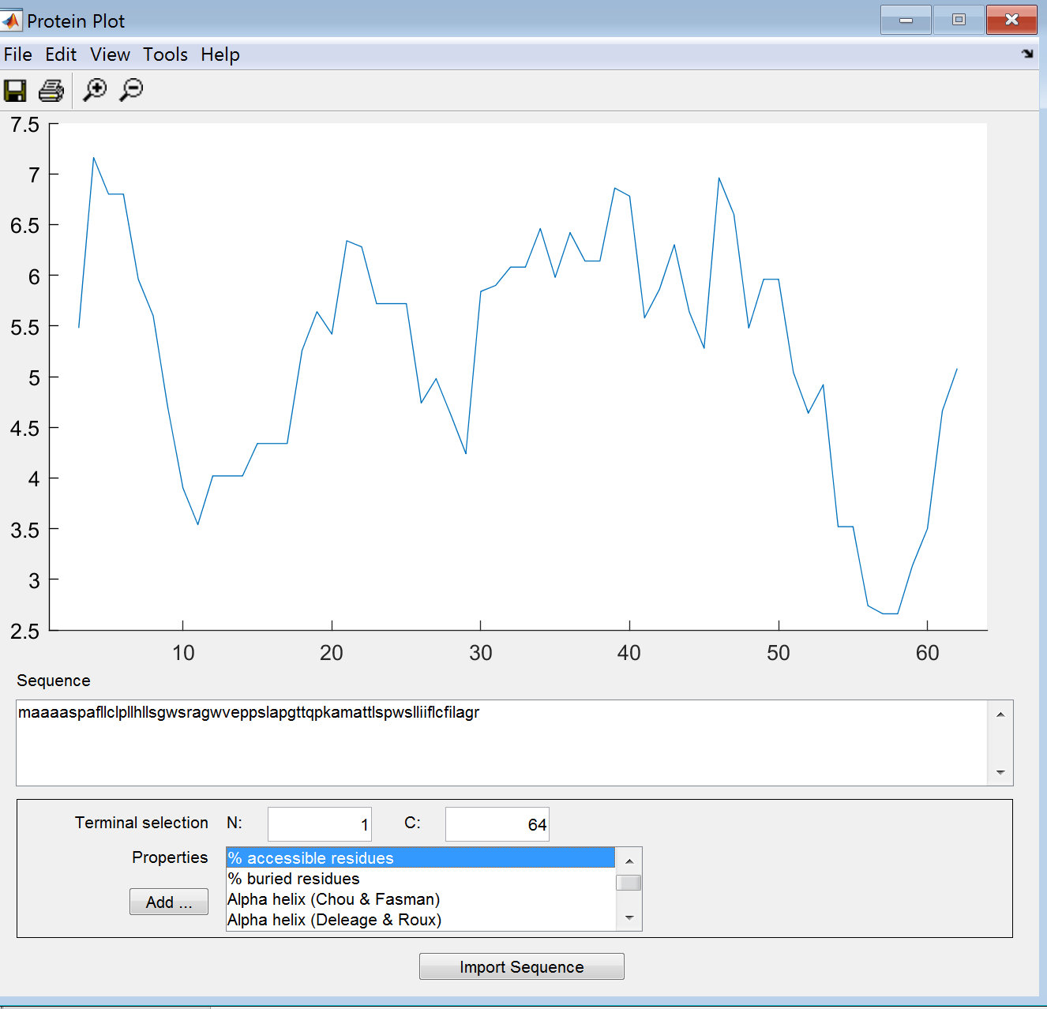

**%Buried Residues**

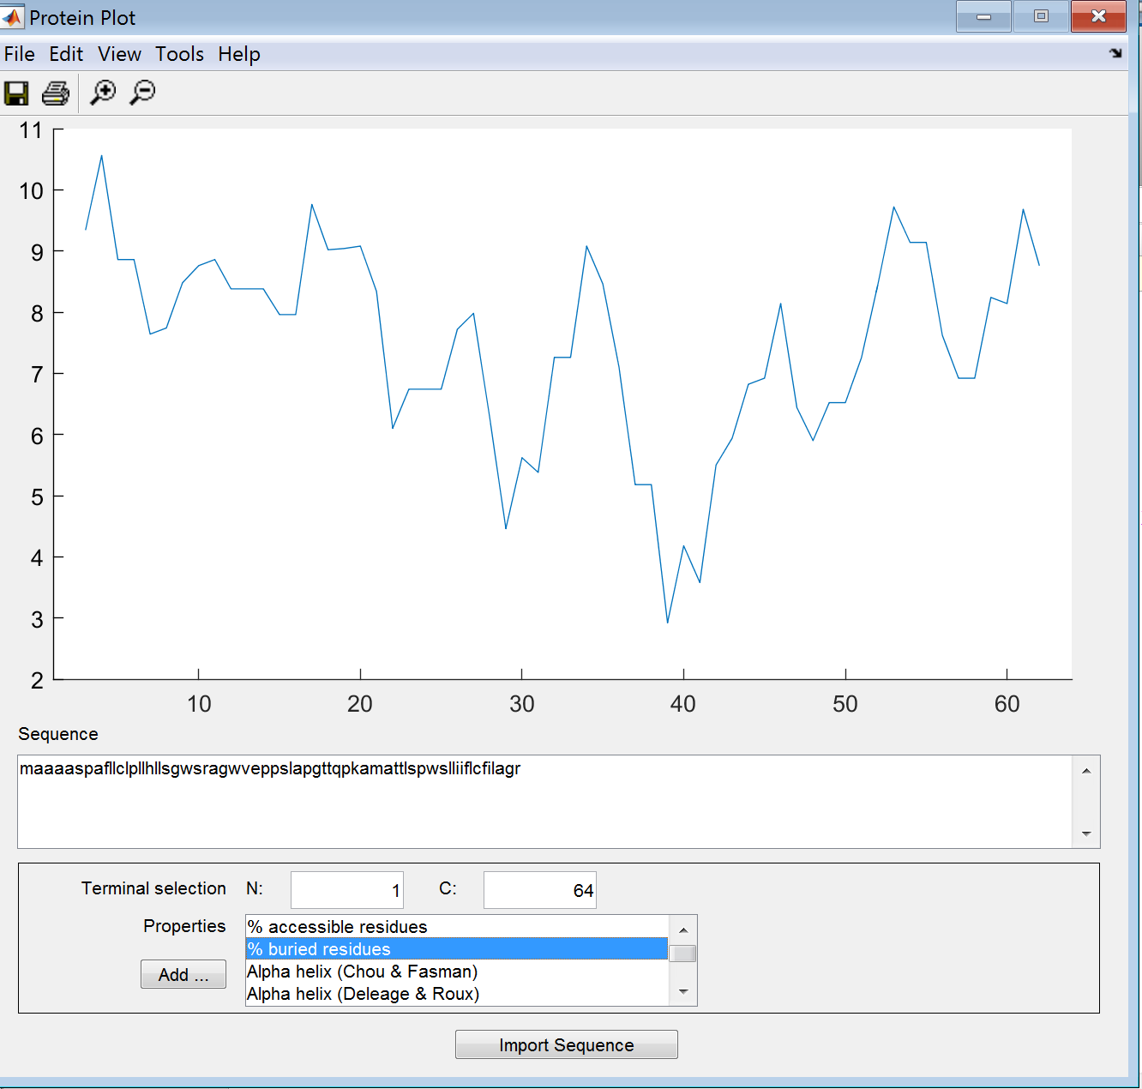

**Alpha Helix (Chou & Fasman)**

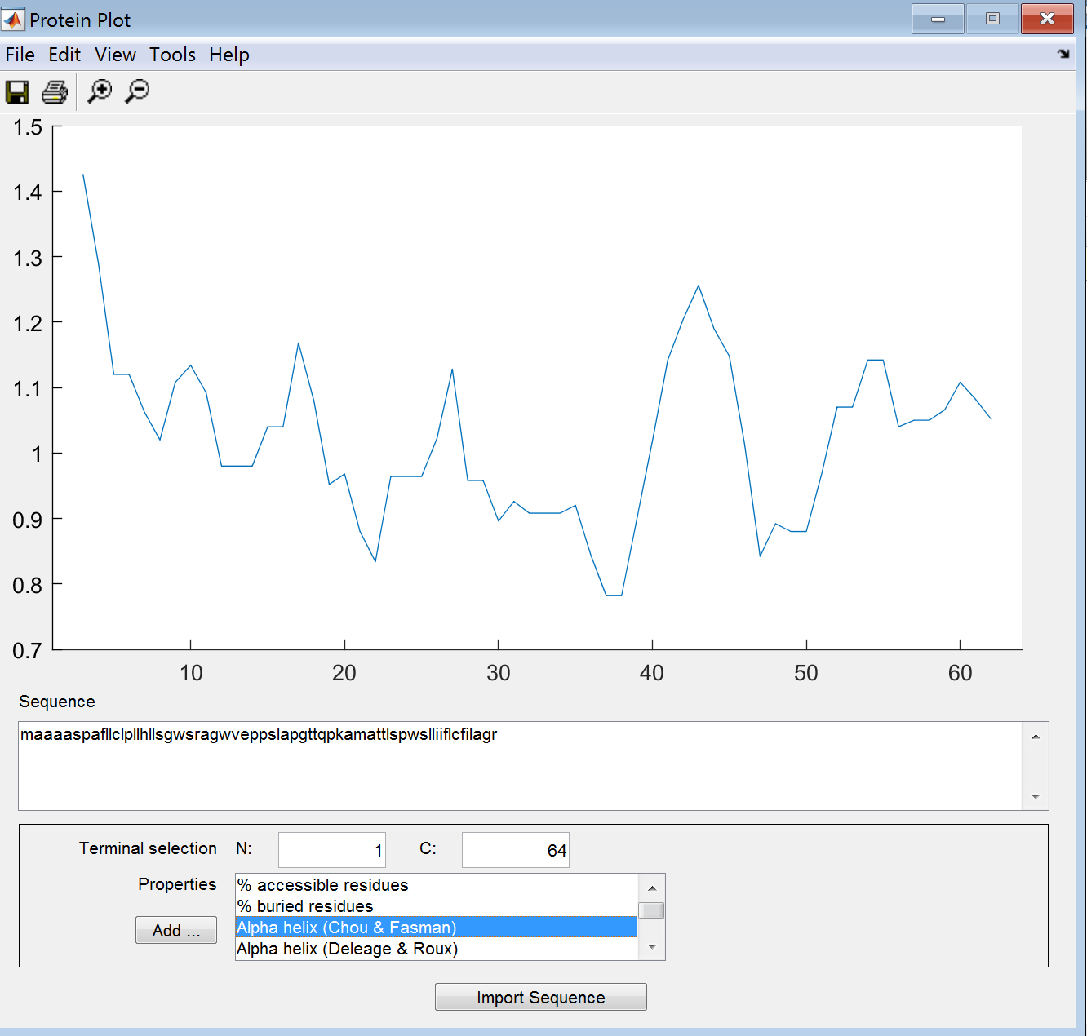

**Alpha Helix (Deleage-Roux)**

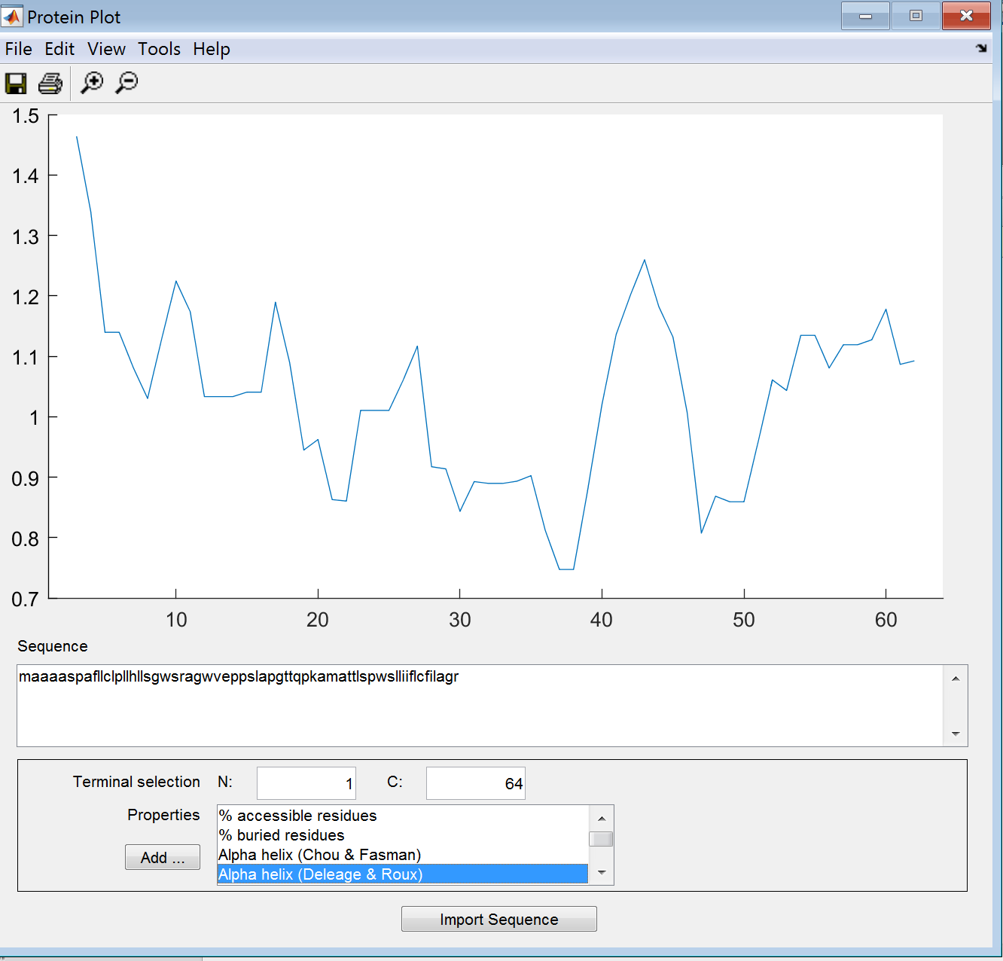

**Alpha Helix (LeVitt)**

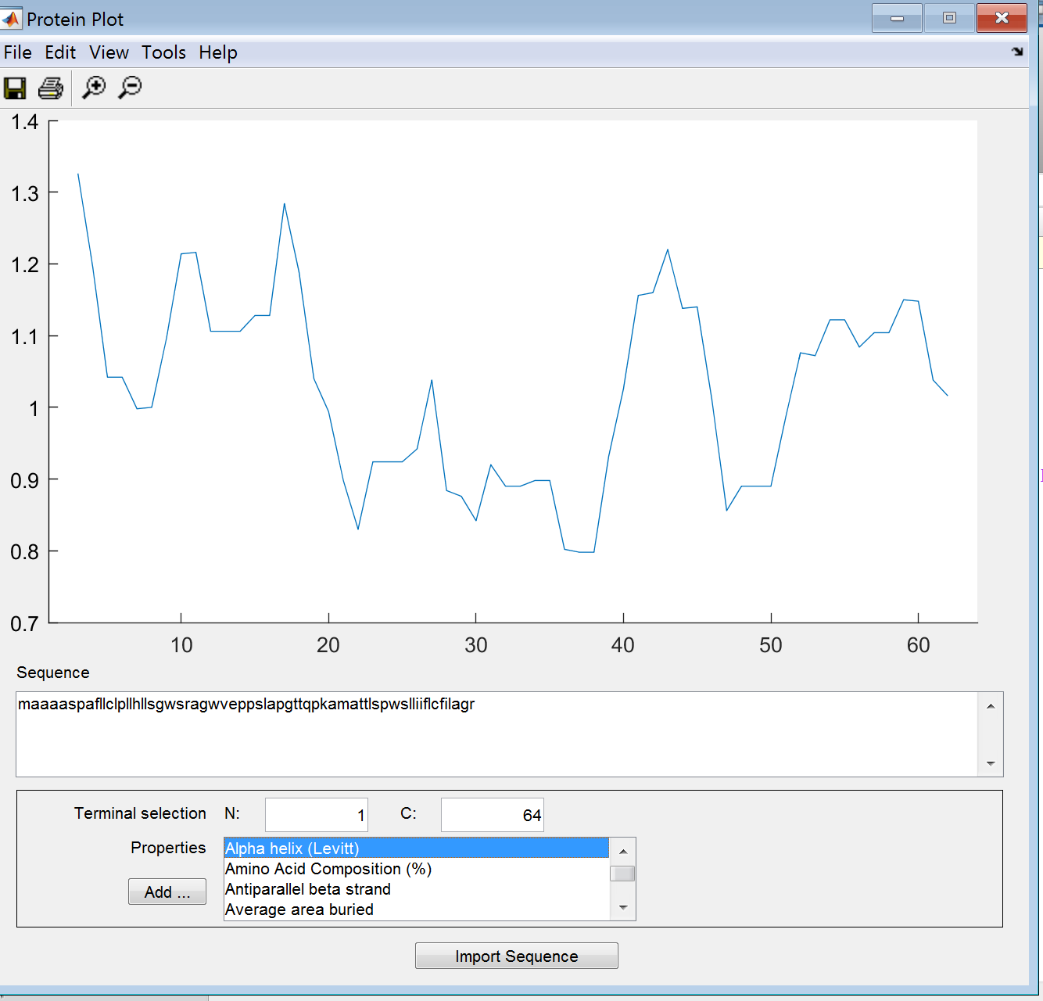

**Amino Acid Composition (%)**

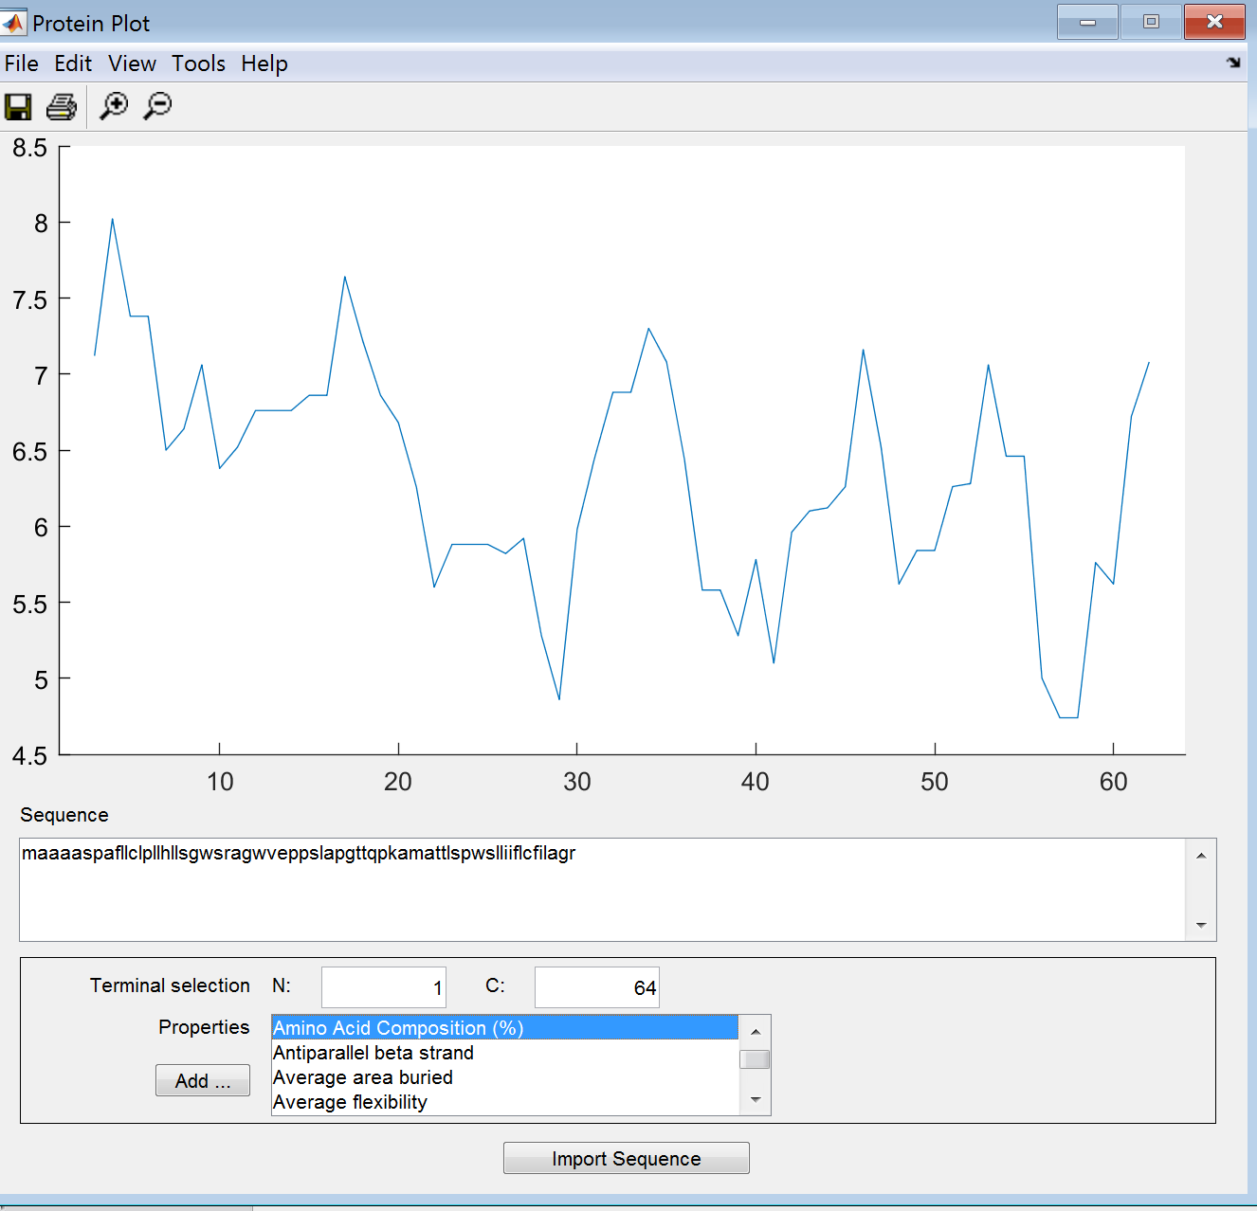

**Antiparallel Beta Strand**

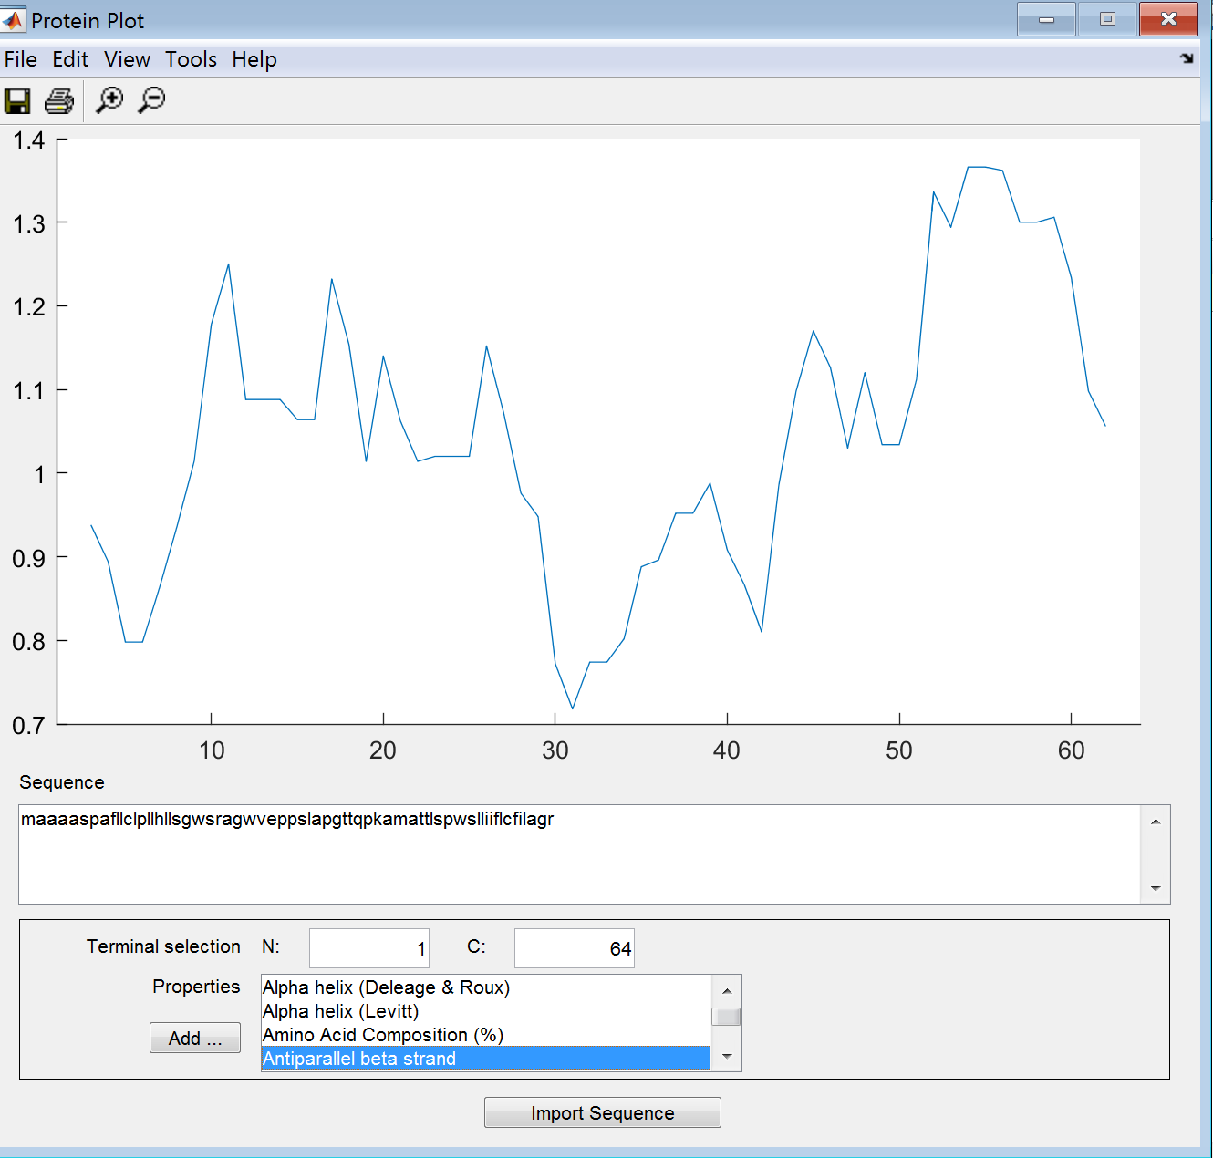

**Average Area Buried**

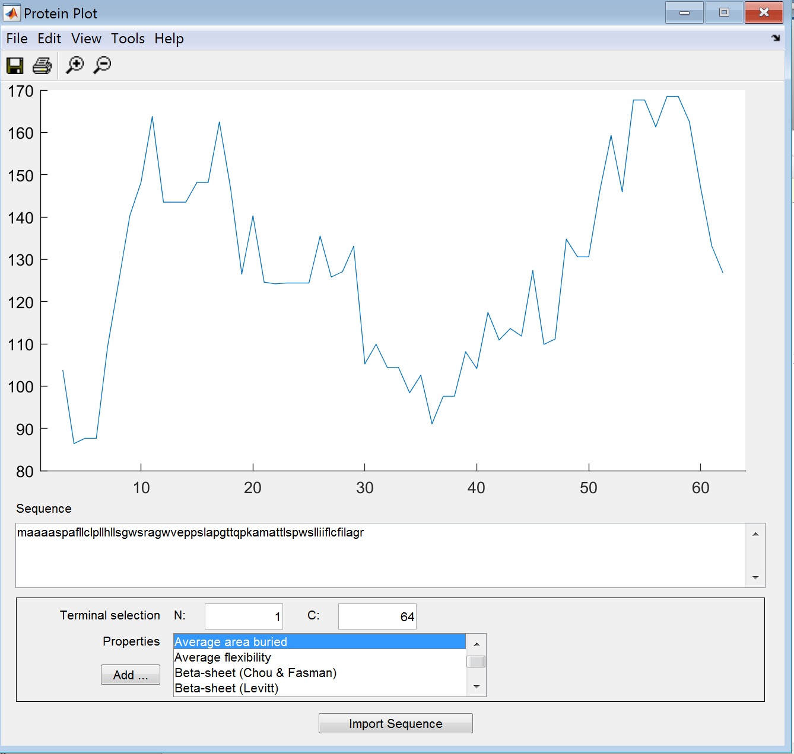

**Average Flexibility**

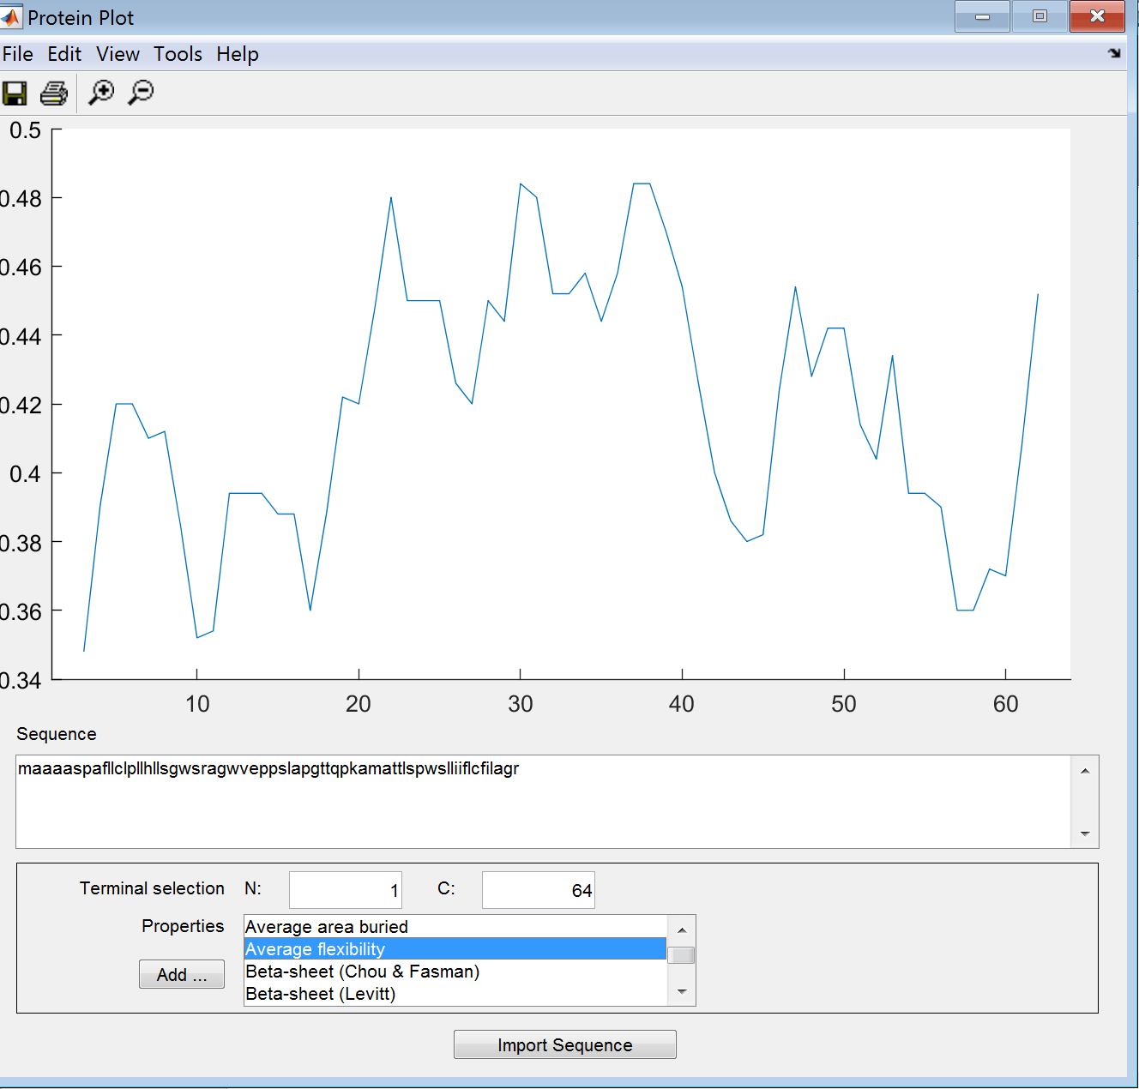

**Beta Sheet (Chou-Fasman)**

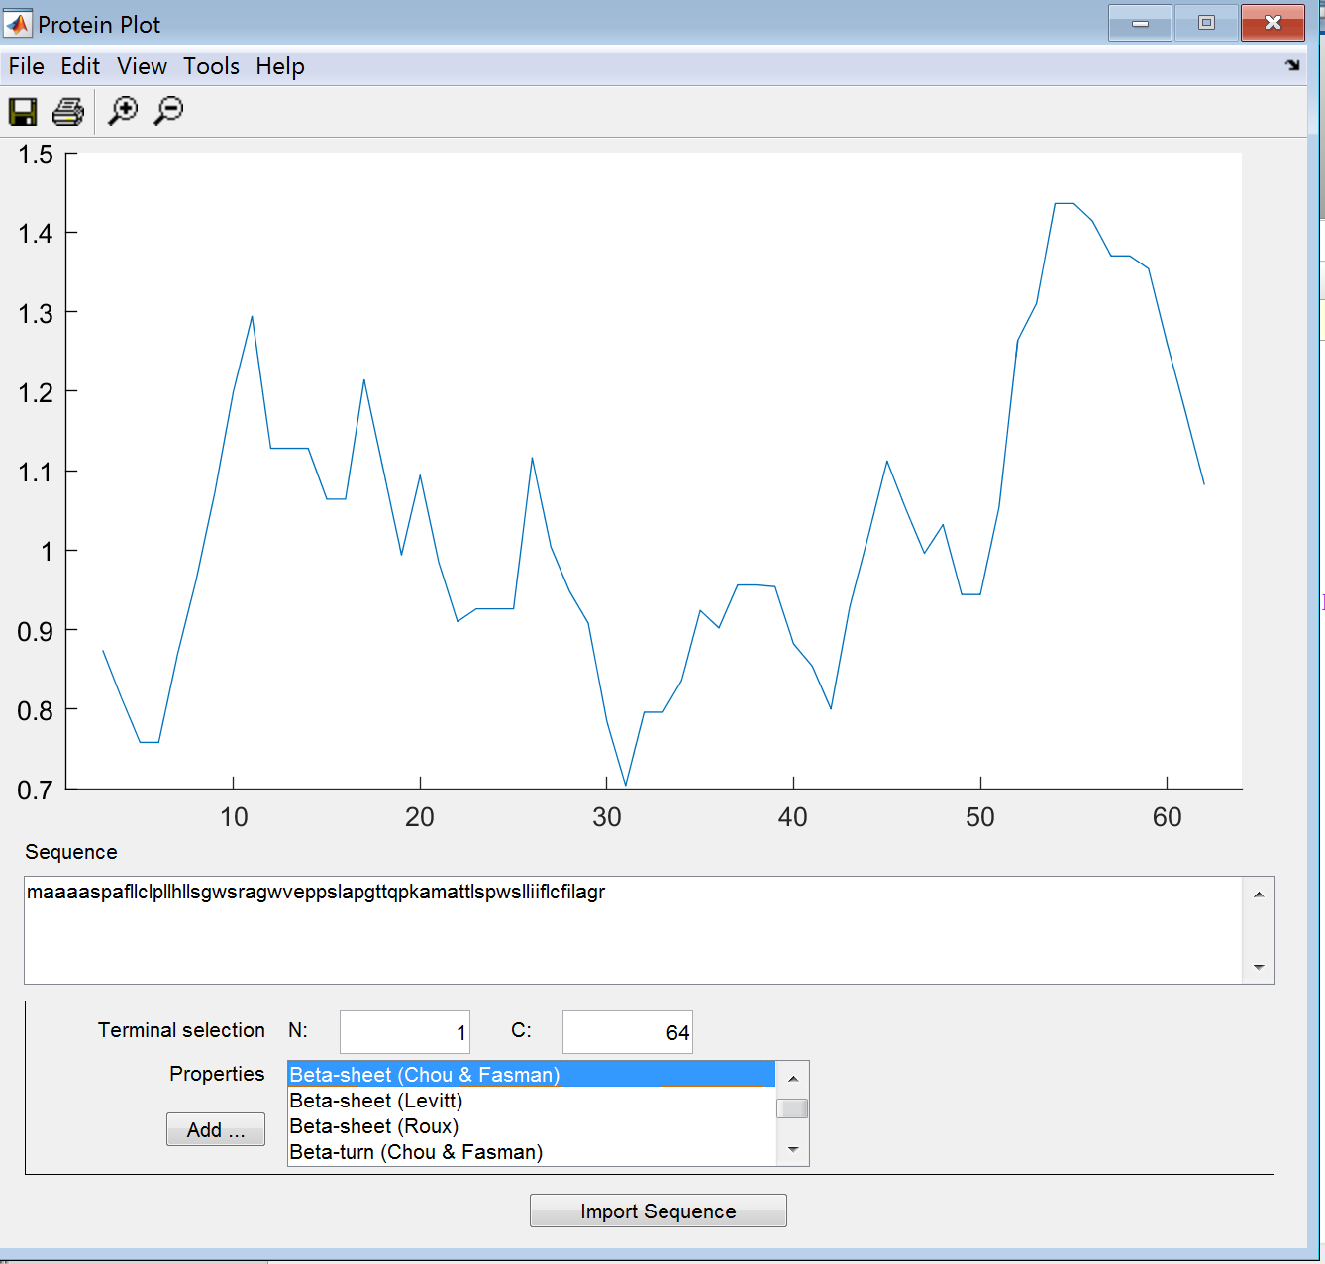

**Beta Sheet (LeVitt)**

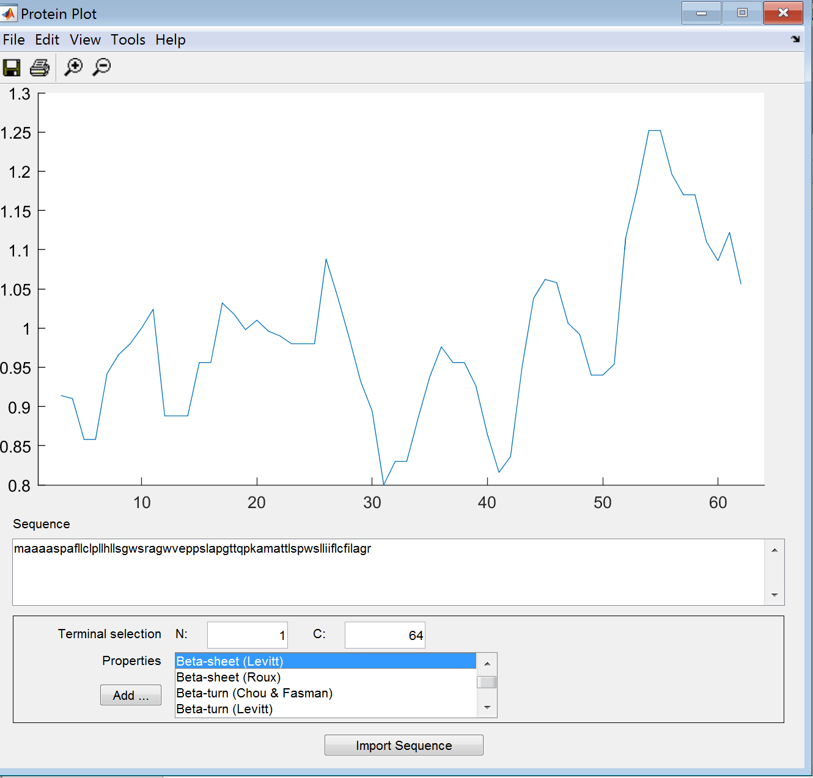

**Beta Sheet (Roux)**

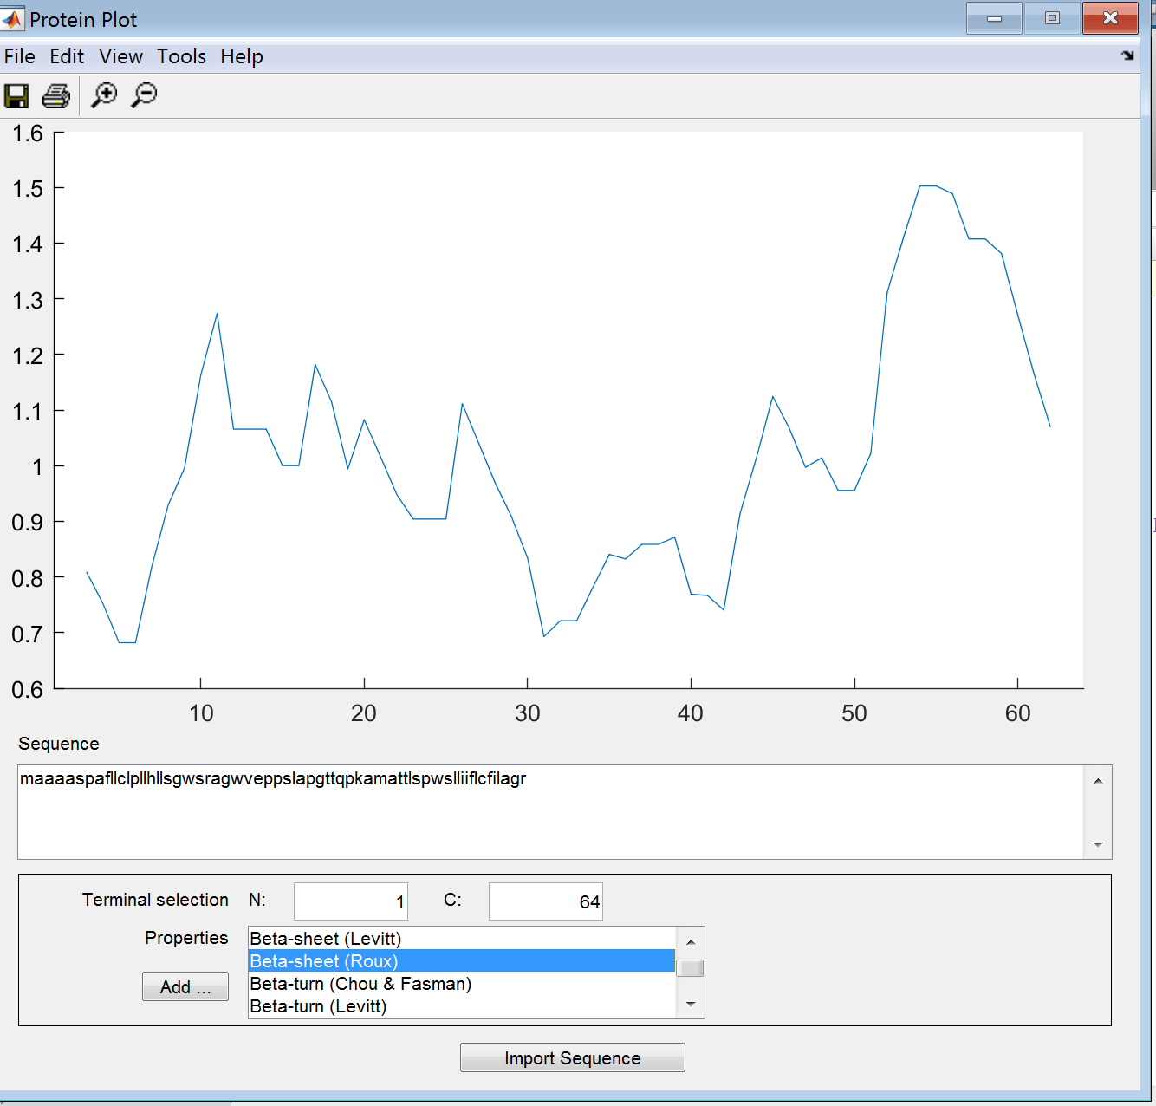

**Beta Turn (Chou-Fasman)**

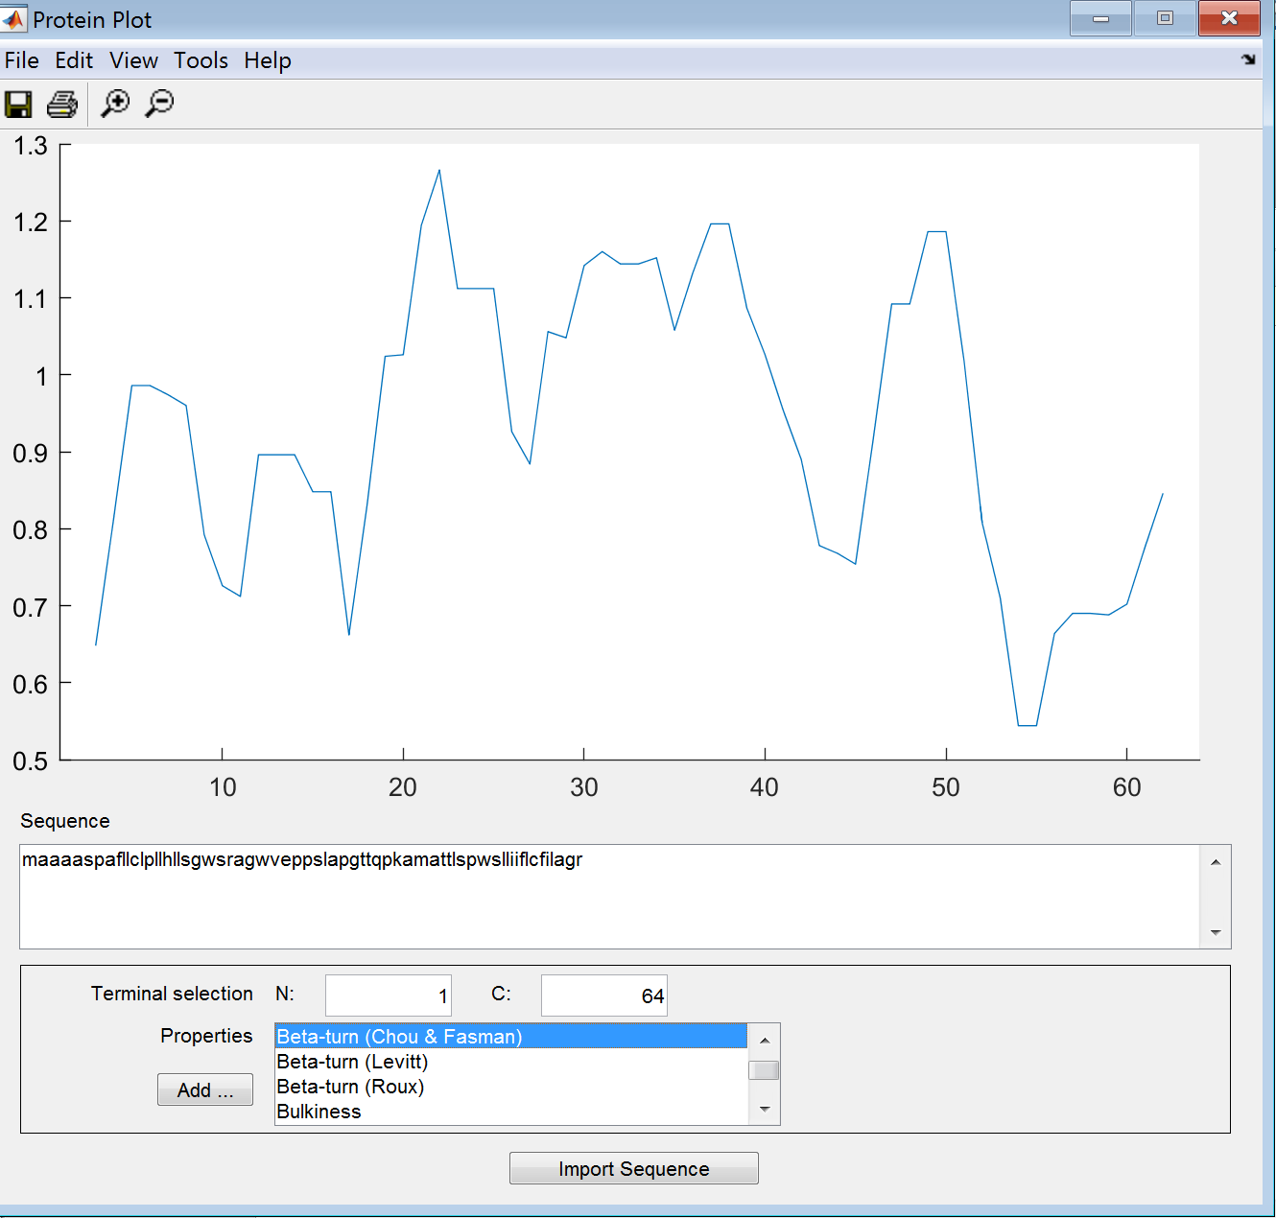

**Beta Turn (LeVitt)**

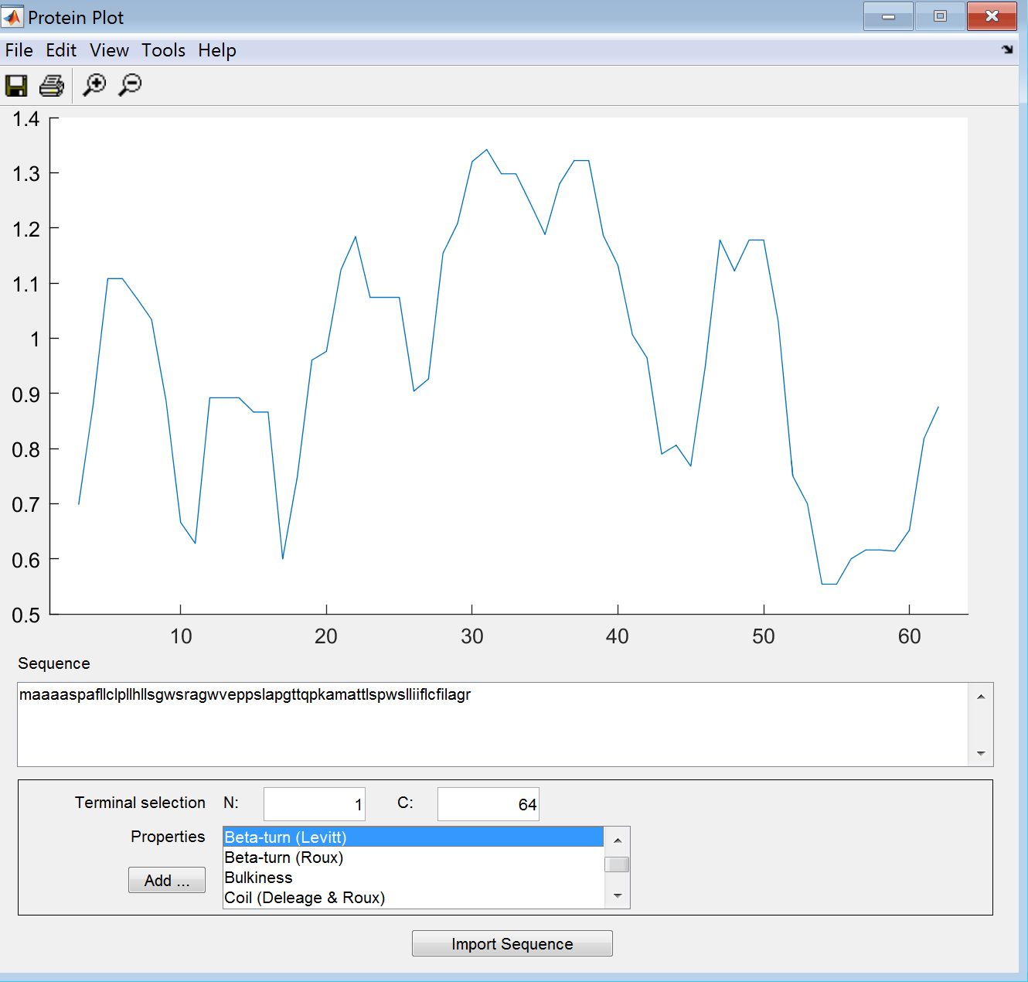

**Beta Turn (Roux)**

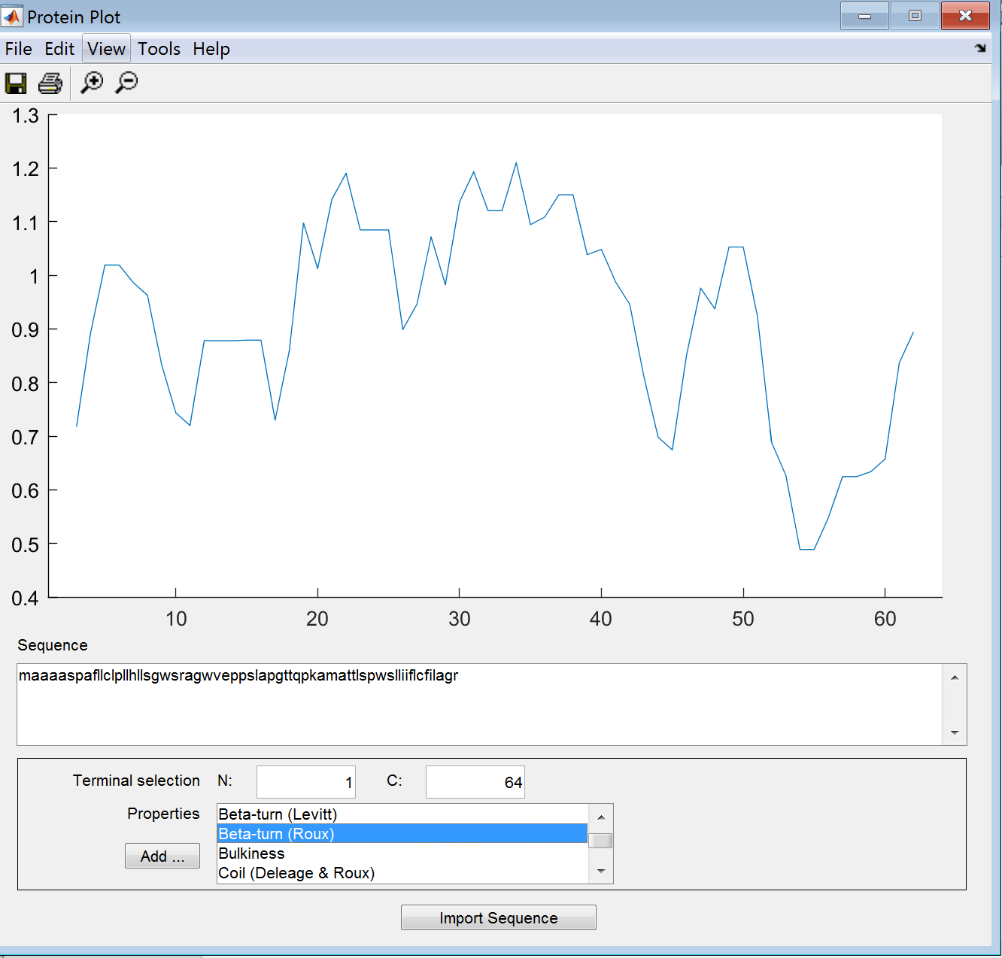

**Bulkiness**

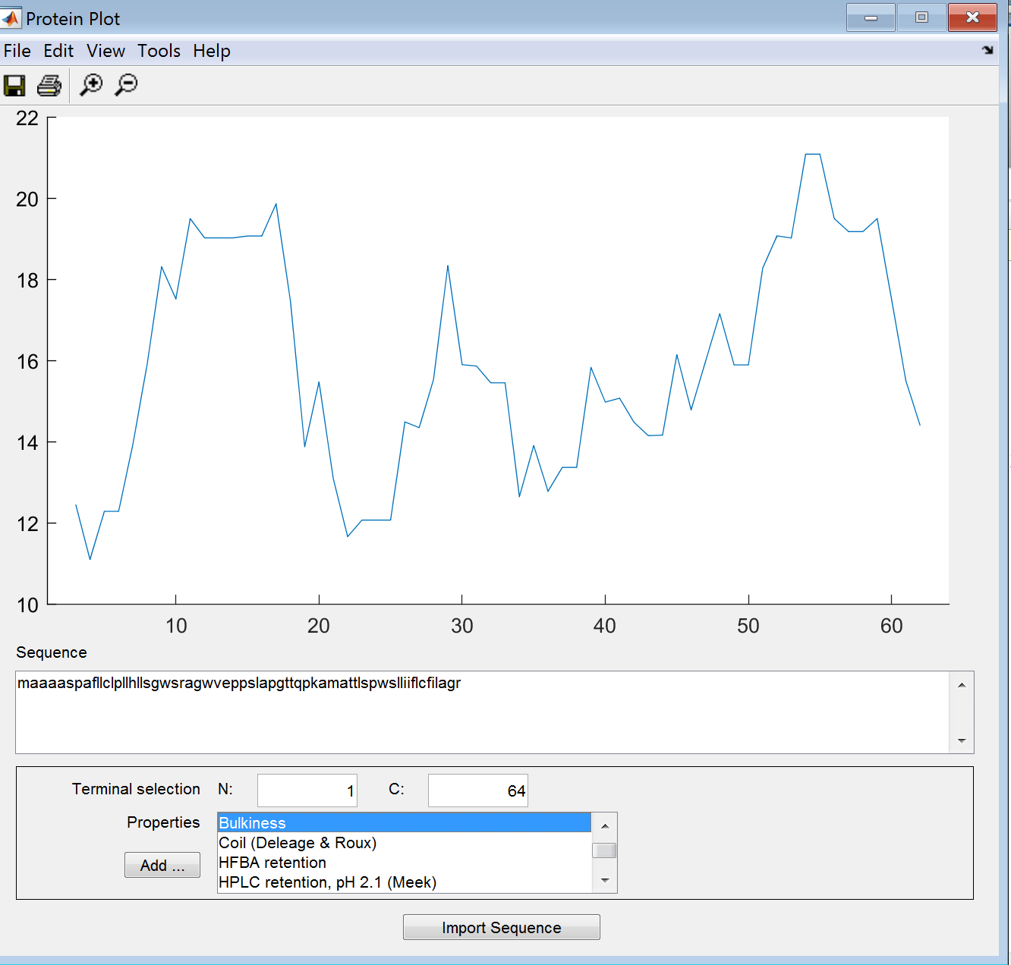

**Coil (Deleage-Roux)**

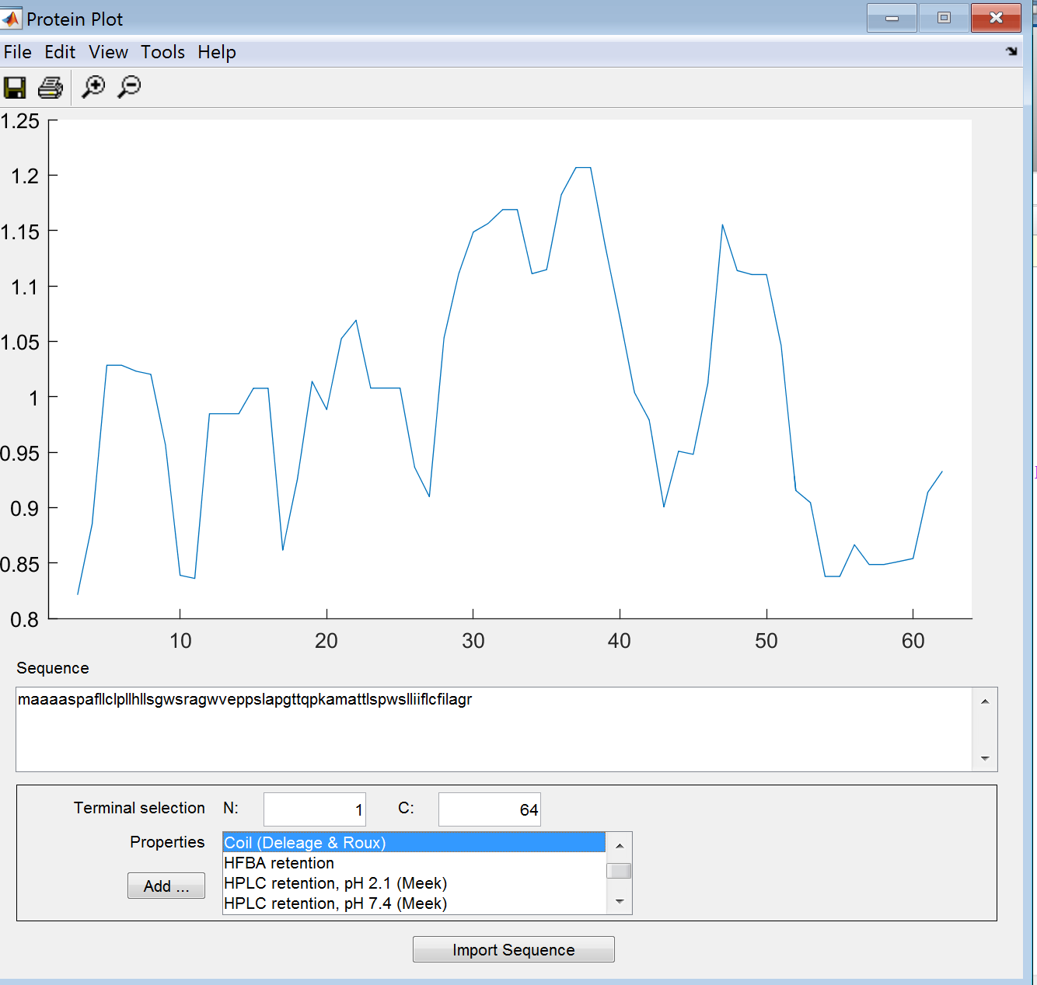

**HFBA Retention**

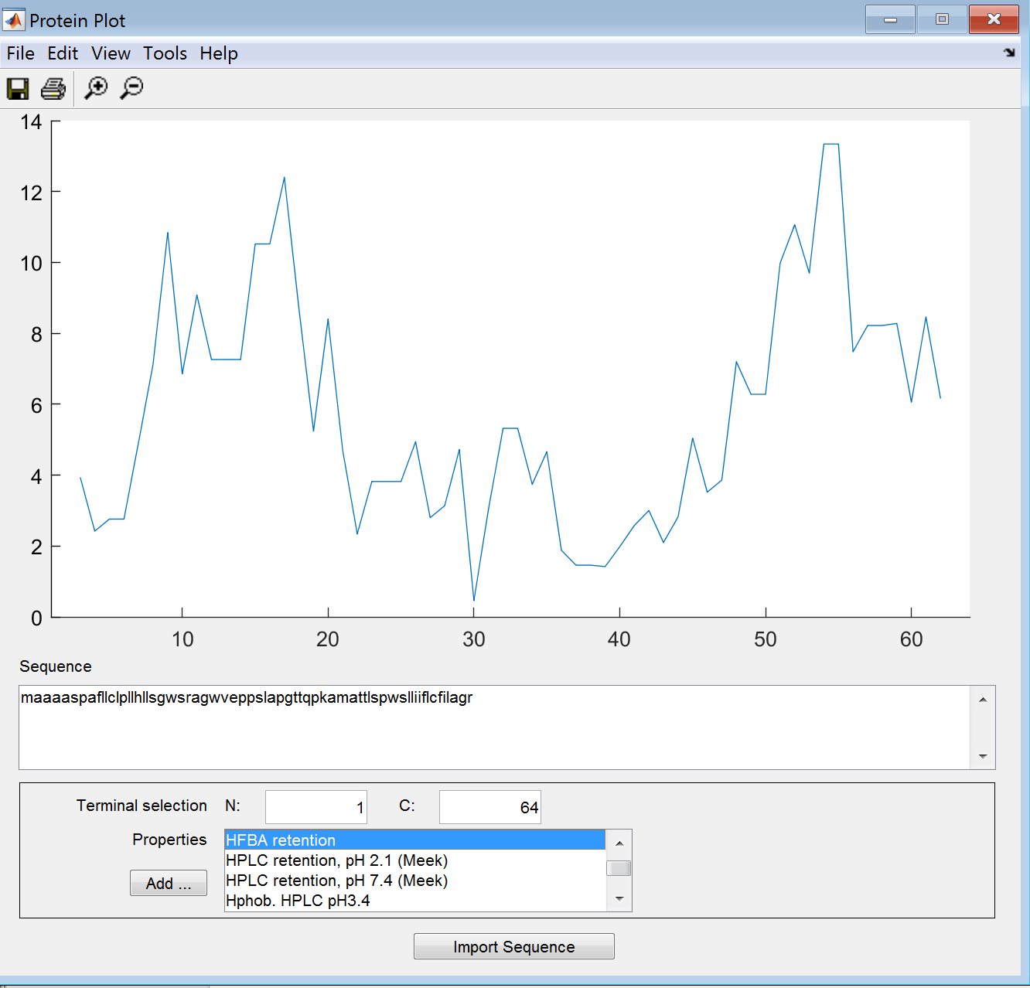

**HPLC Retention, pH 2.1 (Meek)**

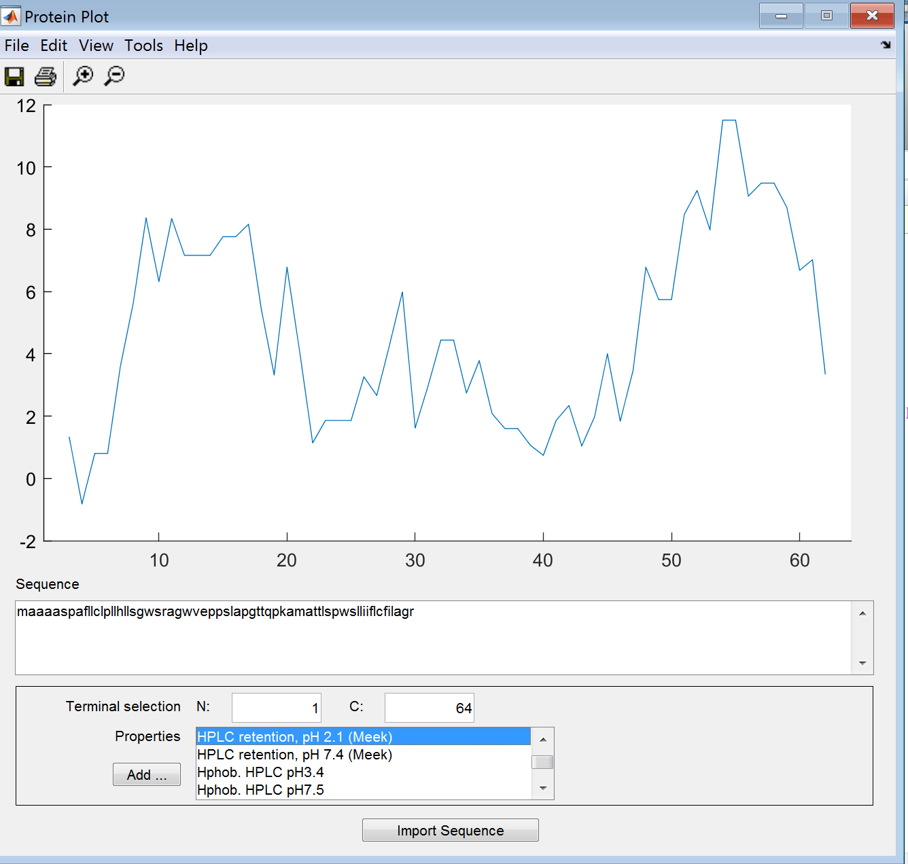

**HPLC Retention pH 7.4 (Meek)**

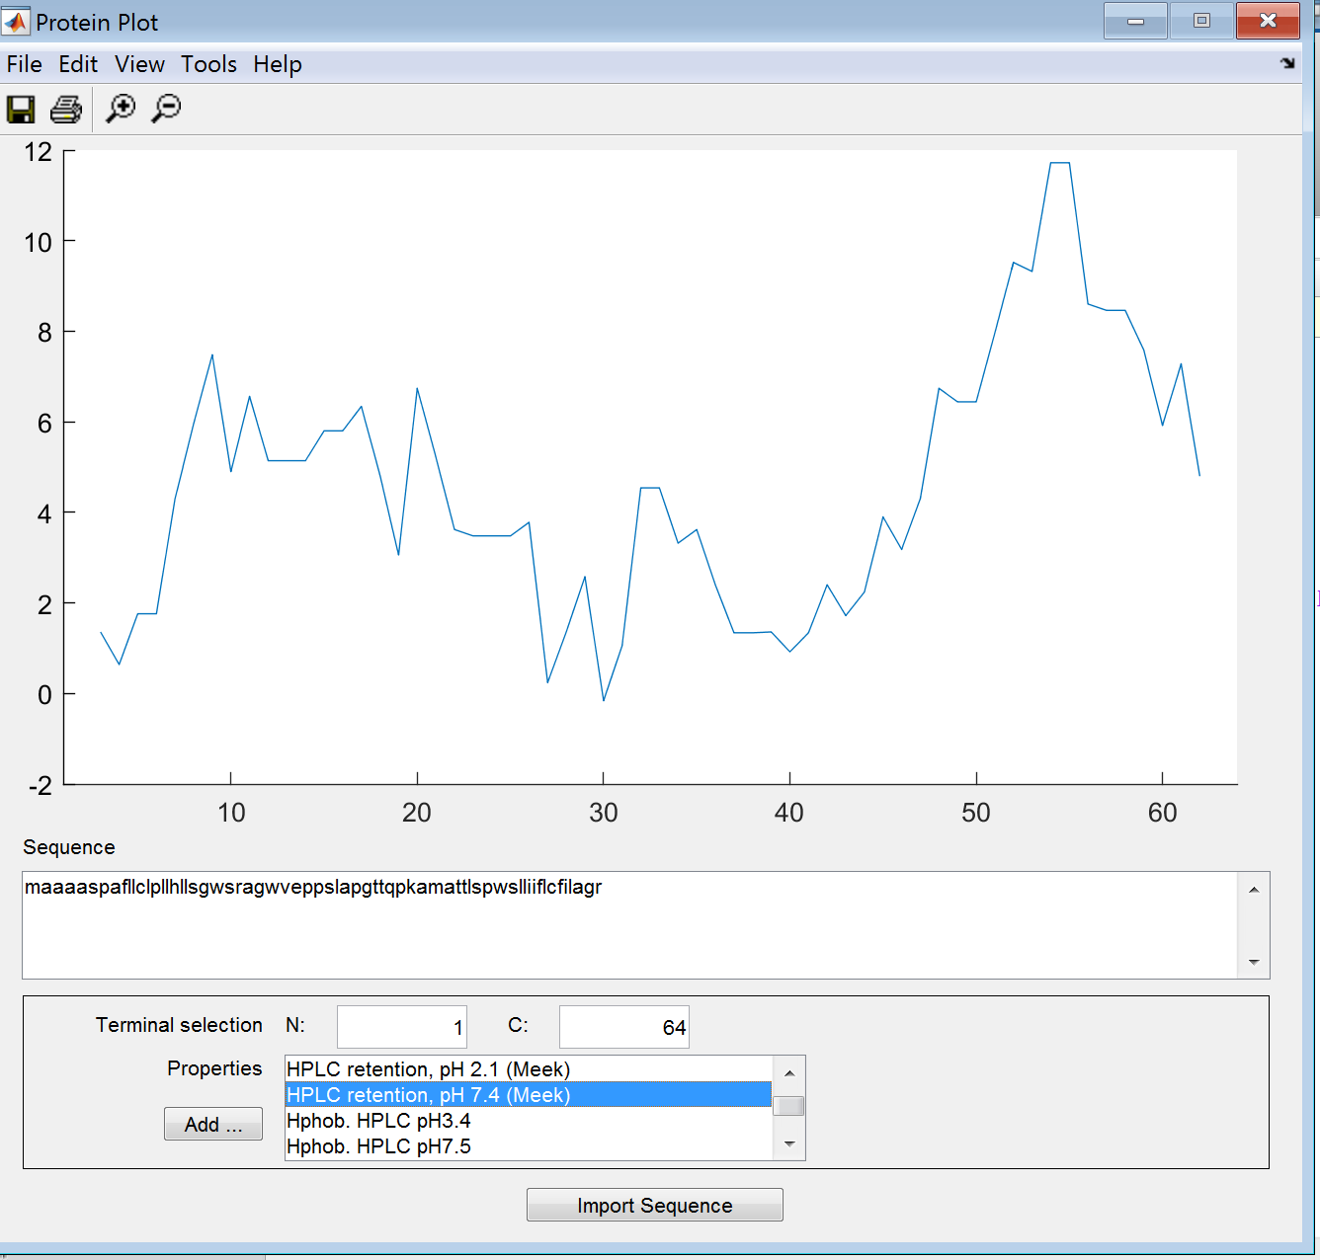

**Hphob, HPLC pH 3.4**

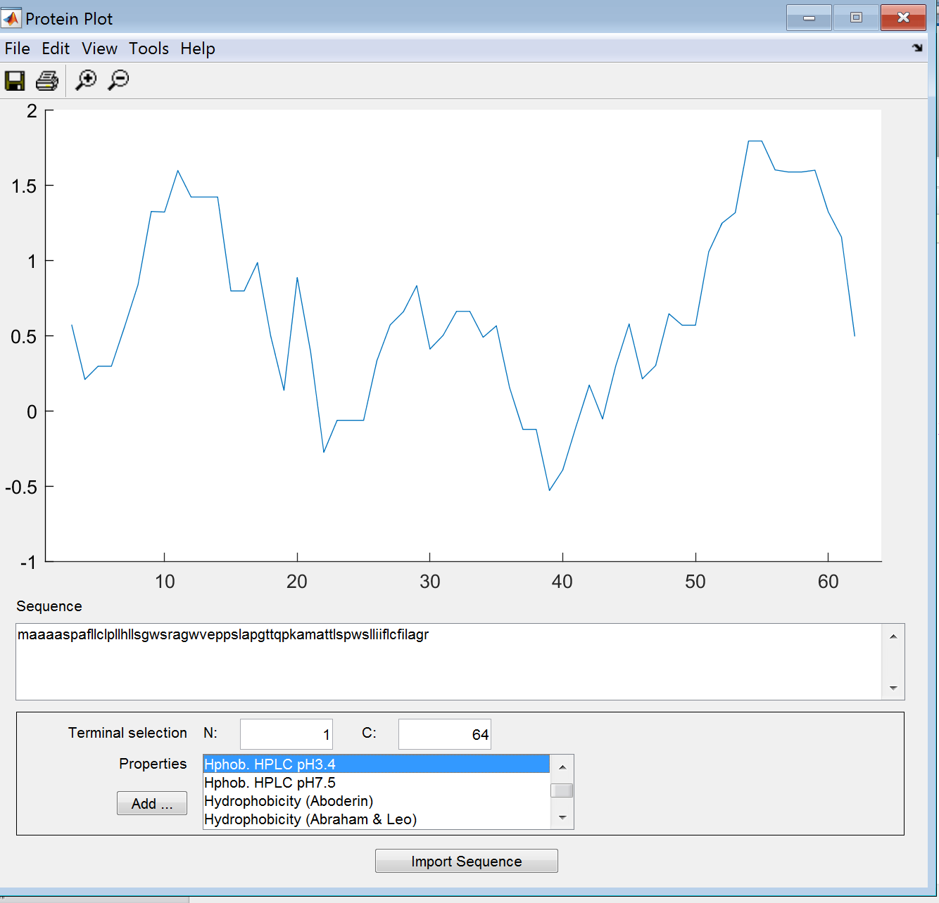

**Hphob HPLC pH 7.5**

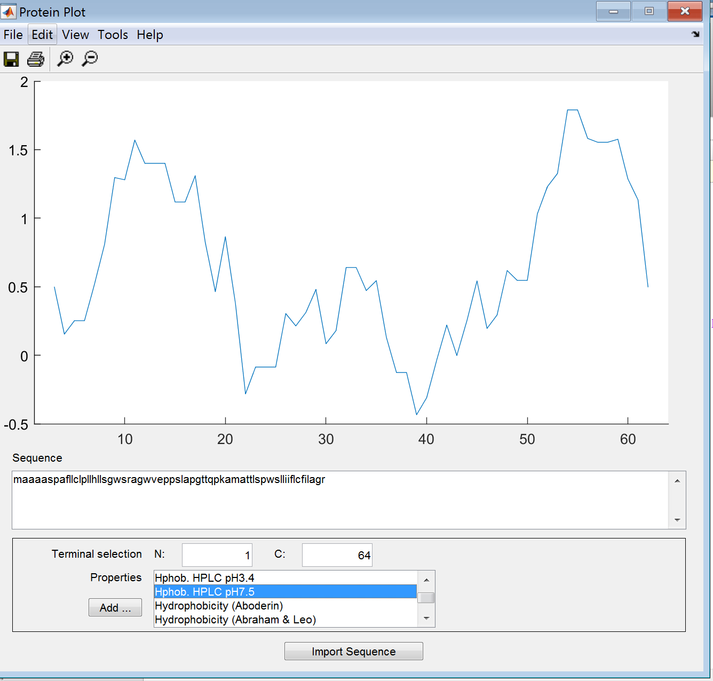

**Hydrophobicity (Aboderin)**

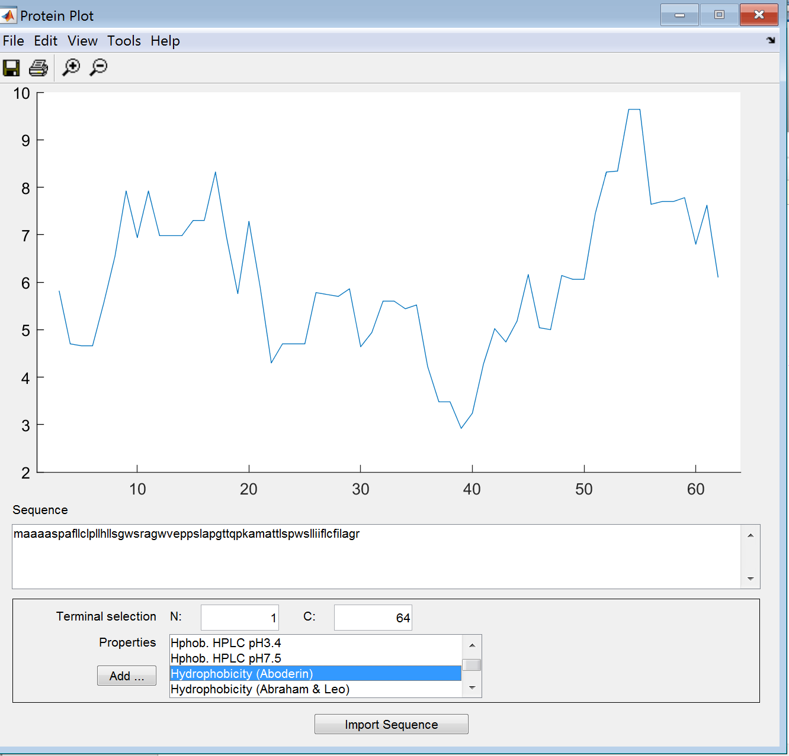

**Hydrophobicity (Abraham & Leo)**

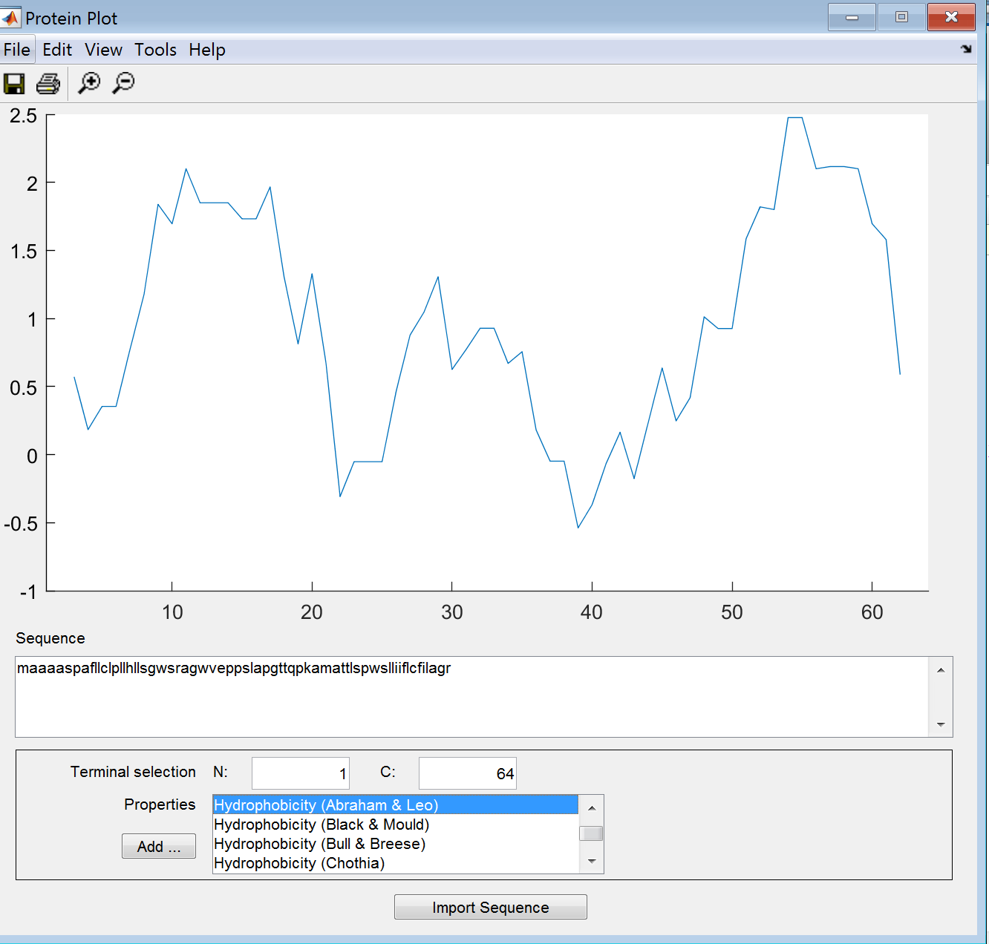

**Hydrophobicity (Black & Mould)**

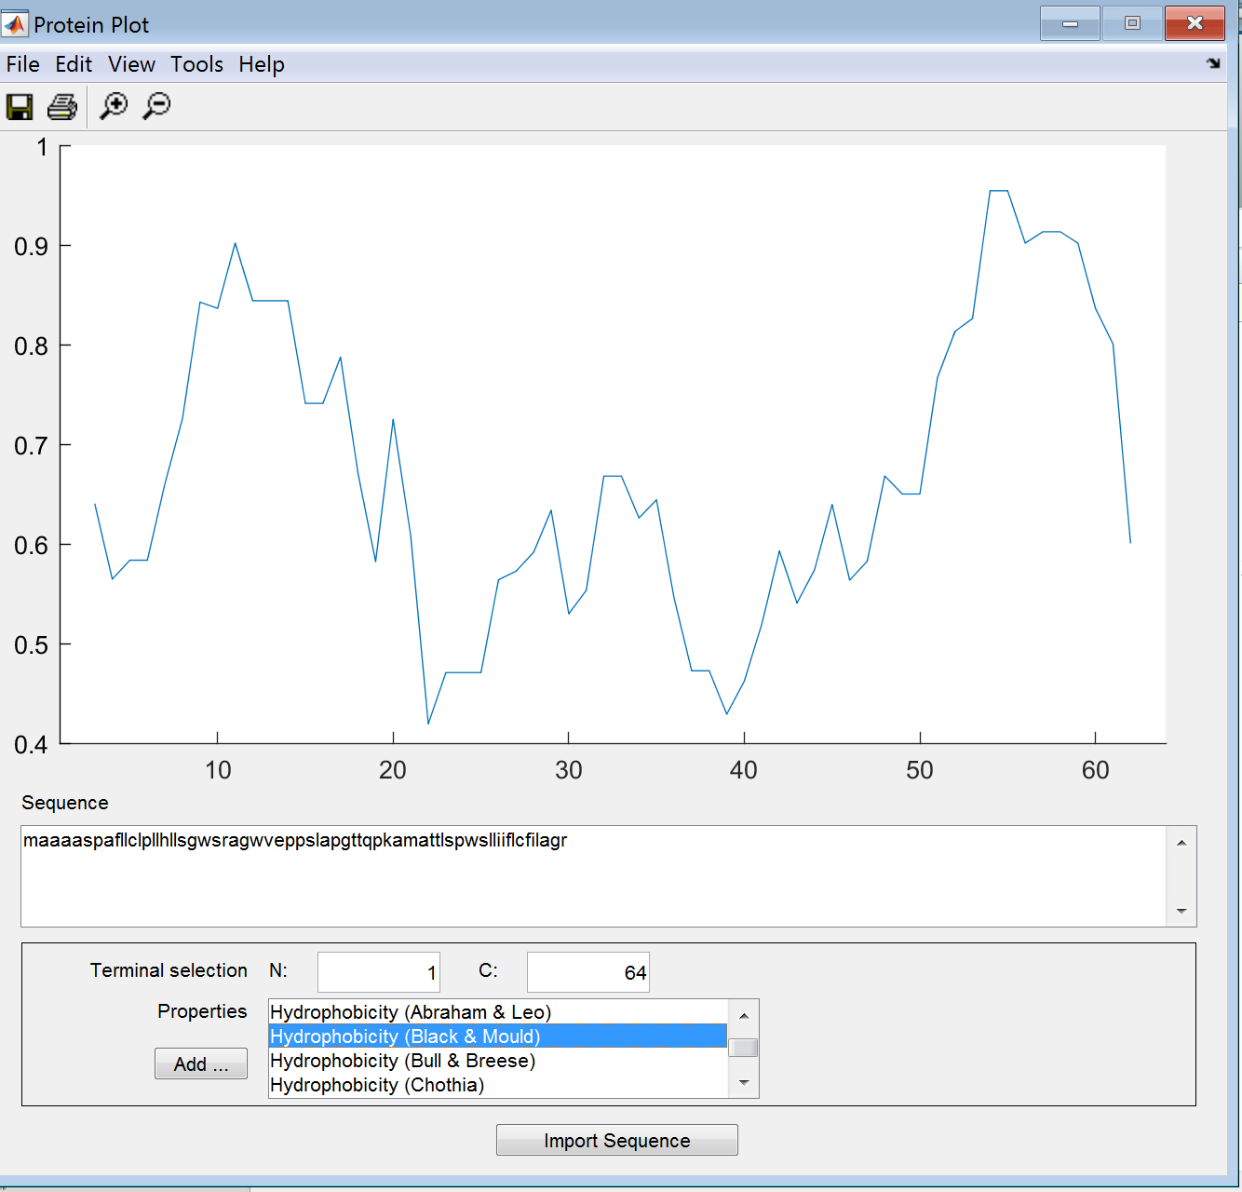

**Hydrophobicity (Bull & Breese)**

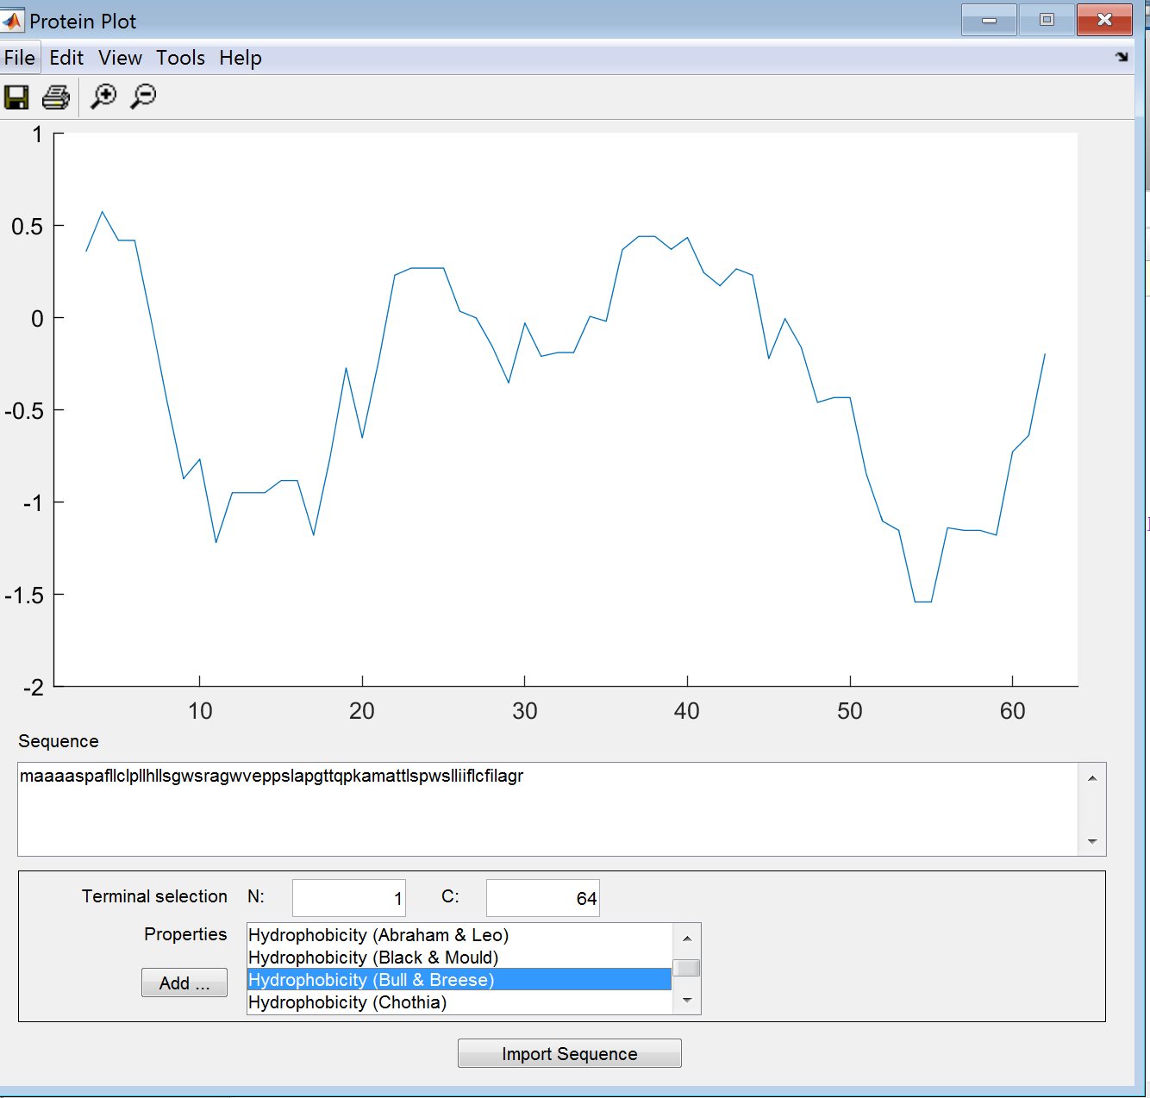

**Hydrophobicity (Chothia)**

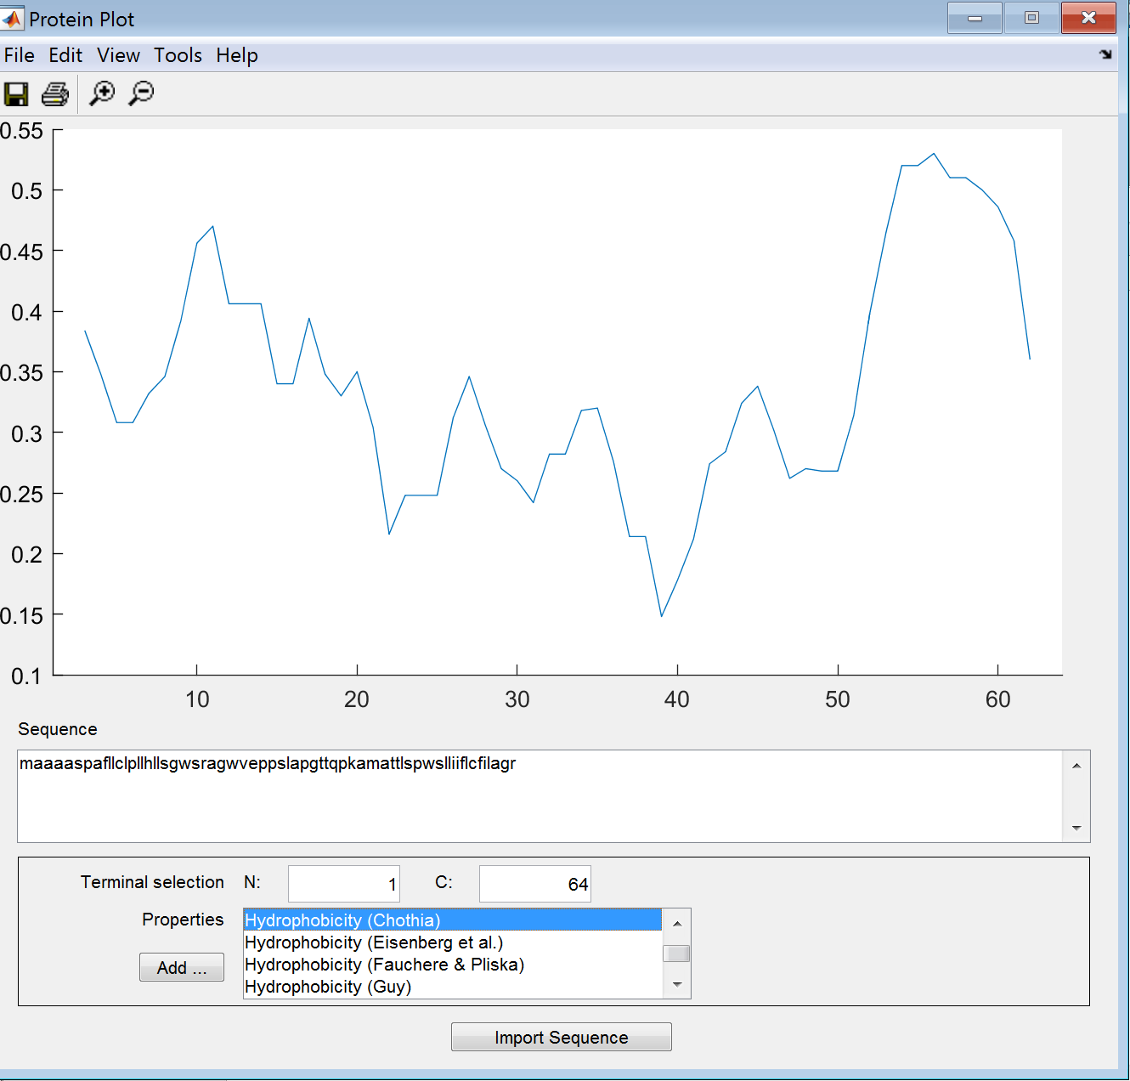

**Hydrophobicity (Eisenberg et. Al)**

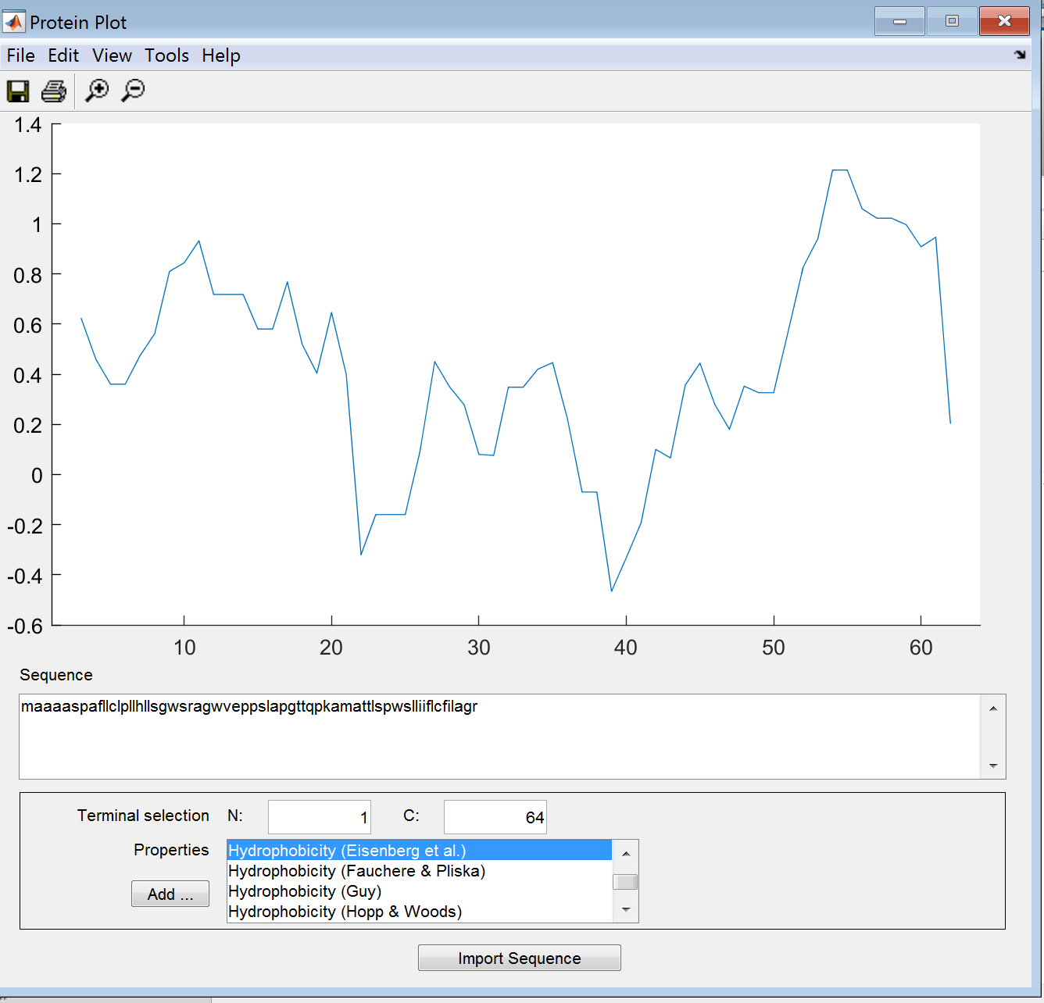

**Hydrophobicity (Fauchere & Pliska)**

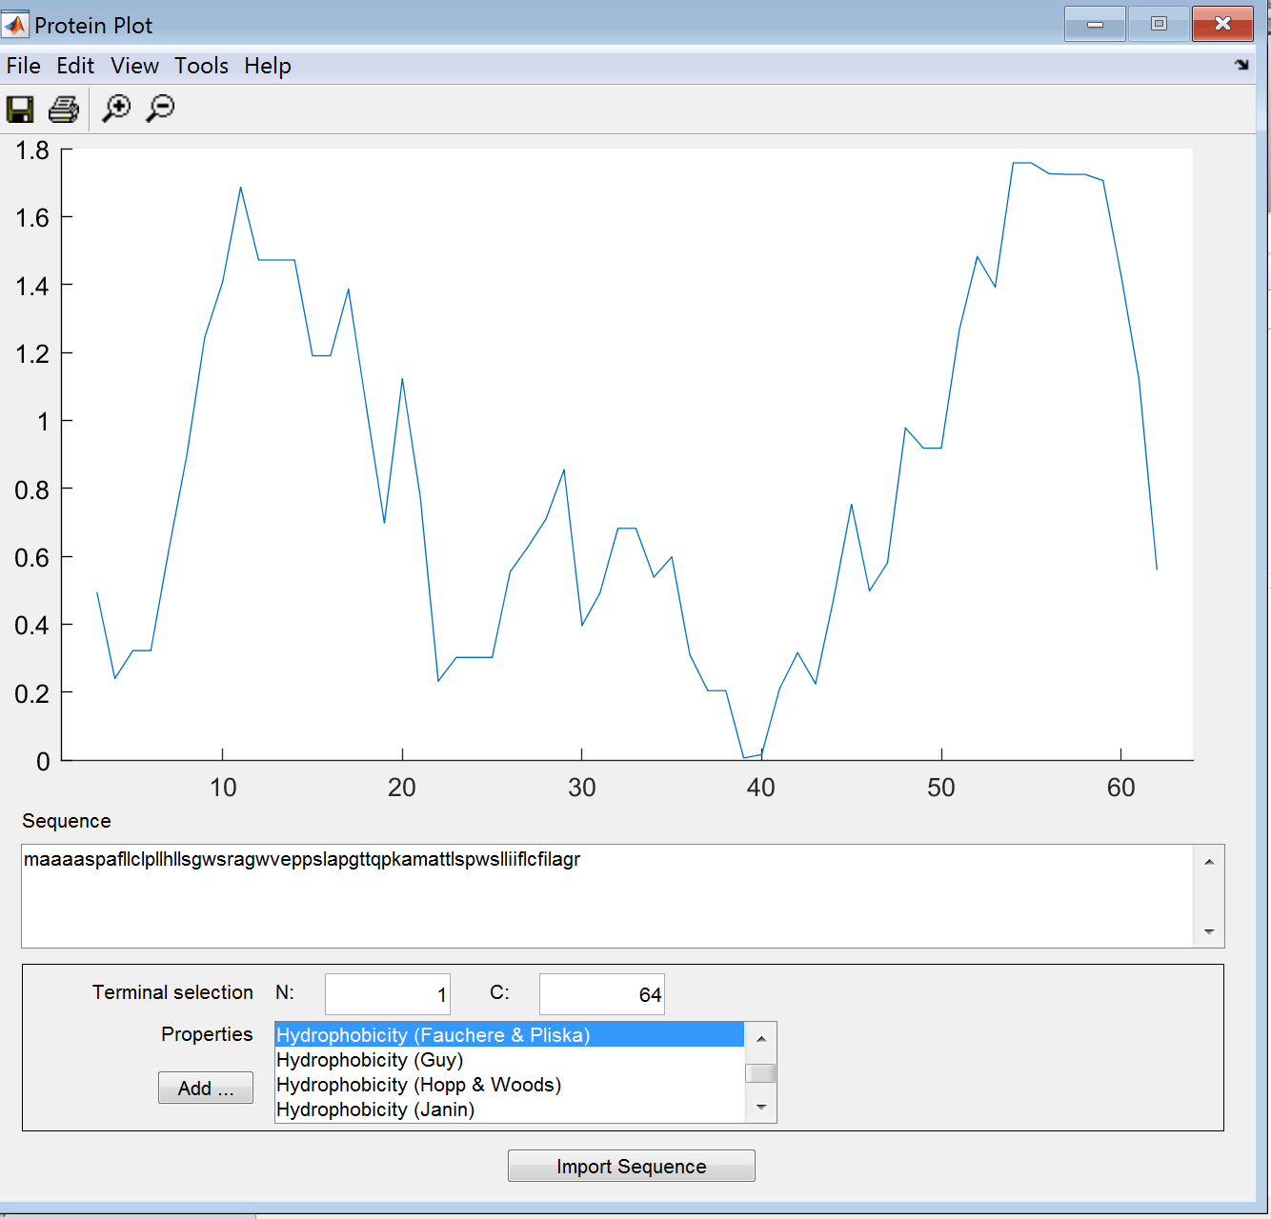

**Hydrophobicity (Guy)**

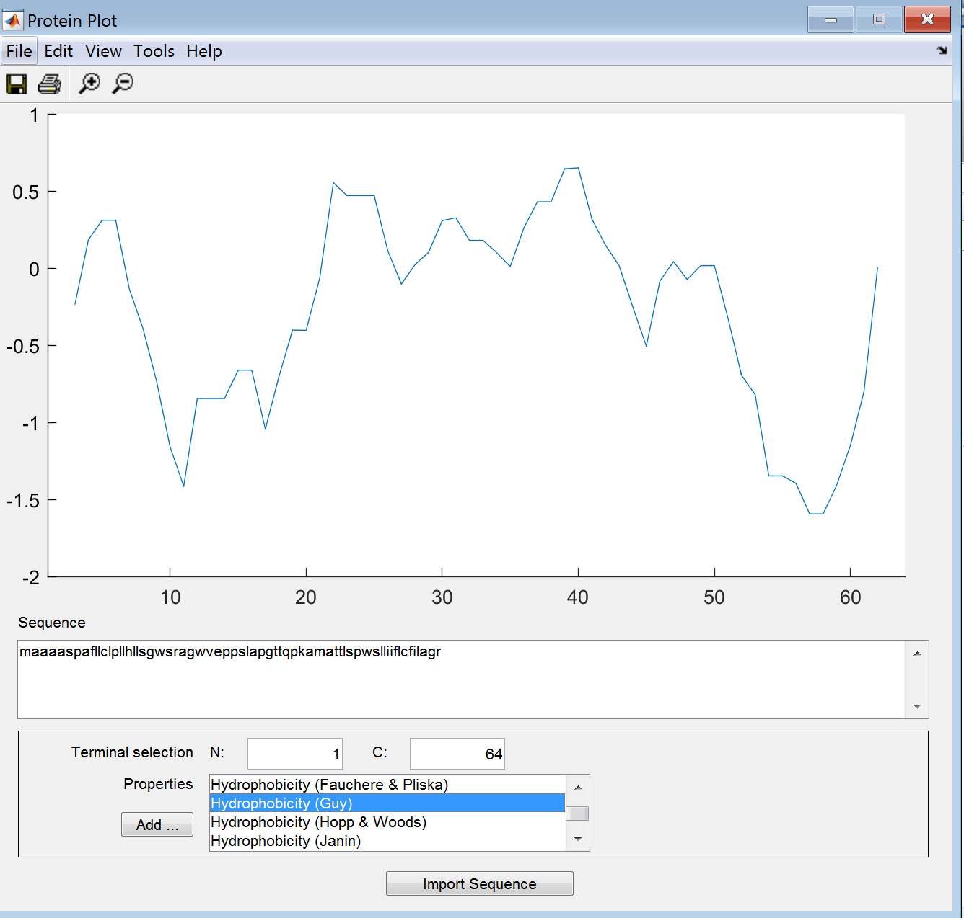

**Hydrophobicity (Hopp & Woods)**

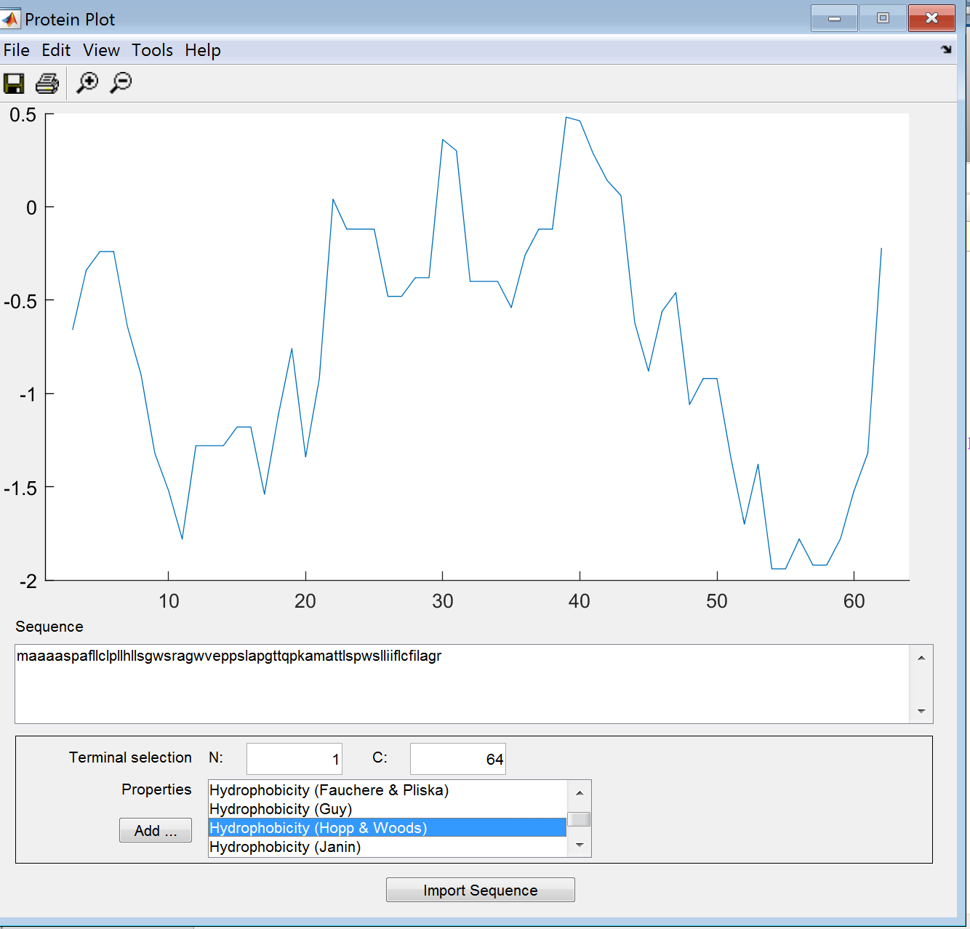

**Hydrophobicity (Kyle & Doolittle)**

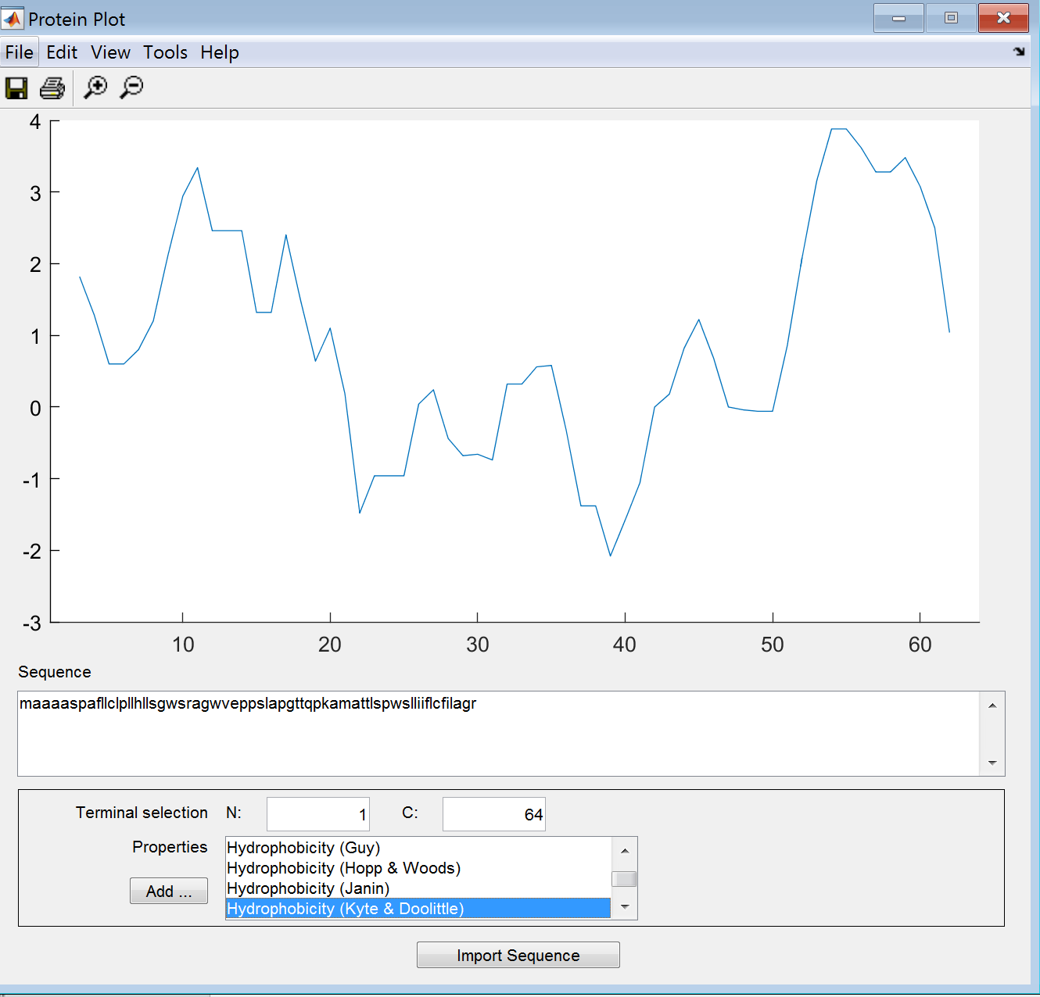

**Hydrophobicity (Janin)**

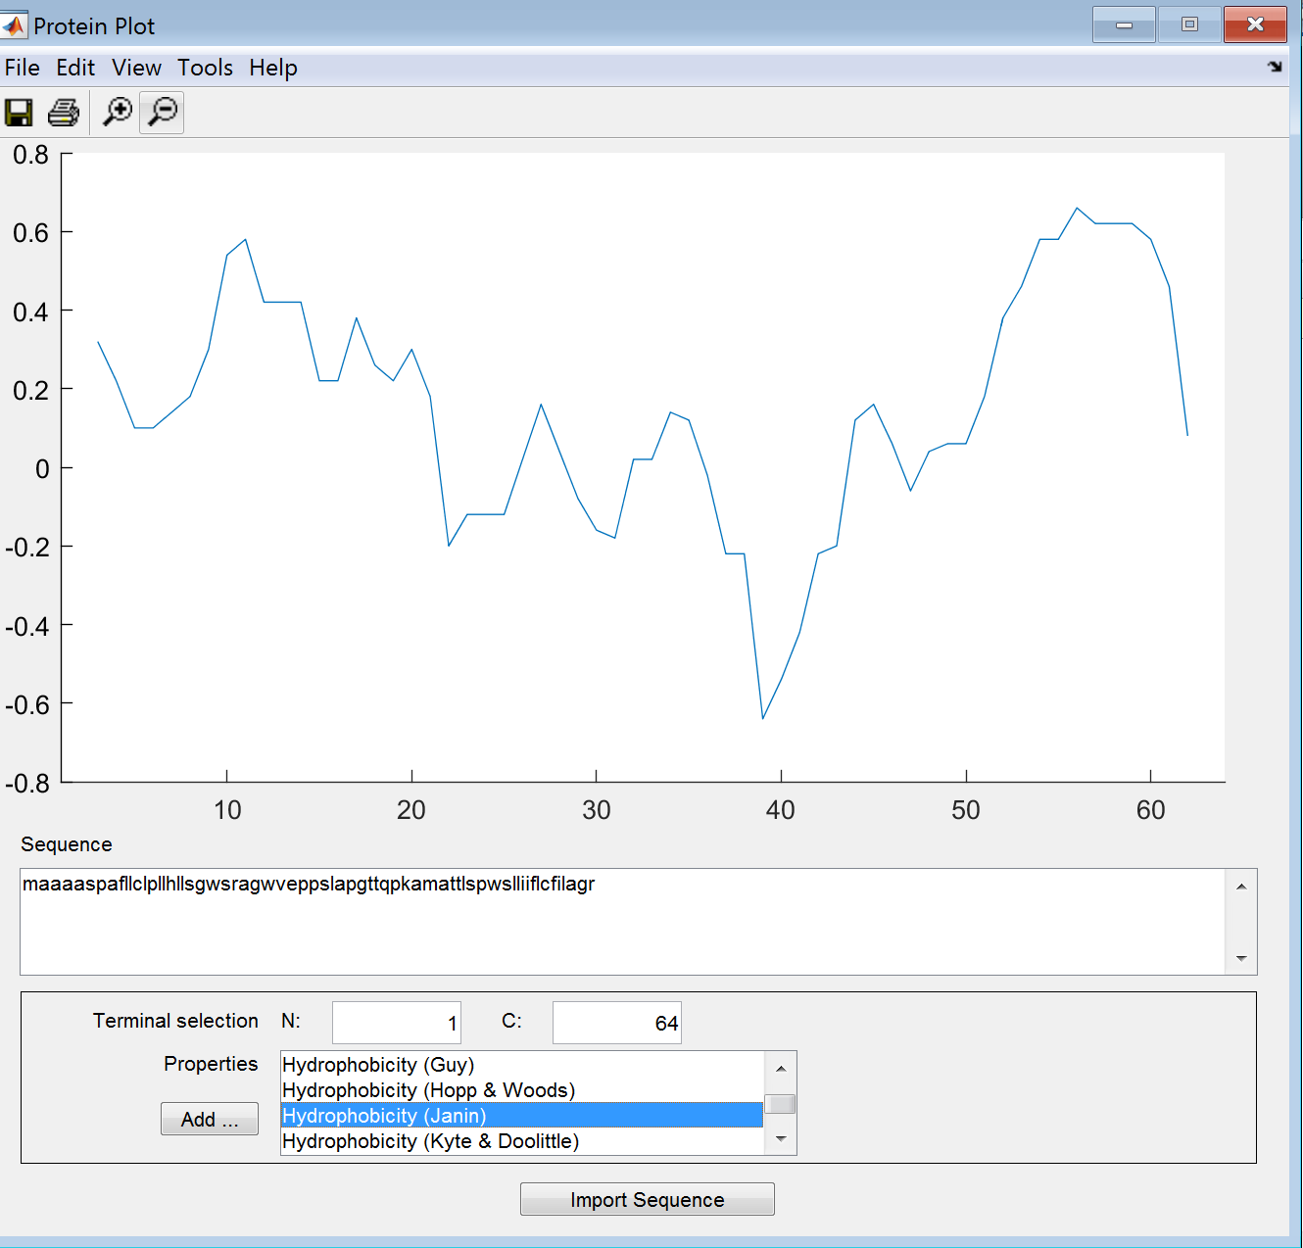

**Hydrophobicity (Manavalan et al)**

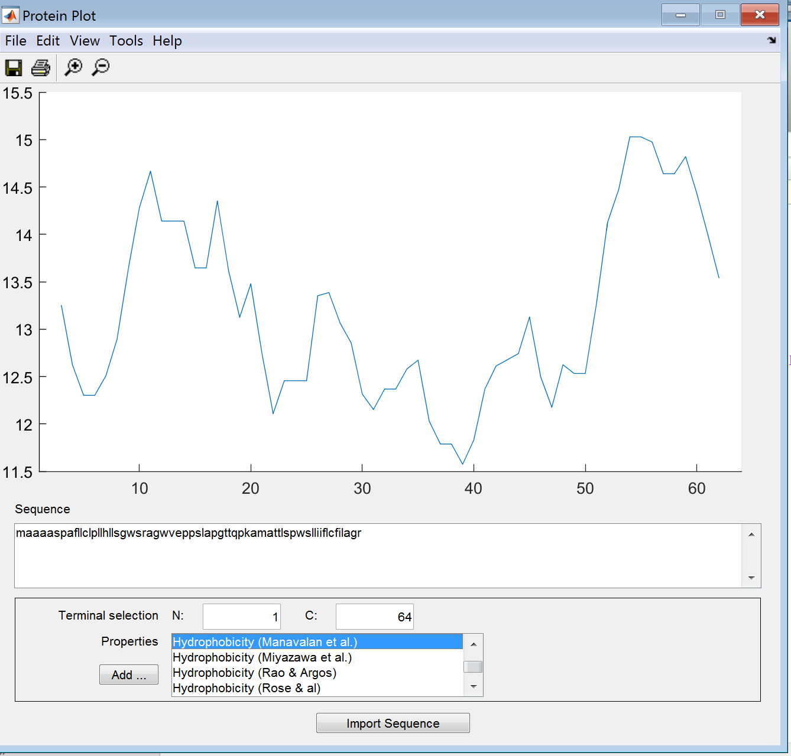

**Hydrophobicity (Miyazawa et al)**

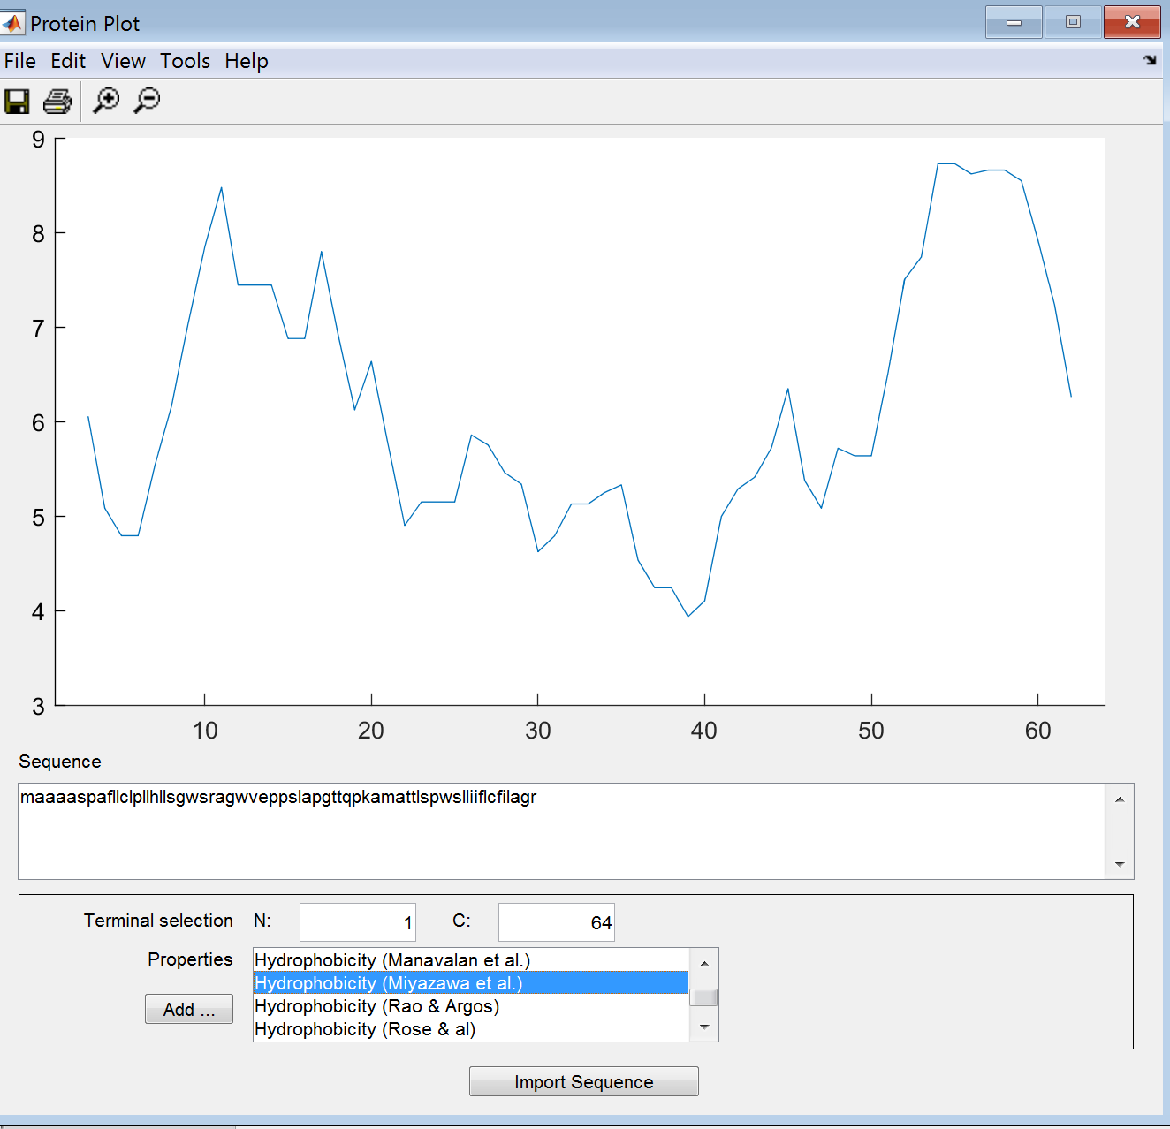

**Hydrophobicity (Rao & Argos)**

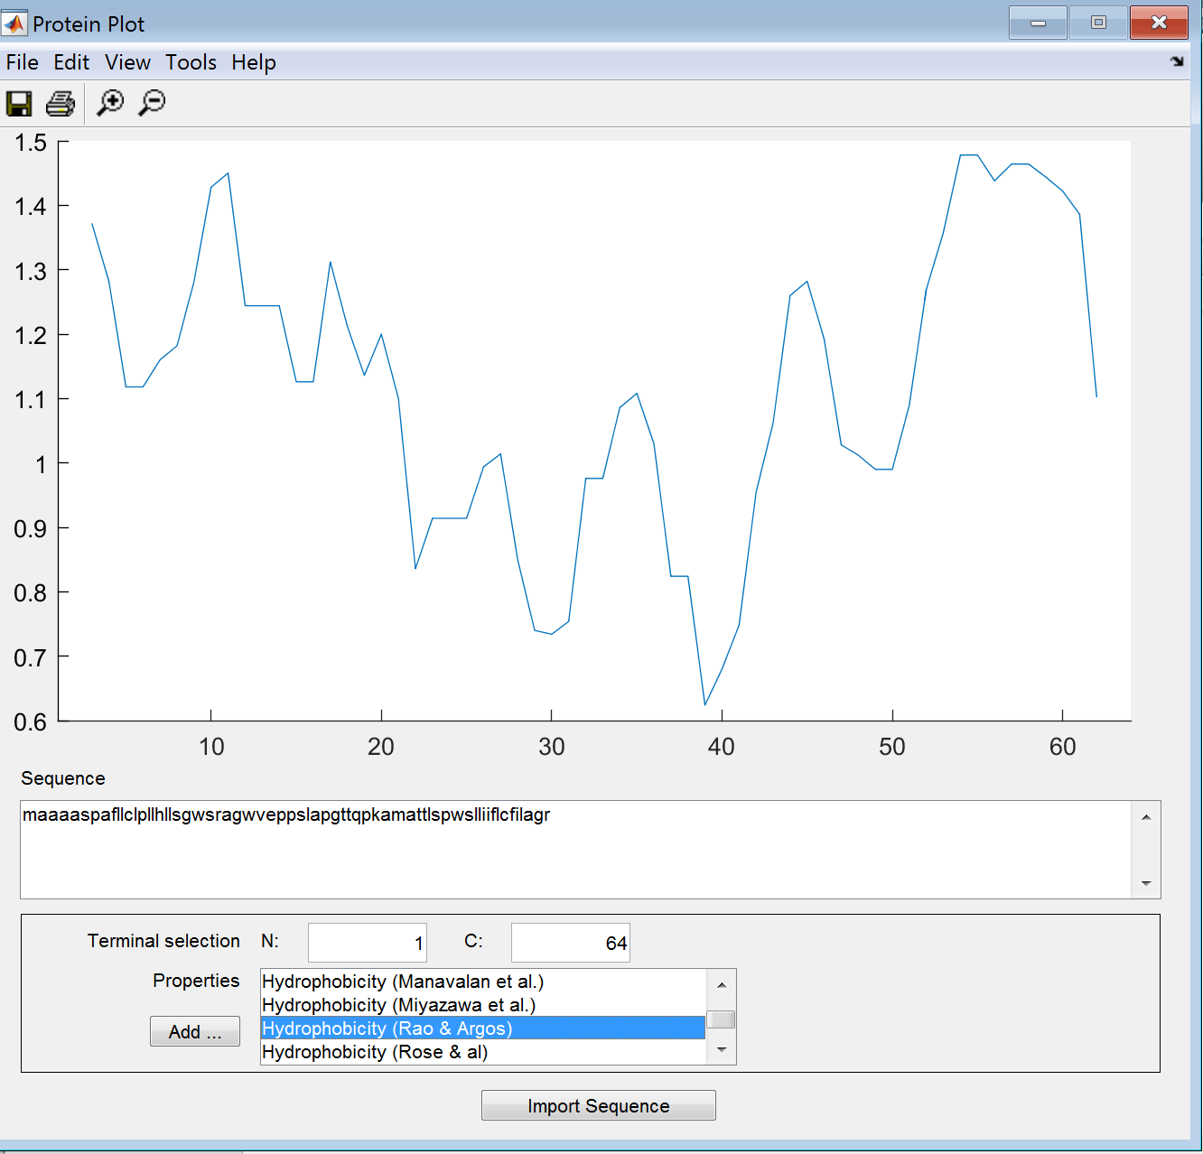

**Hydrophobicity (Rose & Al)**

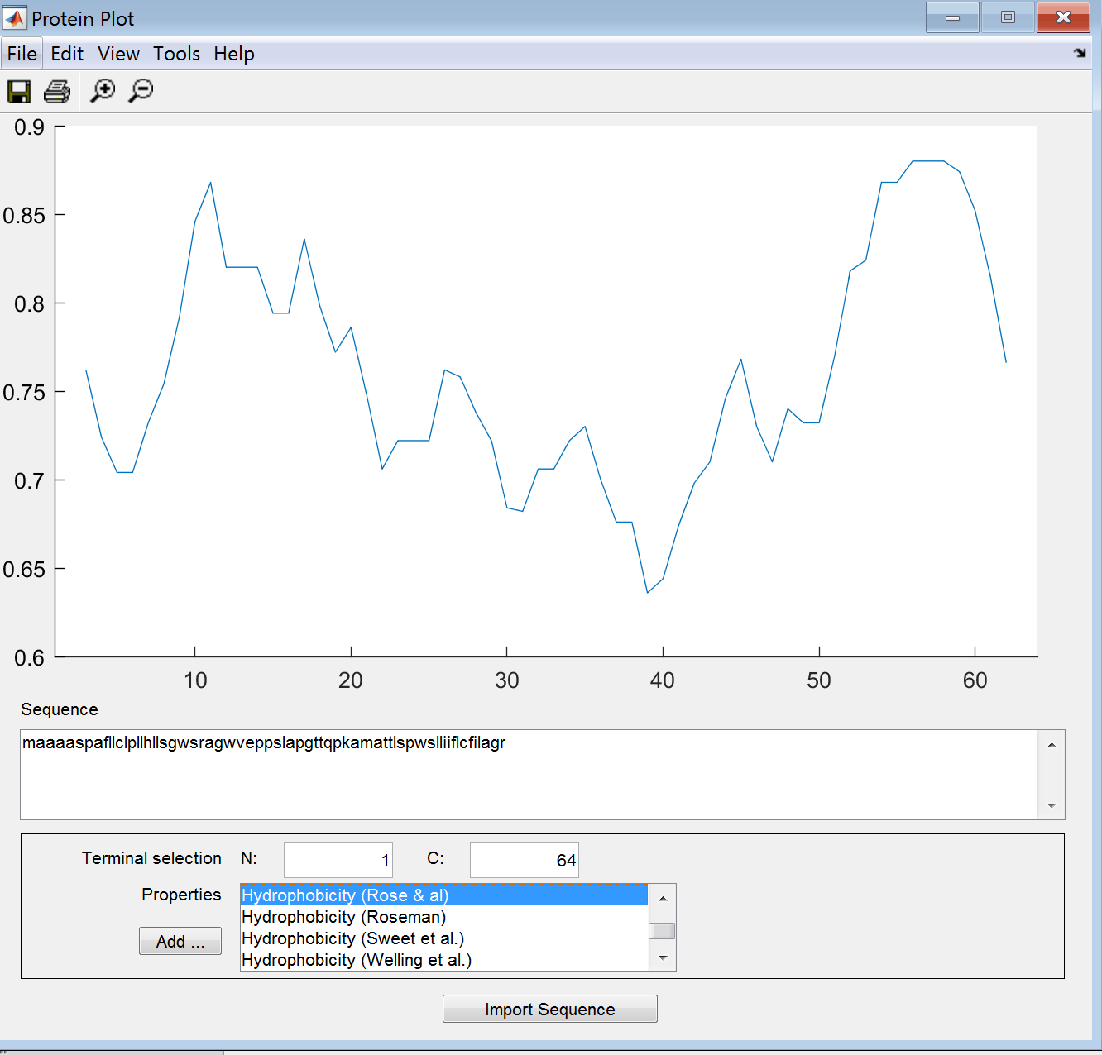

**Hydrophobicity (Roseman)**

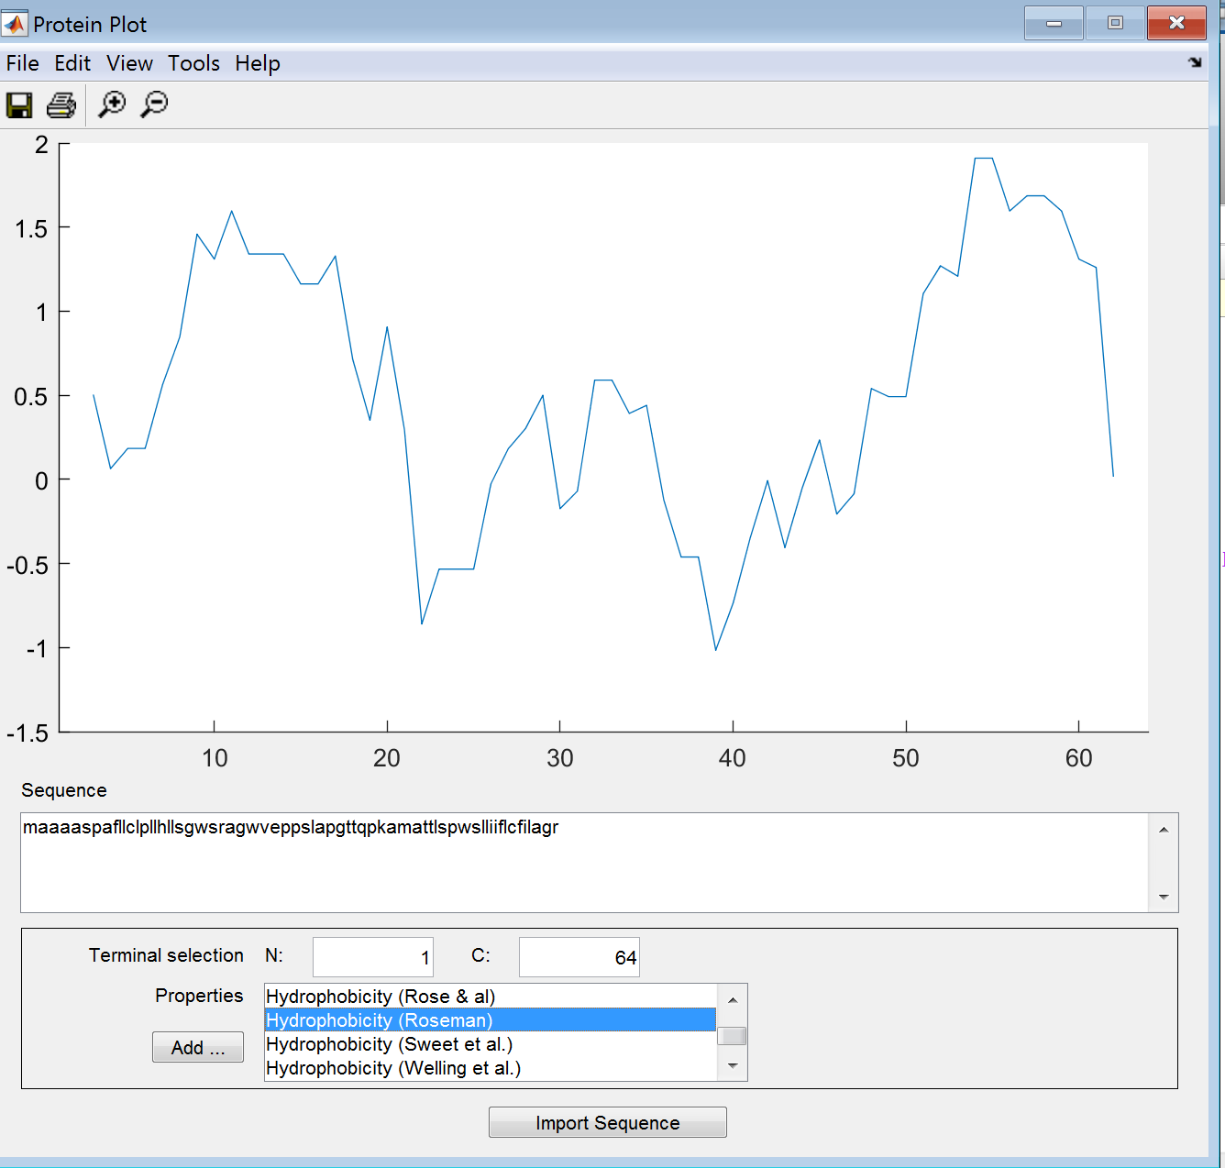

**Hydrophobicity (Sweet et Al)**

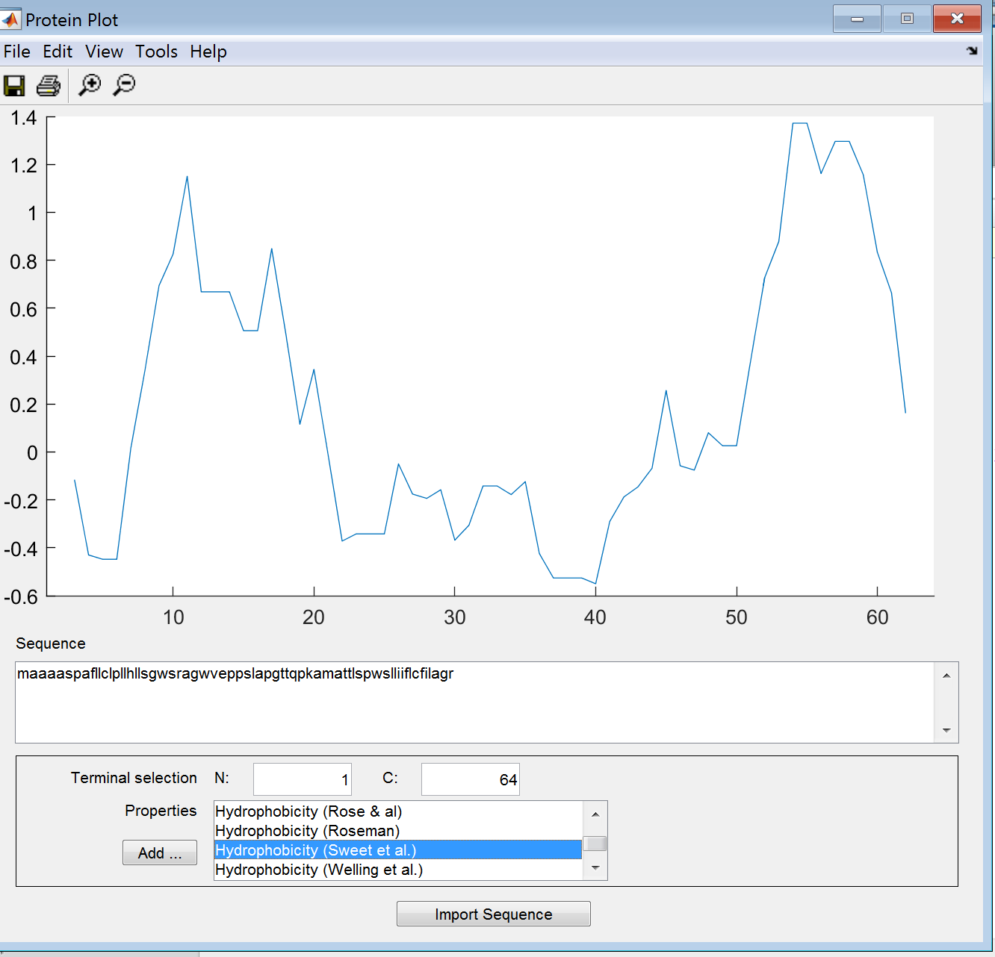

**Hydrophobicity (Welling et Al)**

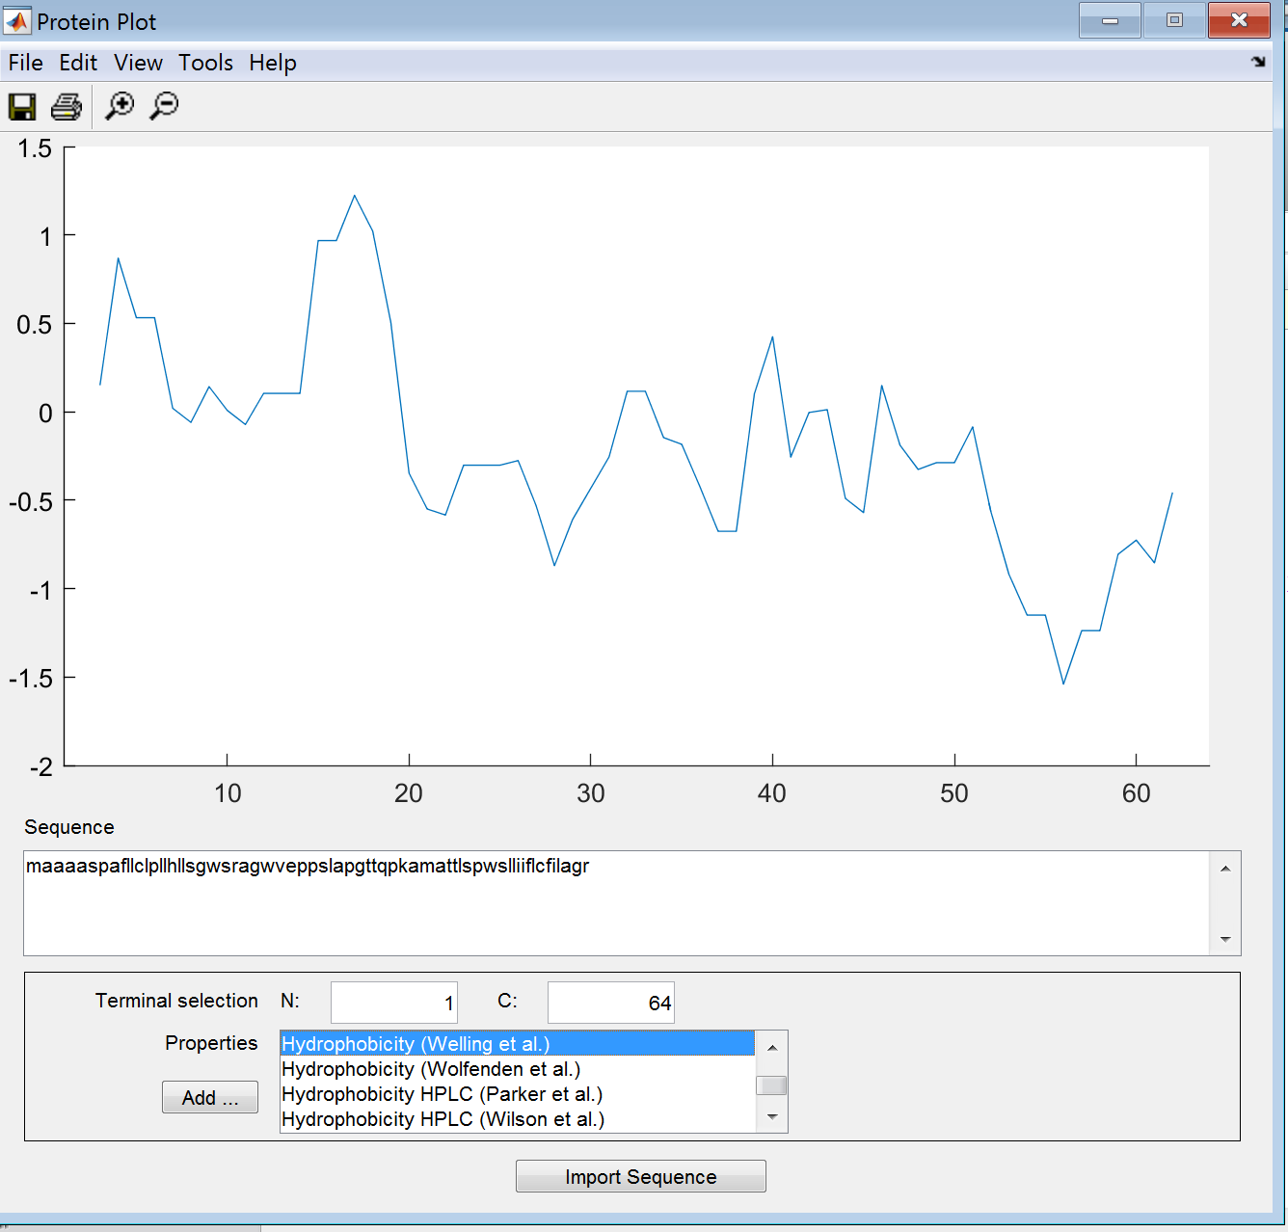

**Hydrophobicity (Wolfenden et Al)**

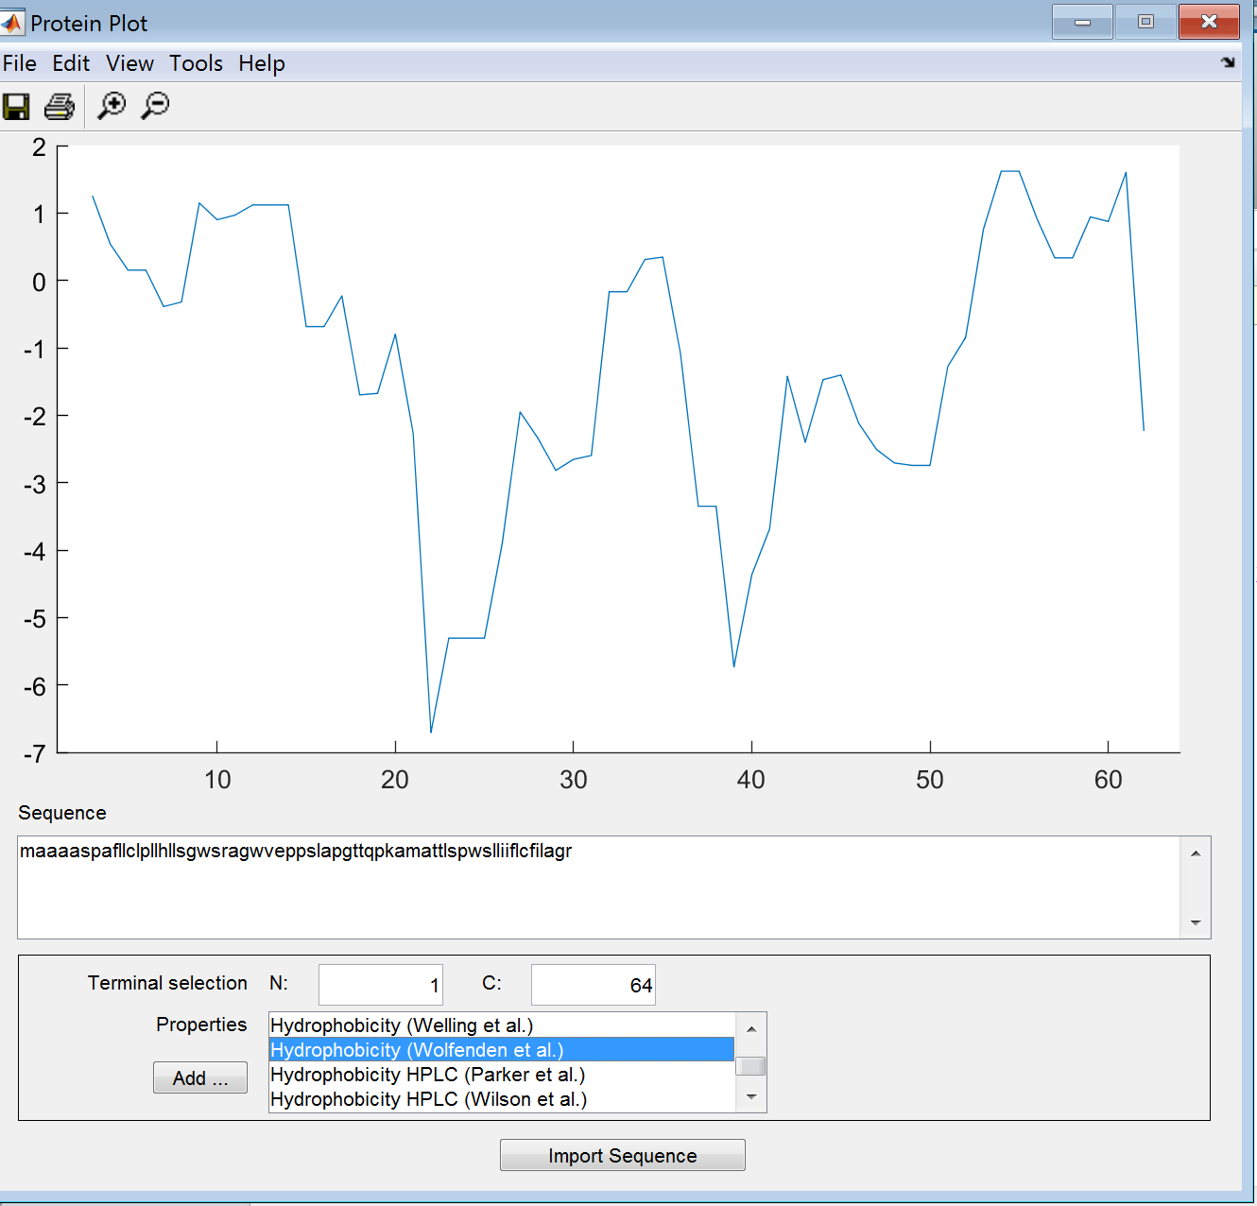

**Hydrophobicity (Parker et Al)**

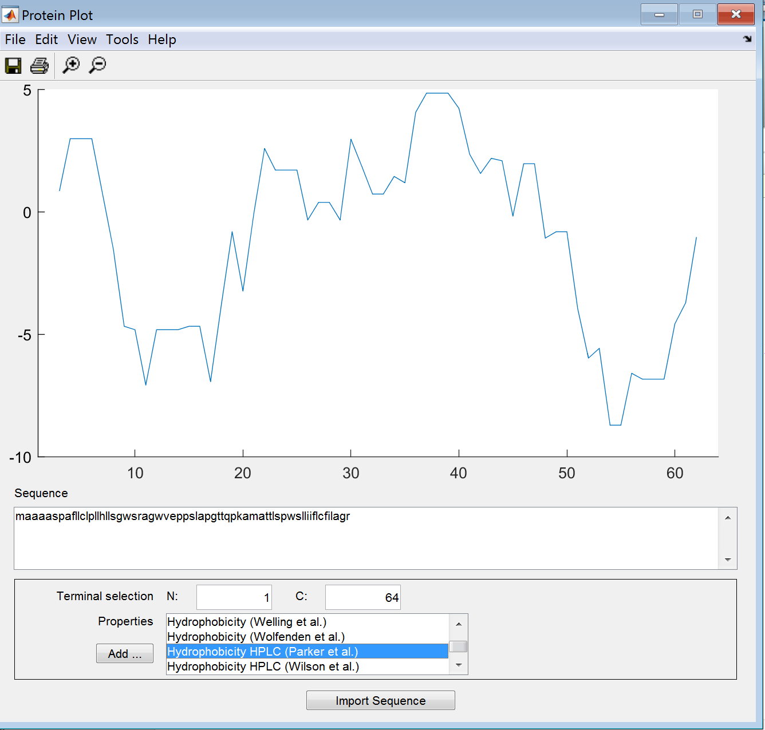

**Hydrophobicity HPLC (Wilson et Al)**

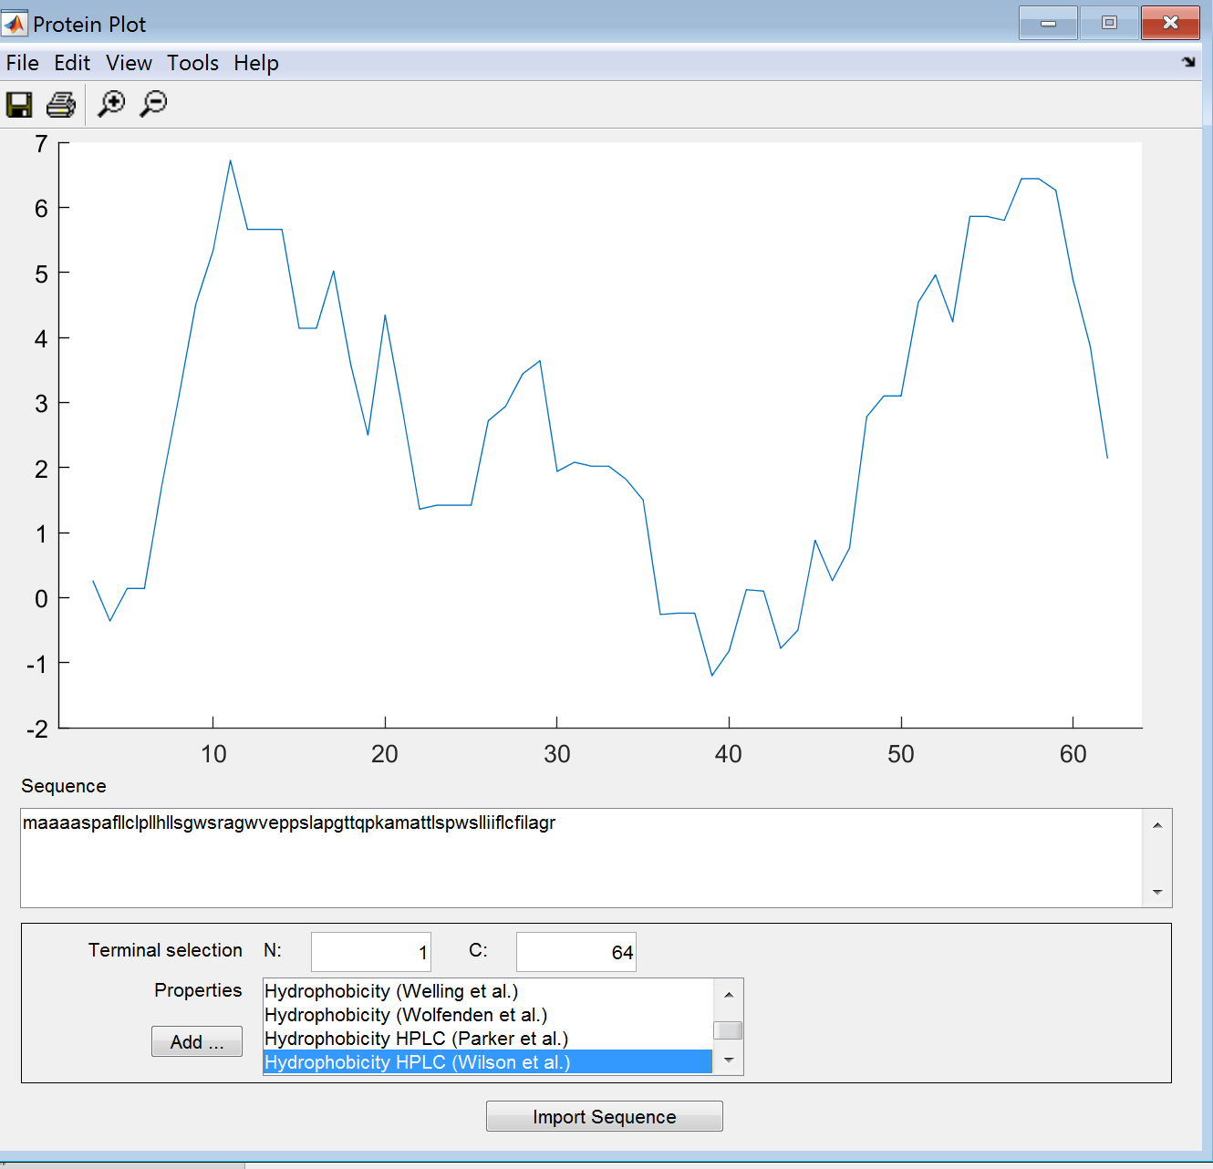

**Molecular Weight**

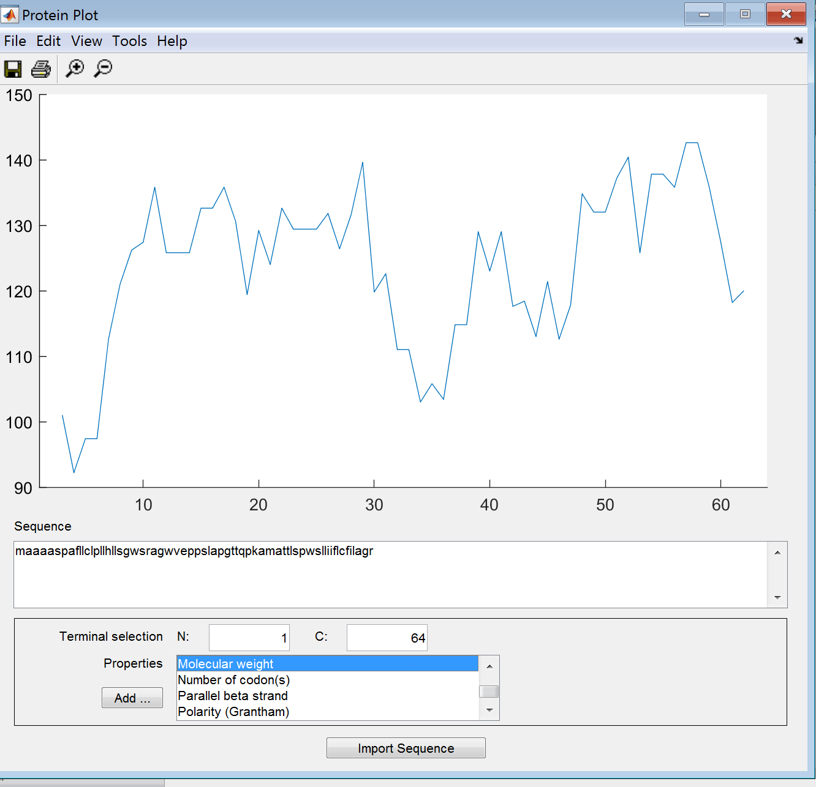

**Number of Codon(s)**

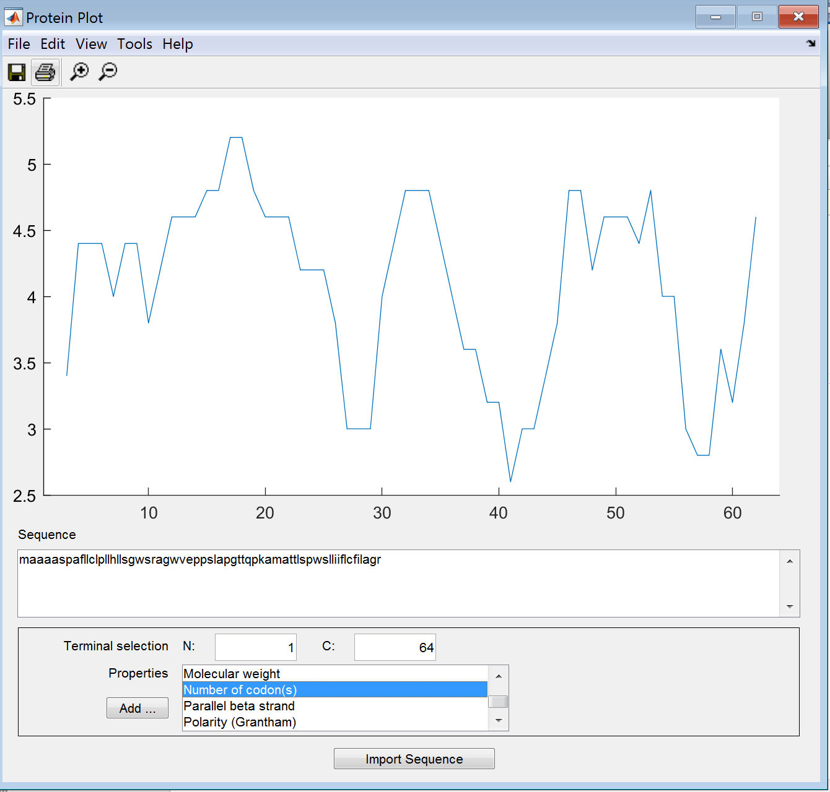

**Parallel Beta Strand**

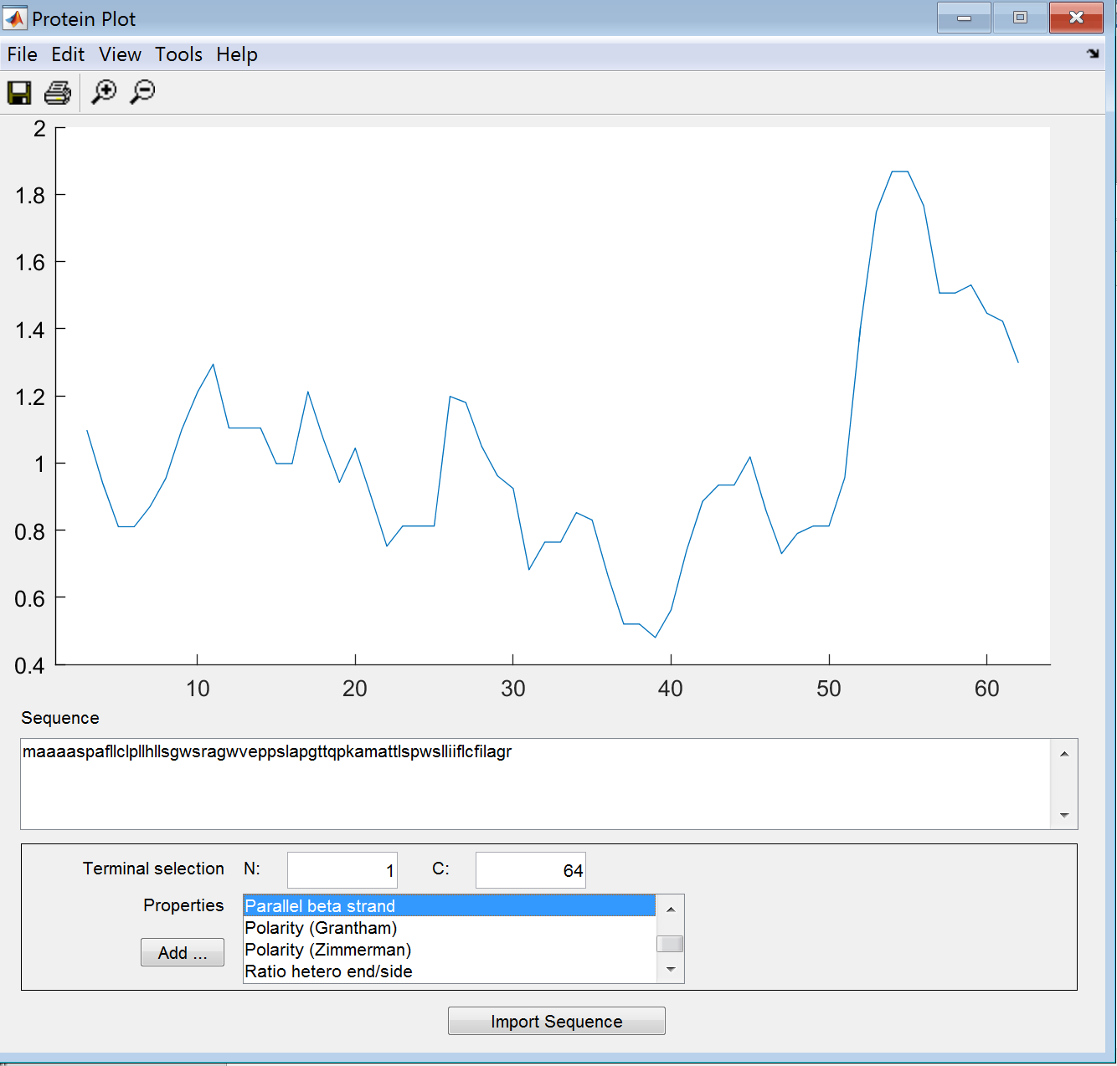

**Polarity (Grantham)**

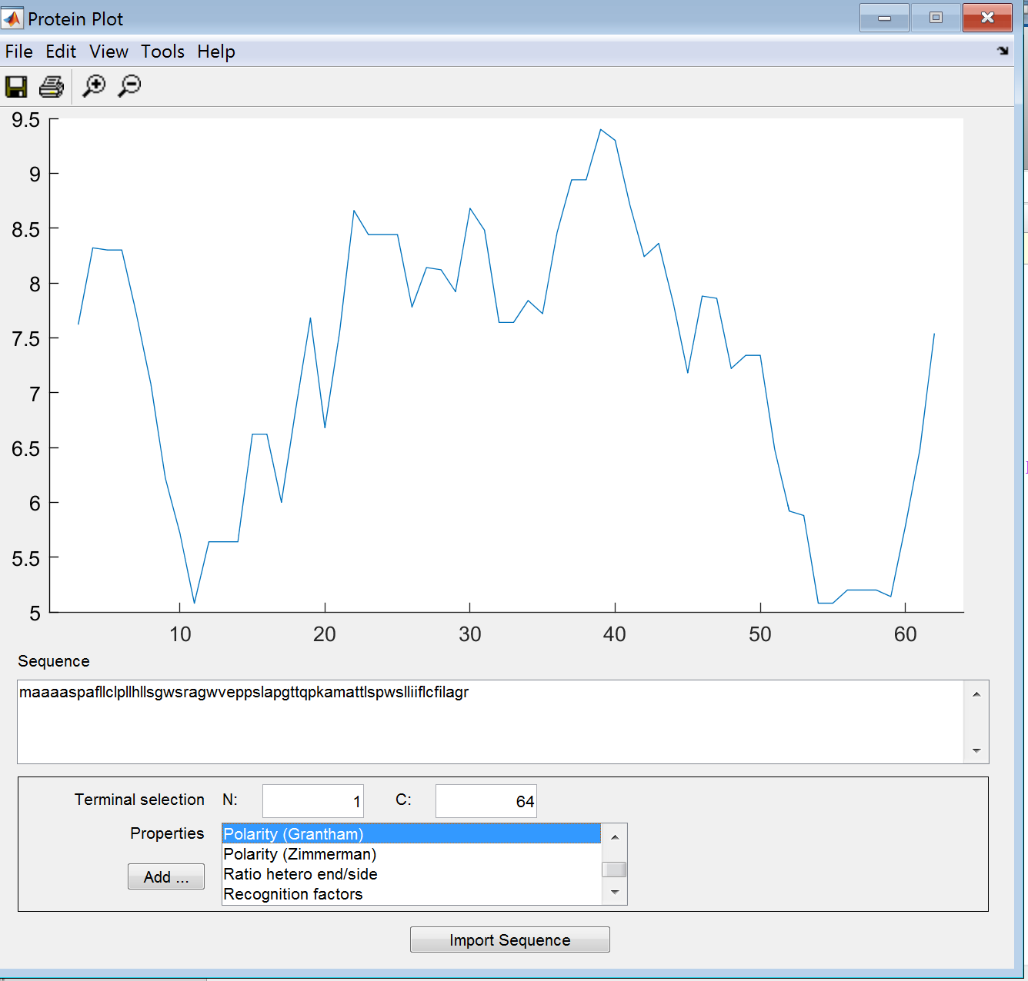

**Polarity (Zimmerman)**



**Polarity (Zimmerman)**

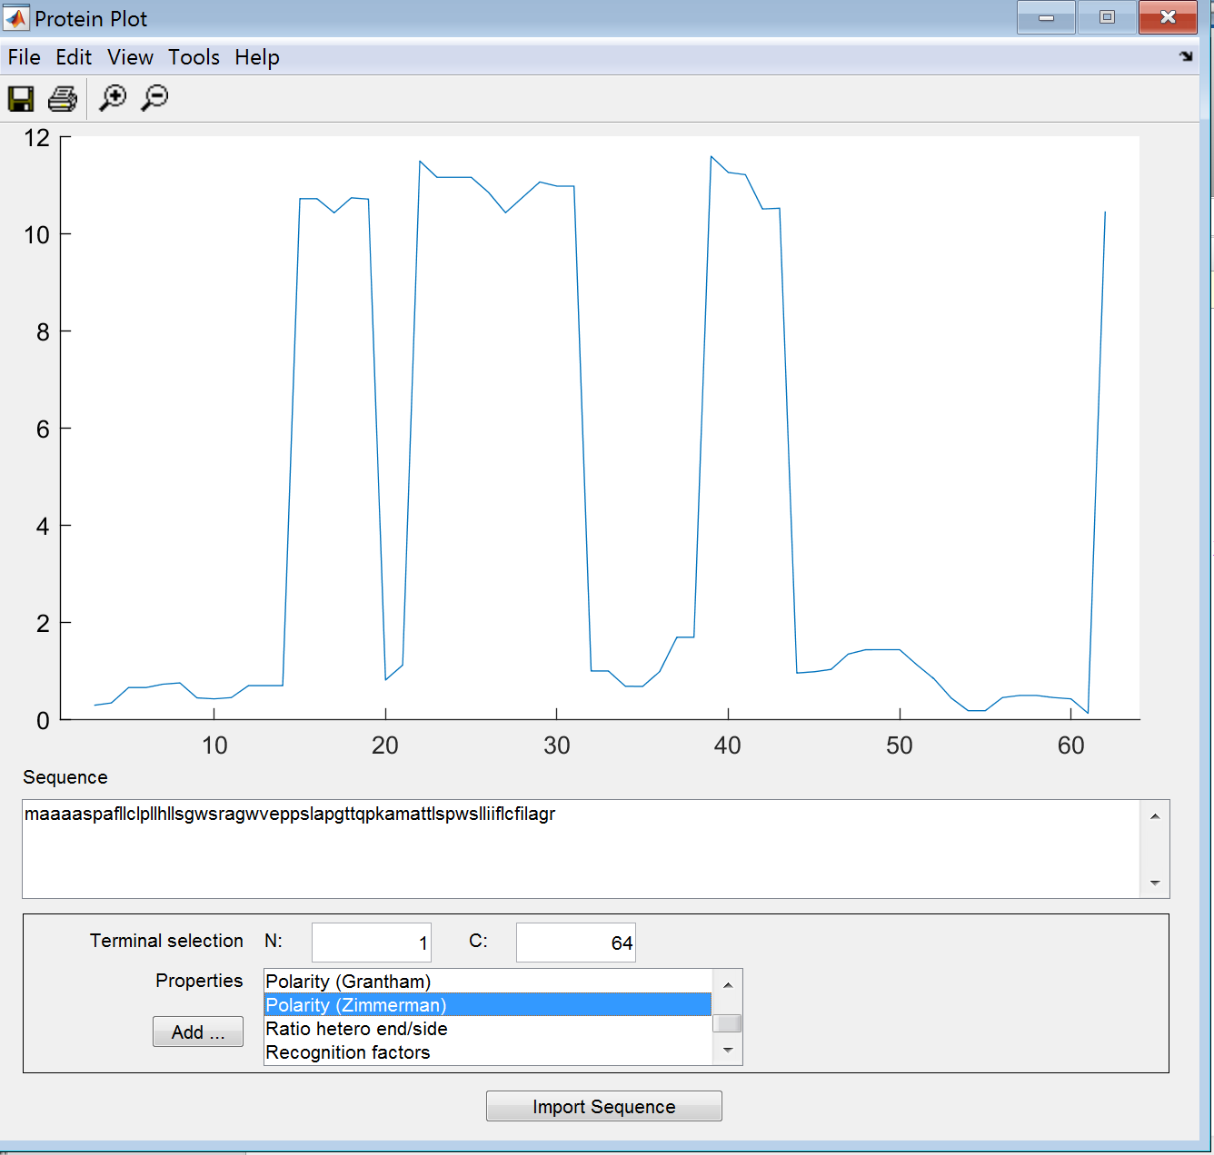

**Ratio Hetero End/Side**

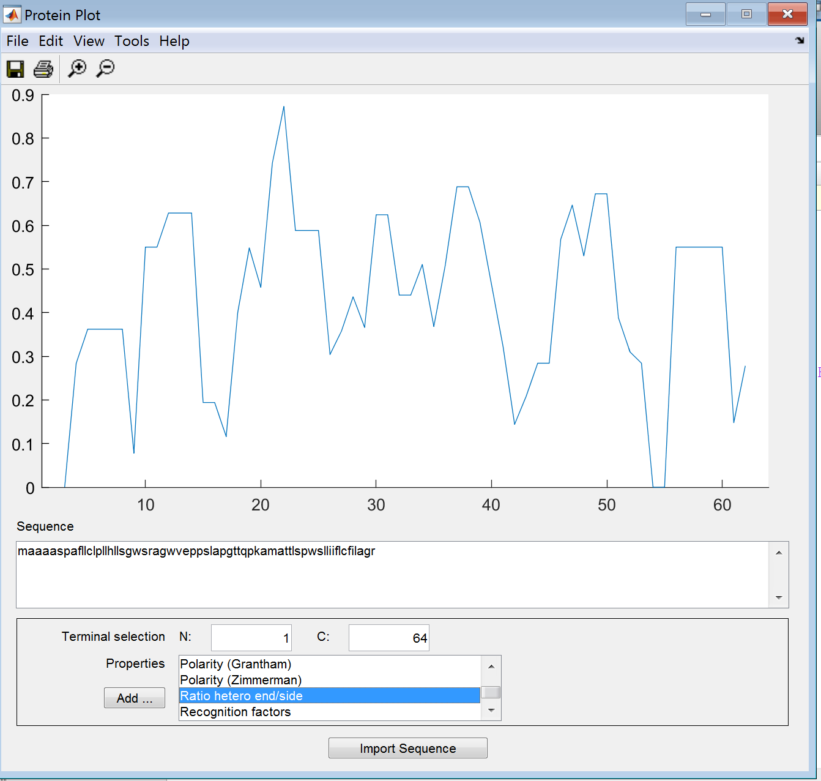

**Recognition Factors**

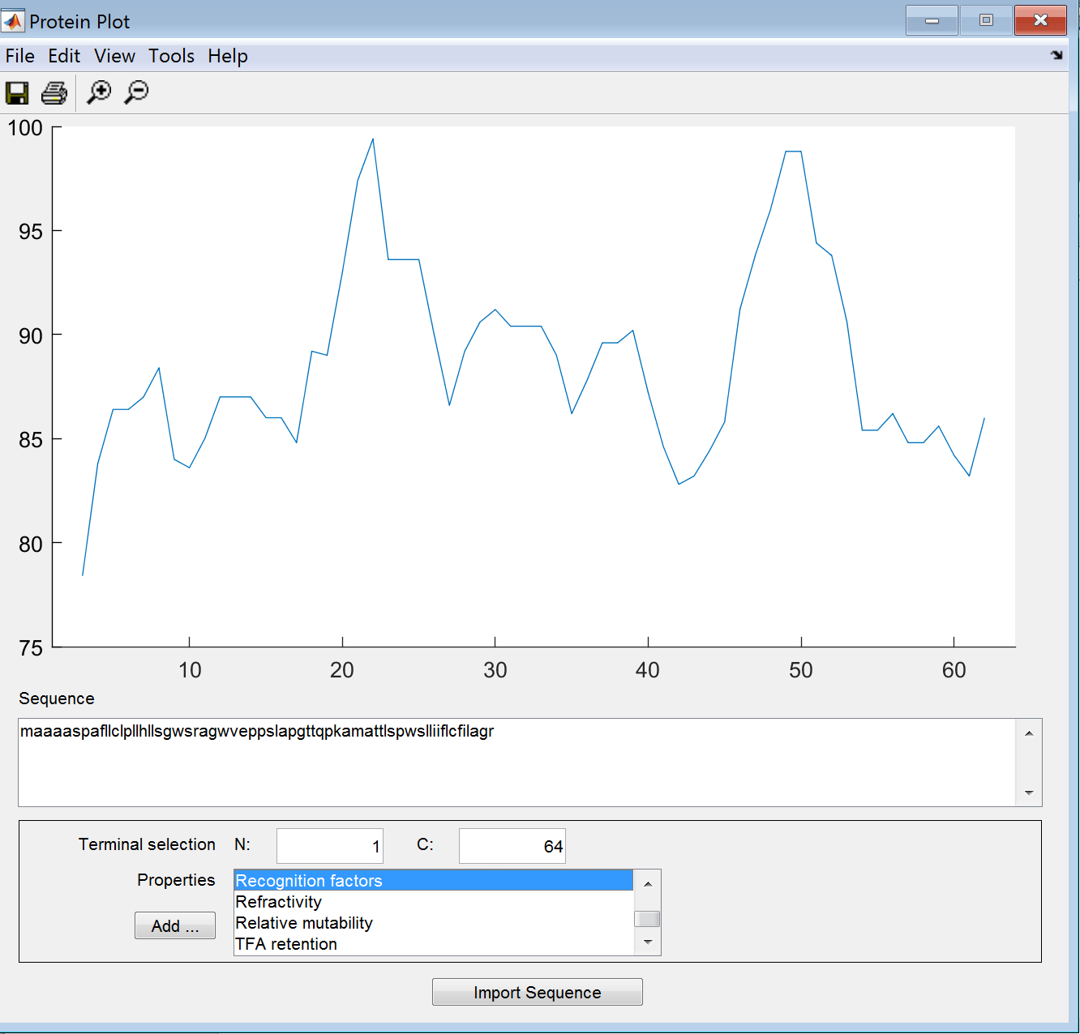

**Refractivity**

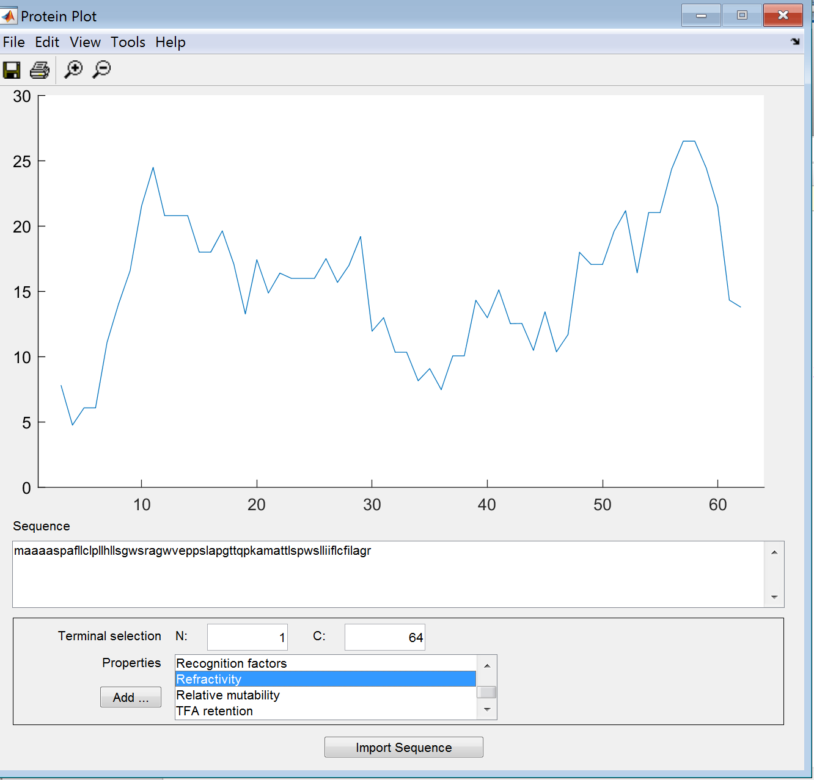

**Relative Mutability**

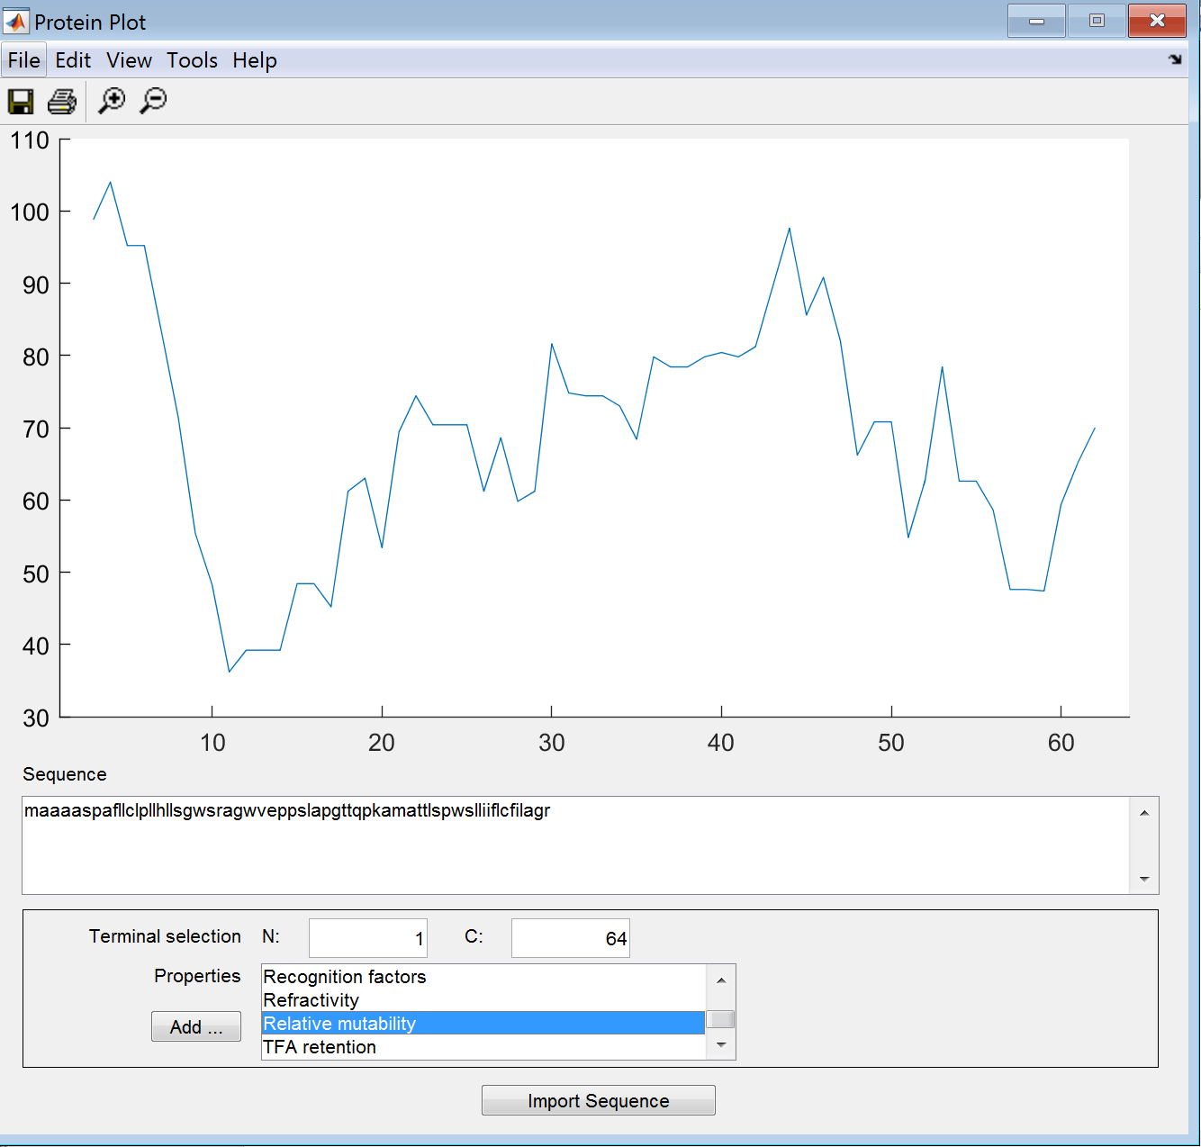

**Relative Mutability**



**TFA Retention**

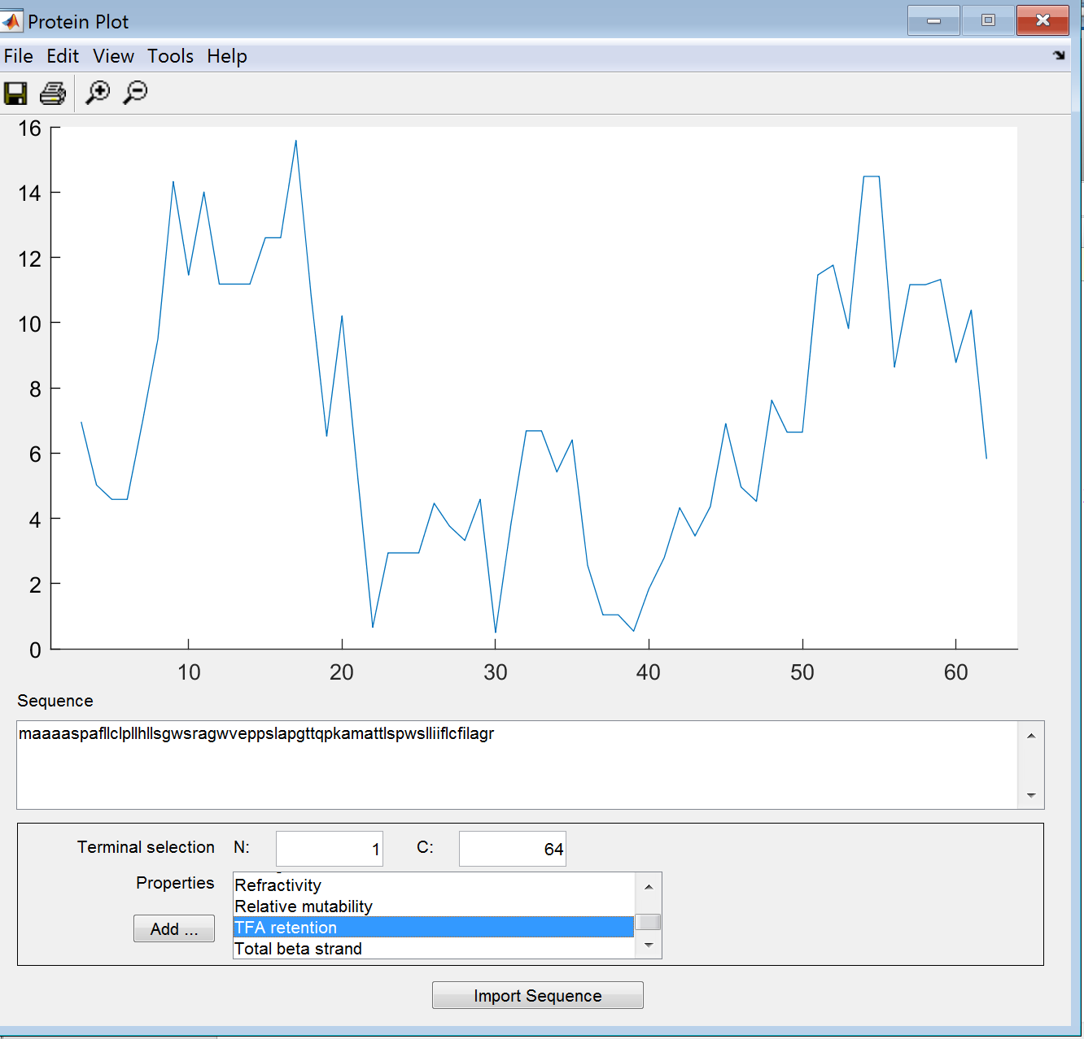

**Total Beta Strand**

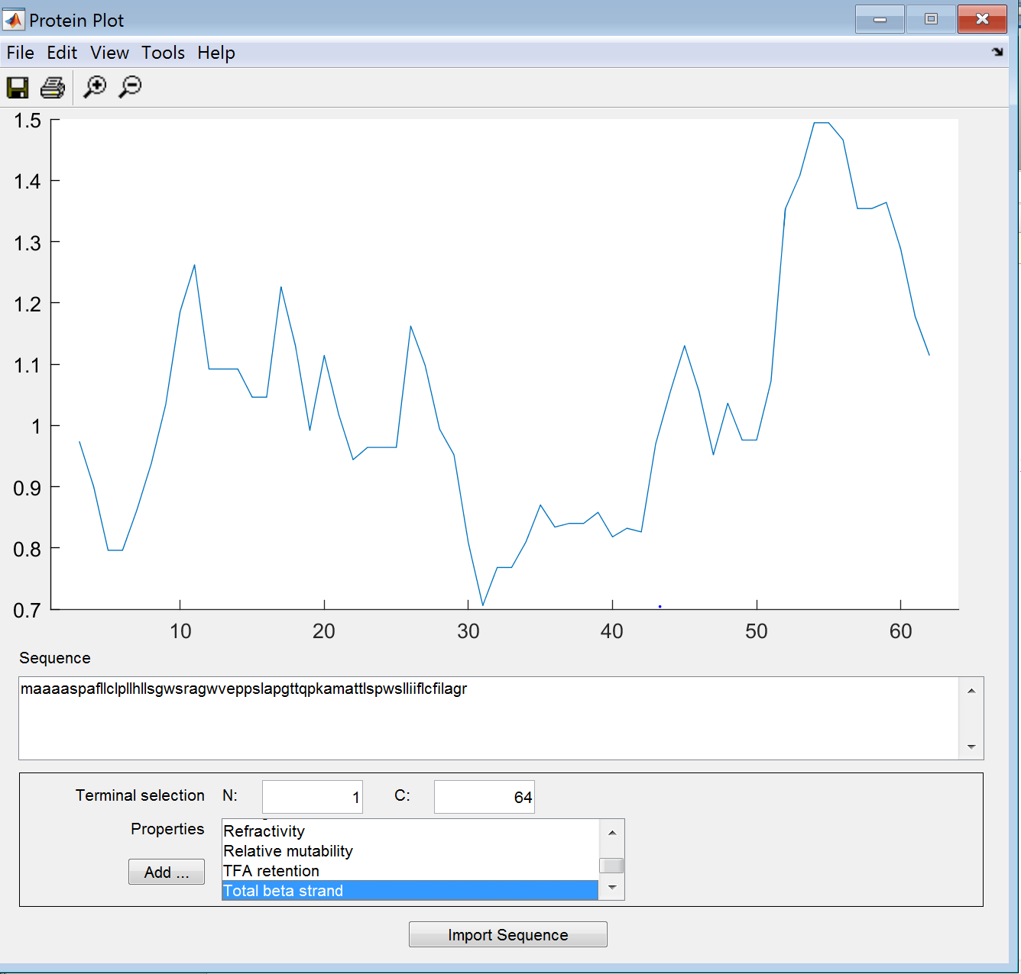

**Box:**

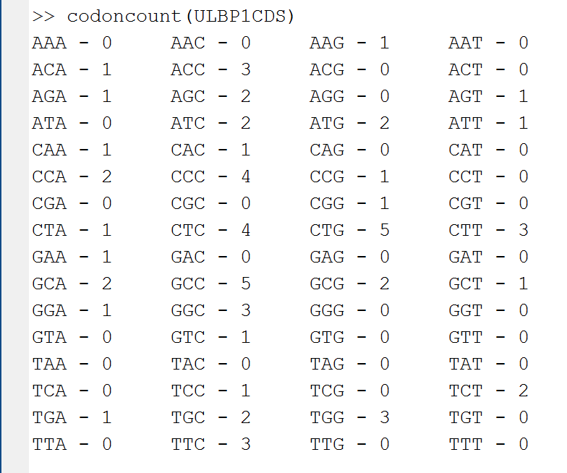

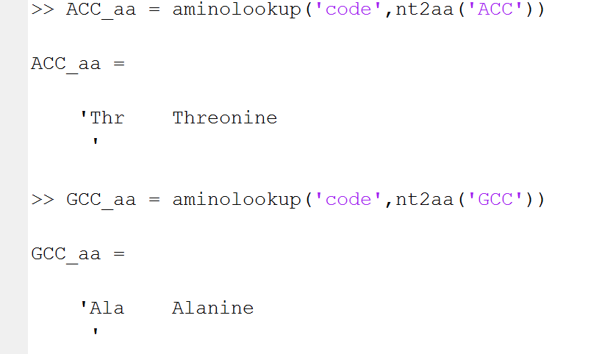

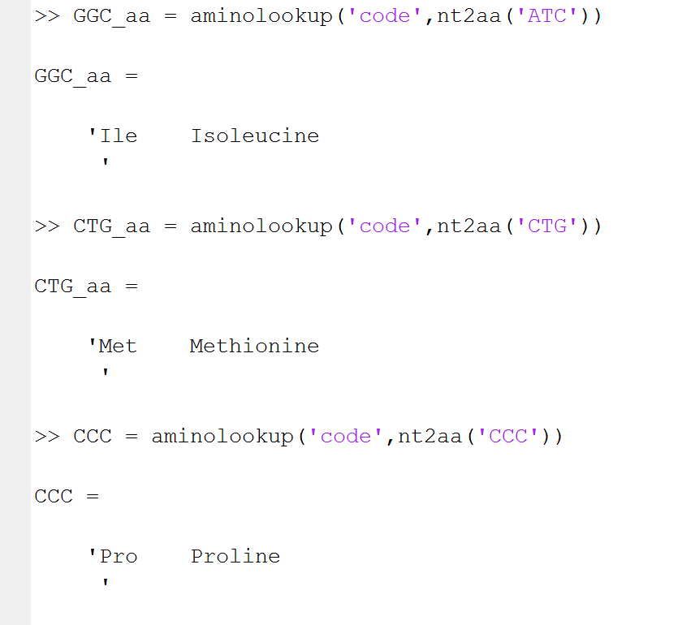

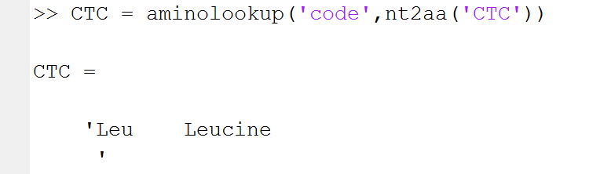









**Figure:**

